This form, which is periodically updated to address new opportunities, is available in PDF and MS Word at the following addresses:
http://www.forestry.msuextension.org or https://www.treefarmsystem.org/montana

Owner’s Name
Plan Author (if not owner)

Forest Stewardship Plan
(double click on box and select ‘checked’)

Tree Farm Plan

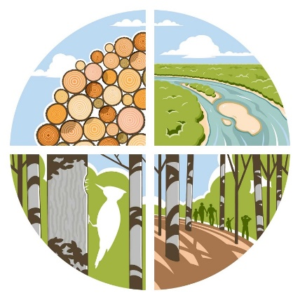
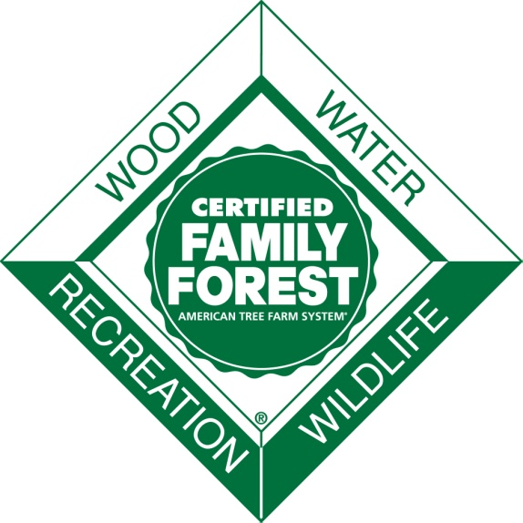
This management plan outlines sustainable forestry guidelines for the conservation of natural resources within this forest and addresses immediate needs (next 5 years) as well as long term (50+ years) objectives and actions. It is endorsed as a certifiable sustainable forest management plan by the American Forest Foundation Family Forestry Program, U.S. Forest Service, U.S. Natural Resources and Conservation Service, Montana Department of Natural Resources and Conservation, Montana Association of Conservation Districts, and Montana State University Extension Forestry.
Forest Stewardship Plans are stored as an electronic copy with the signature page and map removed and stored separately as a hard copy to protect your privacy. Each plan is assigned a number so that the two parts can be made available to you if needed.

Record of Forest Stewardship Certification

Advisor Name Phone

Date of Property Visit MU’s Verified # Acres Verified

Approved By
(Stewardship Advisor – certifies that this Forest Management Plan meets the requirements of the federal Forest Stewardship Program.)

Forest Landowner(s) Signature(s)

Please note: Informal updates to the plan can be made with handwritten notes. Be sure to include a date and initial these notes throughout the management plan.

American Tree Farm Program
I certify that this Forest Management Plan meets the requirements of the American Forest Foundation’s American Tree Farm System.
___________________________ _____________________ ___________
ATFS Inspecting Forester Number Date

Certified Tree Farm Number: (e.g. MT 1234) _______ Date of ATFS Certification: _______

Your Tree Farm plan should be saved and presented at re-inspections which are completed every 5 years, or sooner if yours is selected as a mandatory inspection or audit by National Tree Farm. If you choose MT Tree Farm can also store your plan in a secure location so that it can be made available to you in case you misplace your copy. Please select one of the options below:

__ I will keep a copy of my plan. MT Tree Farm does not need to store a copy.
__ MT Tree Farm may store a copy of my plan.

NRCS Incentive Programs
This plan can be a start for forest owners who might like to participate in USDA Environmental Quality Incentives (EQIP) Program and/or the Quality Criteria for forest activity plans in Section III of the USDA NRCS Field Office Technical Guide, check with your NRCS representative for further guidance and assistance.

Contour Map

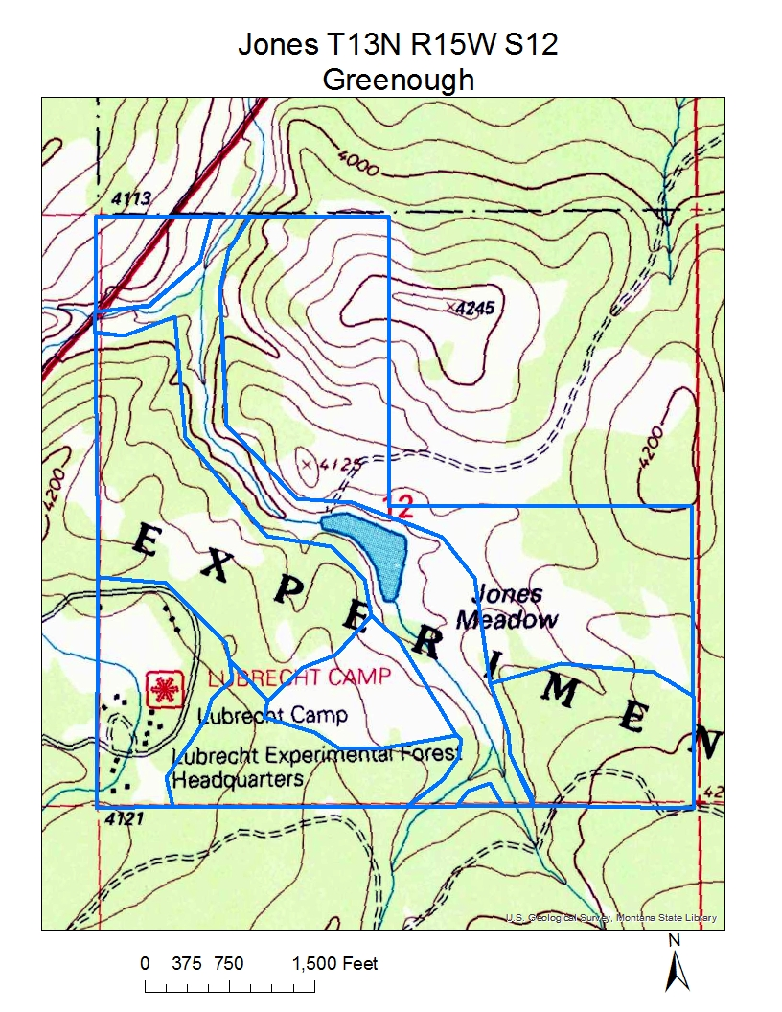

Attach property map (topographic) here

Identify
Property Boundaries and Management Units

Aerial Imagery

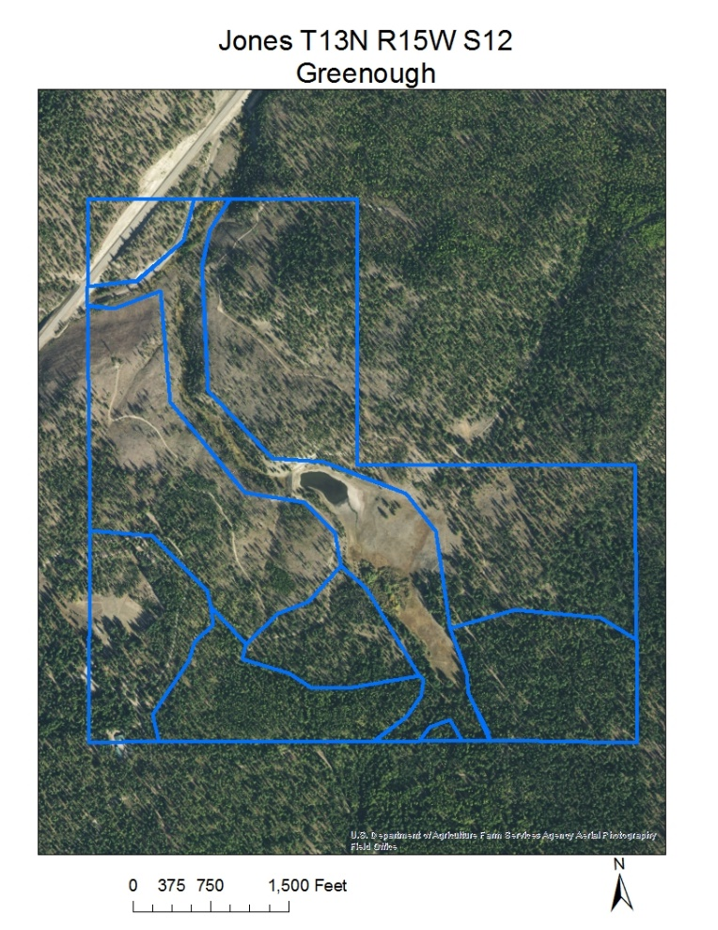

Attach aerial image here

For free aerial photo downloads
http://earth.google.com/

Property Ownership
Landowner(s) (and representative, if different)

Mailing Address(es)
Phone Number(s)
E-Mail(s)
Date of Original Plan Completion Plan Expiration Date (NRCS) ___________________
Revision date(s)
Property and Landscape Description
Legal property description
Nearest city or town County
Total ownership acreage Total forested acreage
Total acreage covered by this plan
Number of unique stands of trees or management units
Do you reside on the property? Yes No
Average aspect (check): N S E W Flat
Average elevation
Basic topography (estimate percent of total acreage that is)
Complex topography (many steep ravines and aspects)
Simple topography (few ravines and changes of aspect)
Percent of land that is Flat-Gentle (0-20% slope)
Moderate Slope (20-40% slope) ________ Steep Slope (> 40% slope) ________
Improved Road Conditions (check) Excellent (100% accessible) Good (at least 80%)
Fair (at least 50%) Poor (less than 25%)
Estimated improved road length (bulldozed with graveled surface)
Estimated unimproved road length (bulldozed with but original soil/bedrock)
Required for Tree Farm
Primary Soil type ______________________ Secondary soil type ___________
This document may help you determine soil types.
Estimated total permanent skid trail length (drivable but no earthwork)
Estimated cumulative stream length class I class II ________ class III ______
Property History
The Property History is a brief description of the history of the land and ownership including past and current ownership, past management activities, and surrounding environment (whether nearby property is developed, private woods, public forests, etc.). This information can be based on personal knowledge, property records, and local information sources. You may find information on the chain of ownership on the title search done by the insuring title company. You can also consider what evidence is seen on the ground, stumps, skid trails, etc. You may or may not know much about your property but can continue to add to this section as your knowledge of your forest history increases and as you develop your own history with your forest.
________________________________________________

Forest Stewardship Goals
The principal management objectives for the ownership.
(Refer to worksheet Goals for my Forest Land). Write your goals in the spaces below. Place a 1 in the box next to your most important goal, a 2 in front of your next most important goal, and so forth. If goals are equal, then give them the same number. Feel free to add or change headings to better fit your specific goals.

Trees/timber

Fire protection

Wildlife

Range/livestock

Understory vegetation & weeds

Building sites (home, barn, etc.)

Aesthetics

Recreation

Legacy _________ ______________

Revenue

___________

______

Stand Level Information

Your property may have multiple management units that are either defined by unique site characteristics, management actions that you desire to implement, or a combination of both. For each stand or management unit, include the following:
1) brief description of the forest management unit and its current condition. Descriptors can include slope, aspect, forest structure, tree species and age composition, health and appearance, % crown cover, the presence of insects and disease, site index and habitat type if known (NRCS required, ask representative for assistance). For a more detailed analysis refer to your Plot Form Summary, Inventory Short List, or Stand Analysis Form to help with this section. https://forestry.msuextension.org/forms-to-download/index.html
2) your management objectives for each management unit
3) your desired future conditions for the stand. (Plans and detailed recommendations will be entered in another section.)
Unit 1 Acres
General current description
Objectives
Desired condition

Unit 2 Acres
General current description
Objectives
Desired condition
Unit 3 Acres
General current description
Objectives
Desired condition

Unit 4 Acres
General current description
Objectives:
Desired condition:
Unit 5 Acres
General current description
Objectives
Desired condition
Add more pages as needed (additional pages at end)
Desired Future Condition (Trees) MU _____
(Complete for each Management Unit - This page is optional, but helpful, in describing your desired future conditions)
Length of planning period ______5yr ______other
Add more pages as needed – (Additional pages at end)
Desired tree species and expected longevity (maximum age you expect
trees to reach before they die of natural causes or are harvested)
PP ponderosa pine
DF Douglas-fir
LPP lodgepole pine
WL larch
GF grand fir
ES Engelmann spruce
WRC w. red cedar
WH western hemlock
WP white pine
SAF sub-alpine fir
LP limber pine
RMJ Rocky Mtn juniper
QA aspen
CW cottonwood
GA green ash

Desired Tree Species Percent of Stand Age
1.
2.
3.
4.
5.
6.
Desired species to naturally regenerate
Desired species to plant
Desired Tree Distribution (Bird’s-eye view of forest-(check one)
Wild Evenly Evenly spaced Variable density
stand spaced with openings spaced with openings
Spacing (feet) | Trees/acre
3x3 | 4,840
5x5 | 1,742
7x7 | 889
10x10 | 436
12x12 | 303
14x14 | 222
16x16 | 170
18x18 | 134
20x20 | 109
25x25 | 70
30x30 | 48
40x40 | 27

Desired spacing (in feet) Large (>9“ DBH) (ft)
Pole (5-8” DBH) (ft) Seedling (<5” DBH) (ft)
Size and shape of openings
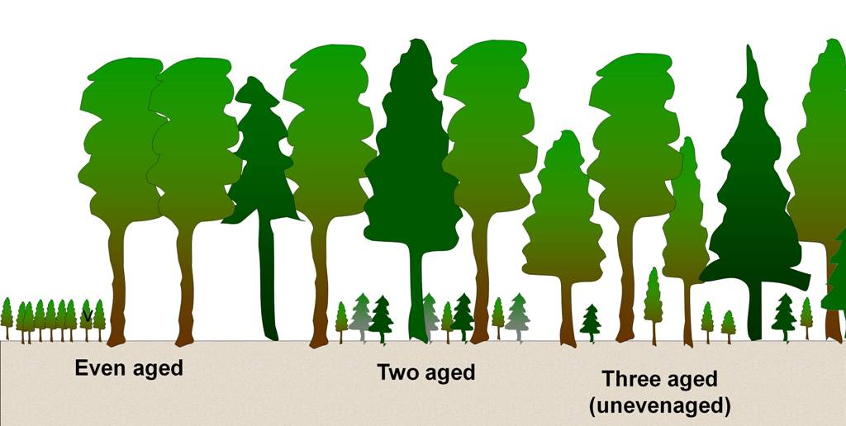
Desired structure:

One canopy layer Two canopy layer Multi-layer/
Uneven aged

Resource Elements
This section relates to the natural resource elements found throughout the entire property. Some treatments related to these resources may qualify for federal and state incentive programs. For this section, include appropriate activities and treatments in the Management Activity Schedule and Tracking table as well as on the map(s). Complete the Activity Schedule and draw and label the areas of management on the map if using this plan as part of an incentive program application.
For each resource element, consider:
- Where will the management take place? (MU number, entire or part of a stand, # acres)
- What treatments/monitoring/protection are planned? (Single tree select, seed tree, precommercial thinning, planting, weed control, trail building, road maintenance, riparian rehab or protection, wildlife habitat improvement or maintenance)
- When will you implement treatments (season, year), follow-up activities, etc.?
- How will the work be done (equipment needed)?
- Who will do the work (your, contractors, your grandson)?
- What else do you need? (permits, professional assistance, applications for the incentive programs?)

Special Sites & Social Considerations
Home fire safety (defensible space, near home site)
Current condition

Treatments/improvements/recommendations planned

Recreation (what recreational uses will you pursue on your property; hiking, skiing, hunting, birdwatching, ATV trails, camping etc. and where and when will you pursue these. Do you need to modify sites for these?)
Current condition or use

Treatments/improvements/monitoring/recommendations planned

Forests of Recognized Importance (FORI) Required for Tree Farm Measure 5.4 of the ATFS Standards of Certification requires landowners and inspectors to address (FORI). Currently, there are no officially recognized FORI in Montana. However, if the property is adjacent to unique protected areas, such as National Parks, the landowner may wish to consider FORI relevant.

Access (Does your property restrict access to public lands, will you allow access across or to your lands, are the boundaries posted with appropriate contact information, have you considered Block Management with Montana Fish Wildlife and Parks)
Current condition or use

Treatments/monitoring/recommendations planned

Roads (general maintenance, erosion potential, Best Management Practices, road surface condition, road runoff, drain-dips, culverts, stream crossings, weed control, time-of-year use)
Current condition or use

Construction/maintenance/monitoring/recommendations planned

Adjacent Ownership Concerns (how does surrounding management affect your forest and how do your actions impact your neighbors? Consider aesthetic quality, wildfire concerns, privacy, wildlife movement and habitat, noxious weeds)
Current condition or use

Treatments/maintenance/monitoring/recommendations planned

Soil protection (Litter layer, understory vegetation, woody debris retention, nutrient cycling, micro fauna) http://websoilsurvey.nrcs.usda.gov/app/HomePage.htm
Current condition

Treatments/protections/monitoring/recommendations planned

Special sites and their protection (including, archeological, cultural and historic sites; are there historical sites on your property that you wish to delineate, protect or contact anyone i.e. universities etc. about)
Current condition

Treatments/protections/monitoring/recommendations planned

Carbon sequestration (optional; will you pursue selling or leasing the carbon being sequestered on your property to someone else?)

Fish, Wildlife and Biodiversity
Describe the resources on your property and the activities you are planning to accommodate your goals.
Fish & wildlife - desired species (species lists, habitat improvement or creation, animal control, den sites, nest boxes, snag retention, access, hunting)
Current condition and use

Treatments/monitoring/recommendations planned

State and federal threatened or endangered species - plants or animals
(to request site specific information http://mtnhp.org/Requests/ )
Current condition or use

Treatments/monitoring/recommendations planned

Streams, wetlands, ponds, lakeshore (Plans and protection; is there a wetland or stream within your harvest area, is it properly marked Streamside Management Zone (SMZ) and are the appropriate laws being followed?)
Treatments/monitoring/recommendations planned

Permits needed (310 for stream/streambank disturbance or alteration)

Range Resource, Water and Soil Protection
What goals do you have, or what steps will you take to conserve, protect and enhance your forest’s air, water and soil resources?

Rangeland resources (if applicable; grasses, sedges, forbs, shrubs, nitrogen fixing plants, grazing animals, sustainable grazing guidelines, # pastures and animal rotation, water sources, salt block placement)
Current condition or use

Treatments/monitoring/recommendations planned

Grazing animals (native and domestic that are present, in what numbers and time of year; or are you planning for them in the future and in what units)
Current condition or use

Treatments/monitoring/recommendations planned

Weed management, invasive species (inventory, control, monitoring, prevention guidelines, consider integrated pest management)
Current condition

Treatments/monitoring/recommendations planned

Management of Forest Resources
(If a stand is being treated, the general area can either be described or identify the impacted areas on your map) Note MU’s in which you are planning activities.
Protection from insects & diseases (mechanical treatments, chemical applications)
Current condition

Treatments/monitoring/recommendations planned

Tree species to regenerate (Natural regeneration or planted; 1) How will this be achieved, 2) What time of year will actions take place, 3) How large an area, 4) How many seedlings or what spacing?)
Current condition

Treatments/monitoring/recommendations planned

Non-commercial thinning treatments (species preference, spacing, time of year, debris abatement)
Current condition

Treatments/monitoring/recommendations planned

Wildfire hazard reduction and fire resilience treatments (herbaceous and grassy fuels, dead woody fuels, live fuels, fire ladders, crown density, firebreaks, access, water)
Current condition

Treatments/monitoring/recommendations planned

Property Management Plan Constraints

Other Considerations

Forest Management Activities
Harvesting: Describe type of treatment and in what unit(s): Even-aged: clearcut, thinning; Uneven-aged: group select, single tree select, overstory removal, understory removal, etc. Treatment methods: ground based or skyline, time of year, type of harvest; seed tree, sanitation, etc.
Treatments/ recommendations/ monitoring and inspection of work planned

Slash management (leave slash at the stump, whole tree skid, burn piles, masticate, chip, leave and distribute woody debris, consider nutrient cycling and future fire hazard)
Treatments/ recommendations/ monitoring and inspection of work planned

Post-harvest activities (when and where will you burn, rehab and seed roads and landings, spray weeds?)
Treatments/ recommendations/ monitoring and inspection of work planned

Permits (where do you get slash hazard reduction agreement, 310 permit for stream crossings)

Monitoring (how often and when do you plan on evaluating harvest units to ensure your overall forest management goals are being met?)

Stewardship Plan Activity Schedule and Record
(MU or all MU’s combined)
(Copy additional pages if needed)
*NRCS Practice Code needed if practice will be submitted for cost share, otherwise leave blank.
MU# | Treatment Activity  Short Description | Treatment  (Acres, Feet) | NRCS  Practice Code* |  | Dates |  |  |  |  | Incentive Program(s) used? |  | Net Cash Flow  (optional)
 |  |  |  |  | Planned |  |  | Completed |  |  |  | Cost | Income
Years 1-2
 | subtotal
Years 3-4
 | subtotal
Years 5-6
 | subtotal
Years 7-8
 | subtotal
Years 9-10
 | subtotal
 |  |  |  |  |  |  | TOTAL

Timber Sale Contract Checklist for Private Landowners and Loggers

Unless a private landowner has the ability to personally harvest trees and transport them to a sawmill or other wood processing facility, the act of logging and transporting trees will be conducted by a contracted professional. The following is a checklist of issues a private landowner and logging contractor may wish to consider on a logging contract. Each of the items should be addressed in a contract to allow for a minimum probability of a dispute. Issues can be as detailed as both parties find acceptable and economically feasible.

___ Property location and legal description are clearly defined

___ Property boundaries and harvest units are clearly and accurately marked
(logging trespass results in a minimum cost of 3x value of trees)

___ Property ownership is documented and type of ownership is specified (Individual, partnerships, corporations, etc.)

___ Insurance is documented (Any contractor working for a landowner must have Commercial General Liability $1 –million, Loggers Broad Form Property Damage Liability $1-million, Workers’ Compensation $100,000 or an Independent Contractor Exemption, and Automobile Liability $1-million. If they do not have these, the landowner will be held liable for any damage or personnel injury that may occur. Logging is a hazardous activity!)

___ Access to the property/harvest unit are specified and documented (To avoid trespass or the disturbance of sensitive areas access routes should be clearly delineated. If access across other ownerships is required, written and notarized documentation of access permission should be obtained). Insurance can be written to include owner and consulting forester.

___ Type of harvest is clearly specified for each harvest unit (Typically trees are marked both at eye level and on the stump, or harvest tree characteristics are defined by species, diameter, crown characteristic, or residual tree spacing)

___ Timing of harvest is specified (Dates when harvesting and/or other treatments need to be conducted or completed by)

___ Residual property specifications should be defined (This is as detailed as the landowner and contractor can agree upon. Issues can be the completeness of residual logging debris disposal, burn pile rehabilitation, grass seeding, skid trail rehab, noxious weed control, tree planting, noncommercial thinning)

___ Hazard Reduction Permit has been acquired and responsible party designated (Under state law a hazard reduction permit must be obtained from the DNRC and a bond posted that covers the expense for meeting the HRA specifications. Either the landowner or contractor is responsible for this)

___ Best Management Practices (BMP’s) and Streamside Management Zone (SMZ) responsibilities are designated (Compliance to Montana BMP’s is ultimately the landowners’ responsibility but should be specified in the contract. Similarly, compliance with SMZ’s are state law and their implementation should be specified)

___ Performance bond or contract penalty clauses some provision for compensation to the landowner for harvesting activities that deviate from specifications. Having the contractor post a bond is the best protection for the landowner but imposes a risk on the contractor. Contractors already post a performance bond with the state to comply with the Hazard Reduction Agreement)

___ Method of payment is clearly defined (Lump sum is one payment for the entire estimated log volume, this method may over or underestimate actual value but is simple and can be demanded in advance of the actual harvesting. Payment by unit is where payment for logs occurs based upon the actual scaled logs at the mill. Either the contractor pays an agreed upon percentage to the landowner or the mill pays agreed upon percentages separately to the contractor and landowner. Downfall is that in cases of salvaging dead and dying trees a delayed harvesting job can result in losses of standing tree value)

___ Method of scaling is defined (Either direct scaling or weight scaling are used. Direct scaling tends to be more accurate though each mill may use different defect deductions. Weight scaling works for large volume sales that have trees of similar species and diameter. In general logs should be trucked to the mill quickly following harvest or they lose significant water weight or for most accurate conversions a continuous representative sample of logs should be check scaled and weighed)

___ Notification (It is defined if and when the contractor or landowner needs to notify the other party about when activities are to start or end and the type of format – written, e-mail, telephone. This is to avoid issues with blocked access, noise, etc.)

___ Expiration date (Any contract should have a defined end date after which the contract is no longer valid)

___ Notarization (Any legally binding document should have signatures notarized)

*** This is simply a recommended check list compiled from a variety of sources including The Montana Logging Association for a harvesting contract. Any contract can be challenged. It is always advised that a contract be reviewed by an attorney. You may also want an attorney’s fees recovery statement in the document that will allow for recovery of legal fees should a dispute require legal action.

Supplemental pages for unit/stand descriptions
and desired future conditions

Additional Stand Level Information
Unit 1 Acres
General current description
Objectives
Desired condition

Unit 2 Acres
General current description

Objectives
Desired condition
Unit 3 Acres
General current description
Objectives
Desired condition

Desired Future Condition (Trees) MU _____
(Complete for each Management Unit - This page is optional, but helpful, in describing your desired future conditions)
Length of planning period ______5yr ______other
Add more pages as needed – (Additional pages at end)
Desired tree species and expected longevity (maximum age you expect
trees to reach before they die of natural causes or are harvested)
PP ponderosa pine
DF Douglas-fir
LPP lodgepole pine
WL larch
GF grand fir
ES Engelmann spruce
WRC w. red cedar
WH western hemlock
WP white pine
SAF sub-alpine fir
LP limber pine
RMJ Rocky Mtn juniper
QA aspen
CW cottonwood
GA green ash

Desired Tree Species Percent of Stand Age
1.
2.
3.
4.
5.
6.
Desired species to naturally regenerate
Desired species to plant
Desired Tree Distribution (Bird’s-eye view of forest-(check one)
Wild Evenly Evenly spaced Variable density
stand spaced with openings spaced with openings
Spacing (feet) | Trees/acre
3x3 | 4,840
5x5 | 1,742
7x7 | 889
10x10 | 436
12x12 | 303
14x14 | 222
16x16 | 170
18x18 | 134
20x20 | 109
25x25 | 70
30x30 | 48
40x40 | 27

Desired spacing (in feet) Large (>9“ DBH) (ft)
Pole (5-8” DBH) (ft) Seedling (<5” DBH) (ft)
Size and shape of openings
Desired structure:

One canopy layer Two canopy layer Multi-layer/
Uneven aged
Desired Future Condition (Trees) MU _____
(Complete for each Management Unit - This page is optional, but helpful, in describing your desired future conditions)
Length of planning period ______5yr ______other
Add more pages as needed – (Additional pages at end)
Desired tree species and expected longevity (maximum age you expect
trees to reach before they die of natural causes or are harvested)
PP ponderosa pine
DF Douglas-fir
LPP lodgepole pine
WL larch
GF grand fir
ES Engelmann spruce
WRC w. red cedar
WH western hemlock
WP white pine
SAF sub-alpine fir
LP limber pine
RMJ Rocky Mtn juniper
QA aspen
CW cottonwood
GA green ash

Desired Tree Species Percent of Stand Age
1.
2.
3.
4.
5.
6.
Desired species to naturally regenerate
Desired species to plant
Desired Tree Distribution (Bird’s-eye view of forest-(check one)
Wild Evenly Evenly spaced Variable density
stand spaced with openings spaced with openings
Spacing (feet) | Trees/acre
3x3 | 4,840
5x5 | 1,742
7x7 | 889
10x10 | 436
12x12 | 303
14x14 | 222
16x16 | 170
18x18 | 134
20x20 | 109
25x25 | 70
30x30 | 48
40x40 | 27

Desired spacing (in feet) Large (>9“ DBH) (ft)
Pole (5-8” DBH) (ft) Seedling (<5” DBH) (ft)
Size and shape of openings
Desired structure:

One canopy layer Two canopy layer Multi-layer/
Uneven aged
Desired Future Condition (Trees) MU _____
(Complete for each Management Unit - This page is optional, but helpful, in describing your desired future conditions)
Length of planning period ______5yr ______other
Add more pages as needed – (Additional pages at end)
Desired tree species and expected longevity (maximum age you expect
trees to reach before they die of natural causes or are harvested)
PP ponderosa pine
DF Douglas-fir
LPP lodgepole pine
WL larch
GF grand fir
ES Engelmann spruce
WRC w. red cedar
WH western hemlock
WP white pine
SAF sub-alpine fir
LP limber pine
RMJ Rocky Mtn juniper
QA aspen
CW cottonwood
GA green ash

Desired Tree Species Percent of Stand Age
1.
2.
3.
4.
5.
6.
Desired species to naturally regenerate
Desired species to plant
Desired Tree Distribution (Bird’s-eye view of forest-(check one)
Wild Evenly Evenly spaced Variable density
stand spaced with openings spaced with openings
Spacing (feet) | Trees/acre
3x3 | 4,840
5x5 | 1,742
7x7 | 889
10x10 | 436
12x12 | 303
14x14 | 222
16x16 | 170
18x18 | 134
20x20 | 109
25x25 | 70
30x30 | 48
40x40 | 27

Desired spacing (in feet) Large (>9“ DBH) (ft)
Pole (5-8” DBH) (ft) Seedling (<5” DBH) (ft)
Size and shape of openings
Desired structure:

One canopy layer Two canopy layer Multi-layer/
Uneven aged

