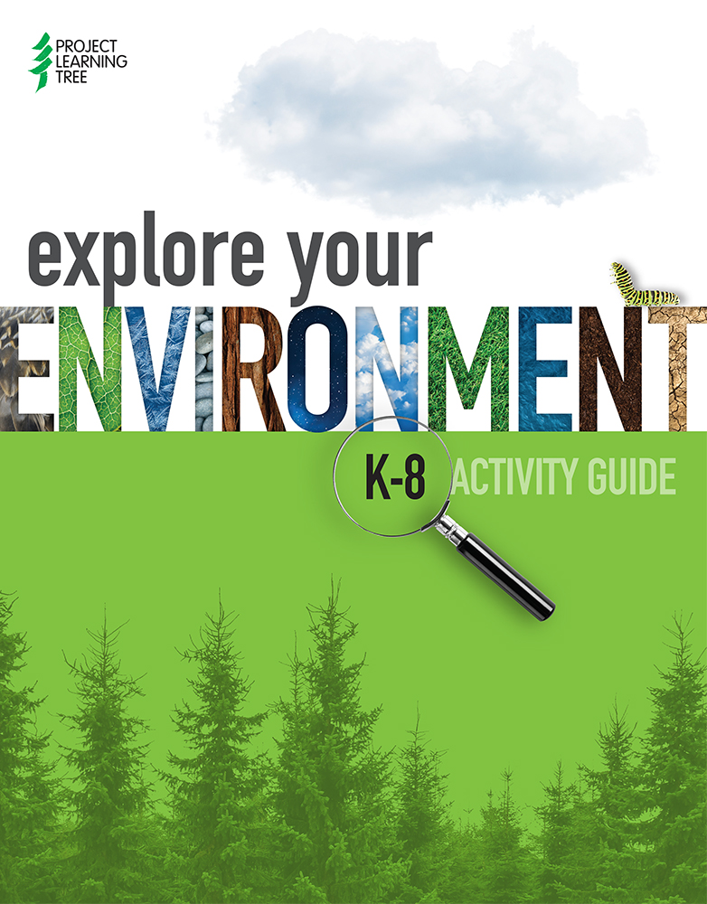

EDUCATOR PD EVENT AGENDA

INTRODUCTION
This document includes a sample detailed Facilitator Agenda for a 6-hour Educators’ PD event about the PLT Explore Your Environment: K-8 Activity Guide. The sample agenda offers suggestions, guidance and key talking points. It is not intended to be prescriptive or limit the content of the training. The agenda and handouts should be modified as needed to meet the needs and characteristics of your intended audience and your event outcomes.
Handouts, including the 2-page participant agenda, are included at the end of this document in the order in which they are used in the PD.
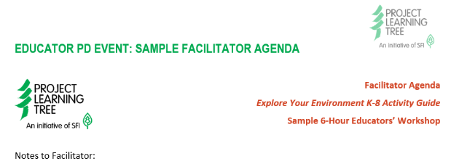
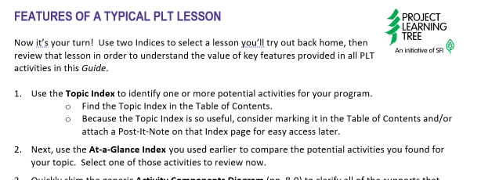
Please note: Resources designed for facilitators have the PLT logo on the left and the heading in orange. Resources designed for the PD participants have the PLT logo on the right and the heading in purple.
Figure 1. Sample heading of a resource for Facilitators Figure 2. Sample heading of a resource for PD participants.

Additional guidance on creating/adapting a PLT PD event agenda can be found on the PLT Next Generation Facilitator Handbook - Chapter V. Developing Your PD Event: Design and Develop.

EDUCATOR PD EVENT: SAMPLE FACILITATOR AGENDA
Facilitator Agenda

Explore Your Environment K-8 Activity Guide
Sample 6-Hour Educators’ Workshop

Notes to Facilitator:
- This agenda should be modified as needed to meet the needs and characteristics of your audience and desired outcomes.
- Share suggestions for improvements to this agenda by e-mailing ana.leirner@forests.org.
Desired Outcome:
- Within three months, participants will engage youth in indoor and outdoor lessons using at least two PLT activities from the Explore Your Environment: K-8 Activity Guide.

Check-List of Important Facilitator’s Items
- Charged cell phone and other devices
- Boots and other clothing for outdoor activities
- Useful cell phone numbers (in case of emergency on day of event):
  - Co-facilitators including community resources
  - Host contact (ex: school principal)
  - Building manager (in case locked out)
- Personal water bottle, coffee, snacks, lunch, etc.
Room Set-Up
Who:  Materials:  - Projector  - Computer  - Internet  - Posters and Tape  - Post-it notes and other supplies for each table  - Presenters’ materials  - Display table materials | For example:  - Set up sign-in table (see Registration Table below).  - Set up projector and computer with internet connection and check to see that everything is working.  - Set up presenters’ table and display tables.  - Set up tables and chairs to facilitate both whole group and small group work. There should be plenty of space to get up and move.  - Check the outdoor spaces for outdoor activities.  - Check the indoor spaces in case of inclement weather.  - Group workshop materials in an organized way.  - Place supplies on each table.  - Post Goals, Outcomes, and Objectives and Agenda.
Registration Table
Who:  Materials needed:  - Registration list  - Nametags and Markers  - Welcome slide or Poster with instructions  - Pens, Highlighters  - Copies of the “Agenda” and the “Finding and Selecting Activities” handout with the name of the first workshop activity listed at the top  - Explore Your Environment: K-8 Activity Guide  - Registration forms (if using) | Set up the registration table in a place that can greet and provide direction to participants as they enter the workshop space.  - Check people in  - Provide Name tags, Agendas, K-8 Guides, and the in-the-door activity handout (“Finding and Selecting Activities”).  - Point out the Welcome Slide or Poster with instructions about the activity and how to register on the PLT website.
Time: As available during registration, to be discussed and finalized during Activity 1. | In-the-Door Activity
Who:  Objectives: Participants can use the Table of Contents and At-a-Glance Index to describe the layout and to find activities in the K-8 Guide.  Materials needed:  - Welcome Slide or Poster with instructions  - Explore Your Environment: K-8 Activity Guide  - Copies of the “Finding and Selecting Activities” handout with the name of Activity 1 listed at the top  - Post-It Notes | Strategy: Using a worksheet to become quickly familiar with and to develop early fluency using the K-8 Guide  Preparing for the Activity:  - Write the name of the first PLT activity to be modeled in the PD event at the top of the “Finding and Selecting Activities” handout  - Copy the “Finding and Selecting Activities” handout (one per participant)  Key Talking Points: (as participants arrive at registration table)  - This handout will help you to dive right in while we’re waiting for others to arrive. You’ll see the Guide layout and use two important, helpful tools.  - The welcome slide / poster has directions for doing this activity and for filling out your registration form.  - Please complete as much as you can now. We’ll be reviewing the handout in a bit, during our first PLT activity.
Time: 10 - 15 minutes | Welcome and Introductions
Who:  Objective: Participants will have an overall picture of what they will gain through the session.  Materials needed:  - Copies of the “Participant Agenda” handout | Setting the stage  - Welcome participants and briefly introduce presenters.  - Walk through the day’s agenda.  - Discuss logistical details.  - Rest rooms, Exits, Breaks, Food and Water, etc.
Time: 20-30 minutes | PLT Overview and Introduction to the Guide
Who:  Objective: Participants will discover what makes PLT a valuable resource for their classroom and for their own growth as educators.  Materials needed:  - Slide presentation  - A/V equipment  - Internet access | Strategy: Presenting an overview of the PLT program and background about the new Guide.  Preparing for the Activity:  - Use your own state’s materials to introduce the PLT program or incorporate ideas from this PowerPoint presentation.  - Set up the A/V equipment for the slide presentation  Doing the Activity:  1. Introduce PLT. Key talking points about PLT include:  - Overview of the PLT program  - Acknowledgment of it as an initiative of SFI  - Explanation of how participants benefit by participating in the PLT network.  2. Briefly introduce the Explore Your Environment K-8 Activity Guide. Key talking points include:  - Why this exciting product was developed to serve as PLT’s flagship EE guide.  - PLT’s rigorous process to ensure the high quality of its instructional materials, including development by expert design teams and pilot testing by educators in the field.  - The website accompanying the new Guide plt.org/myk8guide provides a wealth of supplemental resources.  6. Transition to the next activity. Review the agenda and mention:  To prepare for our first PLT activity, please take out your in-the-door handout, “Finding and Selecting Activities”.
Time: 45 minutes | PLT Activity 1: ____________________________________
Who:  Objectives:  Participants will describe how they can use two features in the Guide to select activities and they will experience key elements of a PLT activity and identify ways they can use or adapt the strategies in their own setting.  Materials needed:  - Facilitator’s answer sheet for the “Finding and Selecting Activities” (Note: Create this based on the activity you choose for Activity 1)  - Copies of “Student Pages” for the Activity  - Post-It Notes  - Materials needed to do the activity | Strategy: Discussing Guide tools, then modeling and debriefing an activity  Preparing for the Activity:  - Select an activity to model from the Guide. The At-a-Glance Index (“Icons” and “Subject”sections) are helpful tools for selecting a PLT activity that matches your audience’s setting and needs.  - Review the activity in the Guide for activity preparation needs (“Materials” and “Getting Ready” sections).  - Photocopy or provide a link to the “Student Page” (plt.org/myk8guide)  - Set up activity materials for easy distribution to each group  - Use a Post-It Note to flag the Table of Contents and At-a-Glance Index in your own Guide  Doing the Activity:  1. Refer to the “Finding and Selecting Activities” handout that participants completed earlier. Mention: this handout gives you a quick snapshot of how the PLT Guide is organized and supports using the Table of Contents and At-a-Glance Index for quickly finding and reviewing activities. As we review, consider filling in any pieces you were unable to complete so you’ll have that information for later use.  2. Ask participants: In what ways did these tools give you a quick snapshot of the activities offered by PLT?  - Table of Contents shows the arrangement of the activities in the Guide, it gives us a sense of the topics that PLT addresses, and it’s a quick way of finding specific Indices in the back of the book.  - At-a-Glance Index is invaluable for selecting PLT activities to fit our educational needs. (We’ll use another helpful Index later in this workshop.)  - Color Coding carries throughout the Guide, including in the Table of Contents, in the coloring of activity pages within each Grade Band, and in the Indices at the back.  6. Transition to the first activity. Mention: You’ll experience our first Activity as a learner, but we encourage you also to observe with the lens of an educator who might use some of the teaching strategies in your own practice.  7. Model the Activity. Facilitate a shortened version of the activity as you would teach it with students. Mention along the way any variations for another Grade Band (see “Doing the Activity” in the Guide).  8. When handing out the Student Page(s), mention:  - Most activities have “Student Pages”.  - You can download printable Student Pages and other activity-specific resources from the Guide’s website plt.org/myk8guide  - All Student Pages are copyright free (although the activity itself and other pieces of the Guide requires permission to copy).  9. Debrief the activity. Discuss how participants would use or adapt this activity with their own learners.  10. Review the next two items on the agenda handout and transition to the break. Ask participants to have their Guide ready and also please prepare what they need for going outside.
Time: 15 minutes | Break
Time: 75 minutes | Activity 2: ____________________________________
Who:  Objectives: Participants will use the Guide for background research about teaching outdoors and in other special contexts, describe instructional strategies and safety procedures for managing and teaching a group outdoors, and experience key elements of a PLT activity in an outdoor setting and identify ways they could use or adapt the strategies in their own practice.  Materials needed:  - Copies of the “Using PLT in Specific Contexts” handout.  - Materials for the demonstration about teaching outdoors, including a backpack or bag and the usual items you carry while teaching outdoors (see Preparing for this Activity in this Facilitators’ agenda).  - Copies of “Student Pages” for the selected Activity. | Strategy: Discussing Guide tools, then modeling and debriefing a streamlined version of an outdoor activity.  Preparing for the Activity:  - Select an activity to model from the Guide. You may use the At-a-Glance Index (“Icons section: Outdoors”) to select a PLT activity for your audience.  - Copy the “Using PLT in Specific Contexts” handout  - Review your chosen activity in the Guide for preparation needs (including “Materials” and “Getting Ready”)  - Photocopy or provide a link to the activity’s “Student Page” (plt.org/myk8guide)  - Set up activity materials for easy distribution to each group  - Set up materials for the demonstration about leading a group outdoors.  Include an empty backpack or bag plus all of the items you would carry such as first aid kit, safety items, tree and other ID books, tick removal tool, clipboards or homemade clipboards (cardboard with binder clip), etc.  - Use a Post-It Note to flag Appendix B (p. 396) in your Guide  Doing the Activity:  1. Start by setting the stage.  - Before doing our next activity, let’s check out the resources in our Guide about teaching in special contexts, including outdoors as well as in urban and nonformal settings.  2. Distribute and walk through the “Using PLT in Special Contexts” handout as follows, with a prompt at the end to find features:  - At-a-Glance Index: Find the second segment of your At-a-Glance Index, the one called “Icons”, and notice that the third row shows “Outdoors” learning activities.  - Ask participants: for your Grade Band, how many Outdoor activities are there? (Did you include any “Grade Level Variations” from the adjacent Grade Band, listed at the top of the Index?)  - Ask participanta to choose one outdoor activity in the Index that interests them and jot down the name and page number so they can check out a couple features in a moment.  - Icon Images: Please skim through all the icon descriptors on your handout and pay particular attention to what the image for “Outdoors” activities looks like. Helpful Hint: Consider flagging p.7 in your Guide to have this list as a reference since the icon listing within each activity shows only the image, not the name of the setting.  - Activity Insert: Notice further down your handout the image called “Take It Outside!”. This special insert is found in any activities that are identified as working well outdoors.  3. Ask participants to turn to the activity they selected and find these features the Outdoors icon (right under the title) and the “Take it Outside!” insert in their activity. These will be helpful tools to recognize and use while planning.  4. Ask participants to skim the TEACHING OUTDOORS: Appendix B and think about strategies they use when leading a group outdoors. Inform that they will share those in a moment.  5. Lead a discussion in which participants share tips and strategies that they found helpful in the Appendix plus any strategies they already use. As they share their hints, hold up any items that are mentioned and pack them into your bag. Then explain any of your own additional strategies plus hold up and explain how you use each of the remaining “teaching outdoors” items, packing each one into the bag as you explain it.  6.Facilitate a shortened version of the Activity as you would teach it with students. Model special strategies for teaching outdoors including keeping groups together or calling them in, pointing out boundaries, safety considerations, etc.  7. Debrief the activity. Discuss how participants would use or adapt this activity with their own learners.  8. Transition to the next activity.  - Before breaking for lunch, let’s take a quick look at PLT’s special resources about Academic Standards. You may want to use these during planning time this afternoon.
Time: 15 minutes | What about Standards?
Who:  Objectives:  Participants find Academic Standards resources in the Guide and on the website.  Materials needed:  - A/V equipment with internet connection  - Guide  - Website | Strategy: Presenting Guide and website resources  Preparing for the Activity:  - Use Post-It Notes to flag in your Guide Appendix A (p. 394) as well as the page in the activity you just did that has the “Academic Standards” inset box.  - Find and prepare to project the NGSS activity listing on the website for the activity you just did.  Doing the Activity:  1. Walk through and point general and specific resources about academic standards in the Guide as appropriate for your audience.  - Here are some general and specific resources about academic standards in the Guide. You’ll have time and support during the Planning Session this afternoon to dig into them. They’ll all be listed on your planning handout.  General Overview about Standards: Appendix A: Teaching to Standards (p. 394)  Specific Standards for Each Activity: At-a-Glance Index: It’s helpful to start with the first segment in the “At-A-Glance Index” to find an activity by Subject - ELA, math, social studies, science.  Activity Inset Box: Within every activity, you’ll find an “Academic Standards” Inset Box that lists standards for each subject.  2. Point out the Inset Box for the activity you just did.  3. Show the Website: Specific codes for NGSS (Next Generation Science Standards) in each activity are listed on this table.  4. Show the NGSS listings for the activity you just did.  5. Transition to the break.  Explain plans for lunch and describe how participants should prepare for the next activity about local community resource(s).
Time: 45 minutes | Lunch
Time: 60 minutes | Community Resource Activity
Who:  Objectives: Participants will use local resources to support teaching PLT in their instructional program.  Materials needed: | Strategy: Experiencing an activity with natural resource professionals or other local resources.  Special Note to Facilitators: This block is set aside for activities or presentations that highlight state and local resource volunteers and professionals.  Transition to the break. Review the agenda and mention:  - Let’s take a break, then please be ready to see more resources and dive in and plan how you’ll use PLT in your own program.
Time: 15 minutes | Break
Time: 60 minutes | Planning Session
Who:  Objectives: Participants will plan to implement PLT by using Guide and website tools to select and review in detail one activity for their setting then consider PLT resources they can use to design a unit.  Materials needed:  - Copies of “Features of a Typical PLT Lesson” handout  - Copies of “Using PLT to Design Units or Activity Sequences” handouts | Strategy: Reviewing Guide features and providing time and support to plan how participants will use PLT in their own instructional setting.  Preparing for the Activity:  - Copy the handouts “Features of a Typical Lesson” and “Using PLT to Design Units or Activity Sequences”  - Use Post-It Notes to flag in your Guide the Topic Index (p.422) , Activity Components Diagram (p.8), and Appendices H (p.406) and G (p.403)  Doing the Activity:  1. Introduce the activity.  - During this hour, you’ll have time to dive into the Guide on your own and plan how you can use PLT in your own setting.  - You’ll begin by selecting your own activity and using a worksheet to review that activity and become familiar with the structures of all Guide activities. Then, you’ll see resources for developing curriculum units (for a classroom) or activity sequences (for nonformal settings).  2. Provide and walk through the “Features of a Typical Lesson” handout.  - This handout adds one more tool for selecting PLT activities, the Topic Index. You’ll use this Index to identify several potential activity options, then use the At-a-Glance Index in a new way, to compare options and choose one activity to review in depth that seems like the best fit.  3. Ask participants to turn to the Topic Index (p. 422). Here are a few points to notice:  - This Index is organized in over 100 Topics.  - Each Grade Band lists activities for each topic.  - The types of Topics include  - Conceptual / scientific ideas (ex: Habitats, Decomposition, Food chains)  - Human connections with the forest (ex: Native cultures, Sense of place, Government)  - Uses of the forest (ex: Forest products, Recreation, Careers)  - Instructional practices (ex: Service learning, Investigations, Community science)  4. Prompt participants to continue working through the “Typical Lesson” handout:  - You’ve already used the “At-a-Glance Index” earlier today, but now you’ll be using it in a new way, the way you’re most likely to use it at home: to compare several different potential activities in order to choose one activity for further review.  5. Prompt participants to turn to the “Activity Components Diagram” in their Guide (p. 8).  - This helpful resource is a quick orientation to the features in every PLT activity, so you can see the value of each one.  6. Provide the “Using PLT to Design Units or Activity Sequences” handout.  - This is a great reference with many more Guide resources for implementing PLT in your program. Explore this on your own after you complete the “Typical Lesson” activity review. Before diving in, let’s take a quick look at one of these features:  7. Ask participants to turn to Appendix H. on p. 406. Point out the handout descriptions of Appendix H features so that participants are familiar and likely to use them.  8. Ask participants to work through the two handouts to study the Guide and plan how they can use PLT in their own setting. If you notice that the participants have lower energy, pair them up and ask them to create a plan for their pair.  Special Note to Facilitators: Participants will be debriefing (discussing their questions and plans) during the PD Event Closure below.
Time: 30 minutes | PD Event Closure
Who:  Objectives: Participants will identify ways they can incorporate PLT into their work and continue to be involved with the PLT program.  Materials needed:  - Slide and/or handout with reflection prompts  - Slide and/or handout describing opportunities for continued PLT involvement. | Strategy: Allowing time for participants to reflect and share  1. Point out the agenda.  - This last half hour will be an opportunity to share and discuss your ideas and questions and then hear about how you can stay connected to PLT.  2. Debrief participants’ planning and discuss their PLT next steps. Consider incorporating questions like these into a one-page reflection form so the debrief will be more considered.  - The Guide Features that I found most helpful are…because…  - My next steps for using PLT include…  - Things that I wonder or have questions about are…  - I’m excited about…  3. Share how educators can continue to use and be involved with PLT:  - Explain the PLT state program, other PLT materials and PD, state-specific resources and on-going support coordinators can provide.  - Provide information about how educators can purchase online PLT materials (including e-units) and how they can participate in online PD.
Time: 5 minutes | Event Wrap-up
Who:  Objectives: Participants evaluate the workshop.  Materials needed:  - Copies of the Professional Development Evaluation Form  - Copies of the Workshop Certificate of Completion | 1. Ask participants to complete a Professional Development Evaluation Form and welcome their feedback.  2. Once they complete the evaluation form, you can provide the Certificate of Completion.

PARTICIPANT HANDOUTS

PARTICIPANT AGENDA
Explore Your Environment: K-8 Activity Guide Educator PD
8:30 am to 3:15 pm
PD Event Outcome: Within three months, participants engage their learners in indoor and outdoor lessons using at least two PLT activities from the Explore Your Environment K-8 Activity Guide.
PD Event Objectives: Participants will:
- Investigate the value of PLT for their instructional program and for their own personal growth within the PLT network.
- Describe activity instructional strategies that they can implement in their own setting, including strategies and safety procedures for managing and teaching a group outdoors.
- Use the Guide and accompanying website for background research and to select and teach activities in their educational setting.
- Plan for implementing PLT activities within the next three months.

Time | Activity | Participant Notes
8:00 – 8:30 | Registration and In-the-Door Activity  Please allow time to register and check out your Guide before the start of the workshop.  We will begin promptly at 8:30.
8:30 – 8:45 | Welcome and Introductions  Introductions  Agenda Overview  Administrivia
8:45 – 9:15 | PLT Overview and Introduction to the Guide  Discover what makes PLT a valuable resource for your classroom and for your own growth as an educator.
9:15 – 10:00 | Activity 1: _________________  Experience this indoor activity as a learner.  Observe with the lens of an educator.  Debrief the book features reviewed earlier.
10:00 – 10:15 | Break Prepare to head outdoors.
10:15 – 11:30 | Activity 2: _______________  Review Guide features about teaching outdoors and in other special contexts.  Discuss outdoor management strategies.  Experience a PLT activity outdoors.
11:30 – 11:45 | What about Standards?  Examine tools within the Guide and on the website (plt.org/myk8guide)
11:45 - 12:30 | Lunch Prepare to head outdoors.
12:30- 1:30 | Community and State Resources  Activity or presentation by natural resource professionals or other local resources.
1:30 - 1:45 | Break
1:45 – 2:45 | Planning Session  Select and review in detail one activity for your instructional practice.  Consider how you might use additional Guide features for designing a unit or activity sequence
2:45 – 3:15 | PD Event Closure  Debrief your planning and discuss PLT next steps  Complete the end-of-day evaluation  Receive a certificate

FINDING AND SELECTING ACTIVITIES

DIRECTIONS:
Whether seeking new activities to fit a need in your program or just looking for the page number of an old favorite, you’ll find the Table of Contents and At-a-Glance Index invaluable time and time again. Dive in and use them now to see how much you can quickly learn about any PLT activity!

Our first PLT activity today will be ____________________.

Find this activity’s listing in each of these two Guide sections and answer the questions below.

1. Table of Contents
Question: What two things do you know about our activity by reading its listing in the Contents?

2. At-a-Glance Index
To find this Index, see Table of Contents, list of Indices at the bottom. Helpful Hint: Because the At-A-Glance Index is so useful, consider highlighting it in the Table of Contents and/or attaching a Post-It-Note on the Index page for easy access later.

Reading our activity’s listing in the At-a-Glance Index, what can you say about its…

Grade Span?
Grade Level Variation (if any)?
Subjects?
Icons (Special Contexts)?
STEM Skills?
Differentiated Instruction Techniques?

What does the color coding used throughout this PLT Guide tell us?

Red =
Green =
Blue =

USING PLT IN SPECIFIC CONTEXTS

AT-A-GLANCE INDEX (P. 420)
The second segment of this index has separate rows indicating activities for: Long-Term; Nonformal; Outdoors; STEM; and Urban settings.

ICONS WITHIN EVERY PLT ACTIVITY:
Just below the title of every activity are icons signifying one or more specific contexts for which the activity would be well-suited. This icon “Legend” is on p. 7 in the Guide.
Outdoors - Indicates that the activity requires an outdoor setting to meet learning outcomes. For more information about outdoor learning, see Appendix B.
Urban - Indicates that the activity is an excellent way to explore urban environments. For more information about using PLT in urban settings, see Appendix C.
Nonformal - Indicates that the activity works well in nonformal education settings, such as in nature centers or with afterschool groups, although these activities are also suitable for formal classroom settings. For more information about using PLT in nonformal education, see Appendix D.
STEM - Indicates that the activity is a STEM exemplar, combining the four elements of STEM—Science, Technology, Engineering, and Math—while engaging students in problem-solving. Note that every activity in this guide incorporates at least some elements of STEM and lists relevant STEM skills. For more information about PLT and STEM, see Appendix E.
Long-term - Indicates that the activity requires more than two 50-minute periods of instruction.

Teaching OUTDOORS
General Tips: Appendix B. Tips for Teaching Outdoors (p. 395), includes answers to: Why Teach Outdoors? What to Teach Outdoors? How to Begin? What is Outdoor Learning? Planning for Longer Excursions; About Collecting

Specific Activity Tips: Take it Outside section in every activity of the guide describes how to extend student learning into the outdoors.

PLT in an URBAN Setting
Appendix C. Urban Outlook (p. 395), described the Urban setting and how PLT can help (list of Guide features and tips)

PLT in a NON-FORMAL Setting
Appendix D. Nonformal is Essential (p. 399), offers a description of Nonformal, how PLT can help (list of Guide features) and correlations to non-formal benchmarks (4-H, Boy Scouts, Girl Scouts and more).

FEATURES OF A TYPICAL PLT LESSON

directions
Use two Topic Index and At-a-Glance Index to select a lesson you’ll try out back home, then review that lesson in order to understand the value of key features provided in all PLT activities in this Guide.

- Use the Topic Index to identify one or more potential activities for your program.
- Find the Topic Index in the Table of Contents.
- Because the Topic Index is so useful, consider marking it in the Table of Contents and/or attach a Post-It-Note on that Index page for easy access later.

- Next, use the At-a-Glance Index you used earlier to compare the potential activities you found for your topic. Select one of those activities to review now.

- Quickly skim the generic Activity Components Diagram (pp. 8-9) to clarify all of the supports that are included in every PLT activity.

- Use the review form below to record information in activity features that will be useful to you.

Activity title and page:

General Description (Summarize briefly what students will do- see the paragraph above the title):

Icons: (List any special instructional contexts indicated by the icons (see p. 7 for Icon Legend))

Academic Standards:

Objectives:

Time Considerations: Preparation ____________ Activity _______________

Materials (List a couple here):

Getting Ready (List a few steps here including at least one “Safety!” item):

Student Pages
(Describe here briefly what students will do and list the related “Career”):

Assessment (List one Assessment you might use):

Enrichment (List one Enrichment you might find helpful):

Other Features (List any Grade Variations, Take It Outside, or other features you might use):

Online (Find your activity at plt.org/myk8guide and review the Glossary, Reading Connections, Resources, Standards Alignment, and downloadable Student Pages, noting any you might use):

USING PLT TO DESIGN UNITS OR ACTIVITY SEQUENCES

Academic Standards
General Overview: Appendix A: Teaching to Standards (p. 394)
Specific Standards: For Each PLT Activity
- See the “At-A-Glance” Index to choose activities by Subject (p. 420)
- See the “Academic Standards” Inset Box within the individual activity
Standards for Subjects including Science, ELA, Mathematics, Social Studies
- NGSS: See website for table of PLT activity titles with NGSS standards code listings

Topic Index (p. 422)
Over 100 Topics: For each Grade Band, a list of PLT activity titles for every Topic

Appendix H: Units of Instruction (p. 406)
- Organized by Grade Band: 5-10 sample unit outlines per grade band
- A “Storyline” for each unit links 3-8 PLT activities together.
- “Forest Literacy Framework” connections for some units are online at plt.org/forestliteracy
- A sample unit in detail: Cycles of Matter and Energy (p. 407)
- Detailed descriptions of every Storyline unit are on the webpage plt.org/myk8guide

Appendix G: Conceptual Framework (p. 403)
- List of “Themes” that underlie all PLT activities
- Note: The themes are very similar to NGSS “Cross-Cutting Concepts” and this Appendix could be a great tool for designing an NGSS-based unit.

Instructional Practices:

- Vocabulary Instruction: Appendix I: Using the Glossary (p. 411)
- Claims/Evidence/Reasoning: Appendix K: Making a Scientific Argument (p. 413)
- Planning an Investigation: Appendix L (p. 414) Student Graphic Organizer
- Assessment Rubric: Appendix M (p. 417), includes 4-point generic descriptors for: Work Product; Content; Collaboration; Presentation; Critical Thinking. Editable version downloadable from the website.

