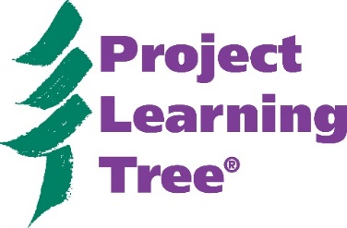
E- Unit Study Guide
Grades K-2: Treemendous Science!

Use this study guide to help introduce and orient you to PLT’s e-unit for Grades K-2, titled Treemendous Science! This PLT e-unit is accessible via http://shop.plt.org/. Please note the purple “log in” button located in the upper right hand corner of the page and enter your credentials (provided separately). The best results will be achieved when viewing the e-unit on a computer screen (opposed to a smart phone or notebook).

- The Treemendous Science! Introduction has eight component parts (Unit Approach; Academic Rigor; Flexible Teaching Levels; Instructional Models; Learning Progressions; Lesson Planning Timeline and Tips; Organization and Navigation; Collaborative Discussion Strategies). Locate and review these sections. Which one was most beneficial to you and why?

- Which five Next Generation Science Standards (NGSS) performance expectations were used to build this instructional unit?

- List the 5 parts of the instructional model applied to this unit, and briefly describe its approach.

- Review the “Team Teaching Progressions” section (the third item under the Treemendous Science! header in left-hand sidebar), then respond: a) What is the purpose of this section?, b) Do you think this would be a useful information for K-2 teachers?, c) Why/ Why not?

- Click on any one of the three levels from the left hand sidebar, under Teaching Levels (Level A – Kindergarten, Level B – Grade 1, or Level C – Grade 2). What new menu appears and why is it useful?

- Click on the “Engage” gray tab for your selected teaching Level, and read through the information provided on this page. In what ways does this activity a) engage the student learner and b) serve as an informal pre-assessment opportunity for the teacher?

- Click on the “Explore, Explain, Elaborate” gray tab for your selected Teaching Level, then respond: a) In addition to the framing Essential Questions found on this page, where else might you look for your Level’s overarching learner outcomes and crosscutting concepts? and b) How many individual lessons comprise your teaching Level?

- Select and click on one of the individual lessons that comprise your teaching Level, and respond: a) what is useful about the way in which this information is organized?, and b) How will you navigate among and between your Level’s individual lessons in the future?

- Click on the “Evaluate” gray tab for your selected activity, and review the content. Why are there three different types of evaluation offered?

- Take a few moments to explore either the Learning Centers OR GreenSchools Appendix. How might you envision teachers using this information to support the selected Teaching Level?

Bonus: Note the small “Toggle Highlight Colors” toolbar, located near the top right corner of your screen. What does clicking the options presented here do? How might this be useful in planning classroom instruction? Can you discern what the different colors signify?
Revised by J. Stallard, Nov 2017

