Family Entry
Important Reminders
- Your fair probably has dates when entry is accepted into the fair. Be sure to complete your entry (including the final “Submit” step) prior to the cut-off date.
- Recommended browsers: Google Chrome or Mozilla Firefox. Older versions of Internet Explorer may cause unexpected results.
- Register all entries for each exhibitor in the family before proceeding to the Payment section.
- Be sure to click the “Submit” button when you have completed your entries. Entries are not final until they have been submitted.
- Check your email inbox for a confirmation email with a list of your entries and any related fees.
- You will receive a second email when your entries have been approved by your fair.

Steps  - Go to http://www.fairentry.com and click “Find Your Fair”. | 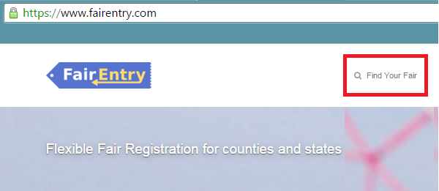
- Filter by your state, click Search, and then click on the correct fair.  Search by Keyword – Judith Basin | 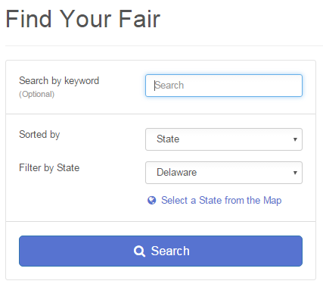
You do not have a 4HOnline account anymore and have not registered with FairEntry itself before. Select “Create a New Account”. Follow the instructions to create your account. | 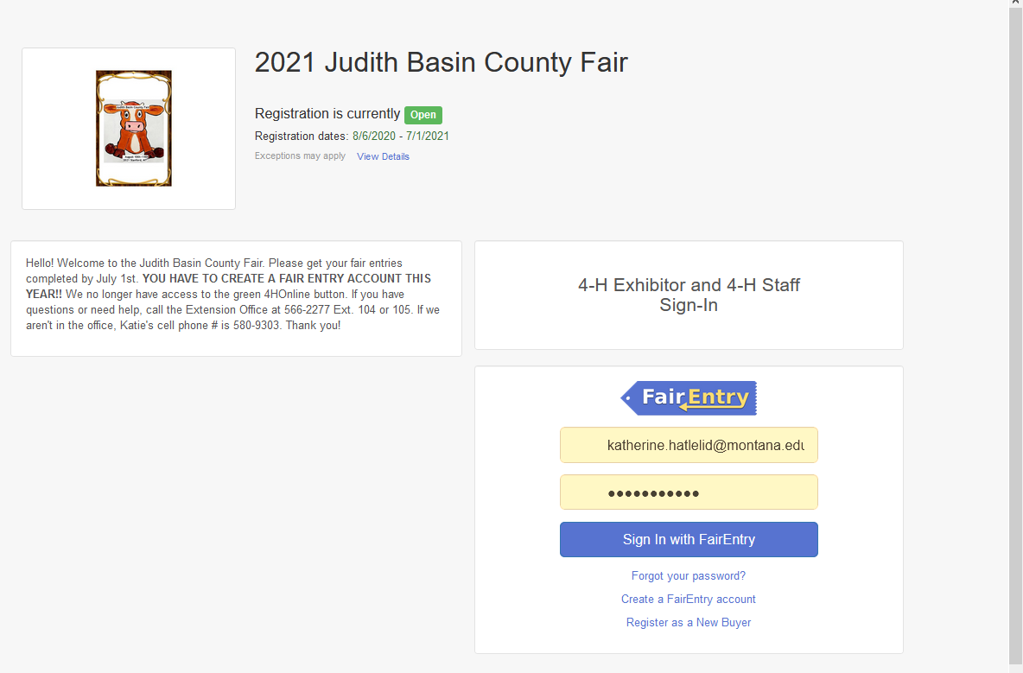
- Click “Register an Exhibitor”

Exhibitor Information  - Click on Individual | 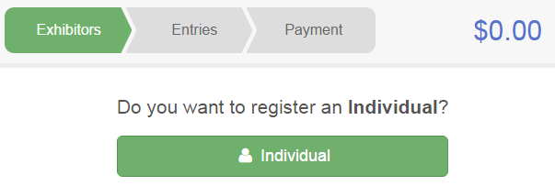
- Enter Your Exhibitor’s Information | 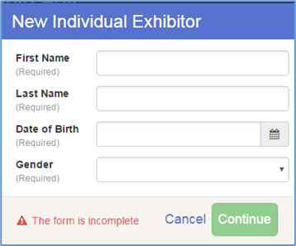
- Answer the Food Booth Schedule & Setup questions and continue | 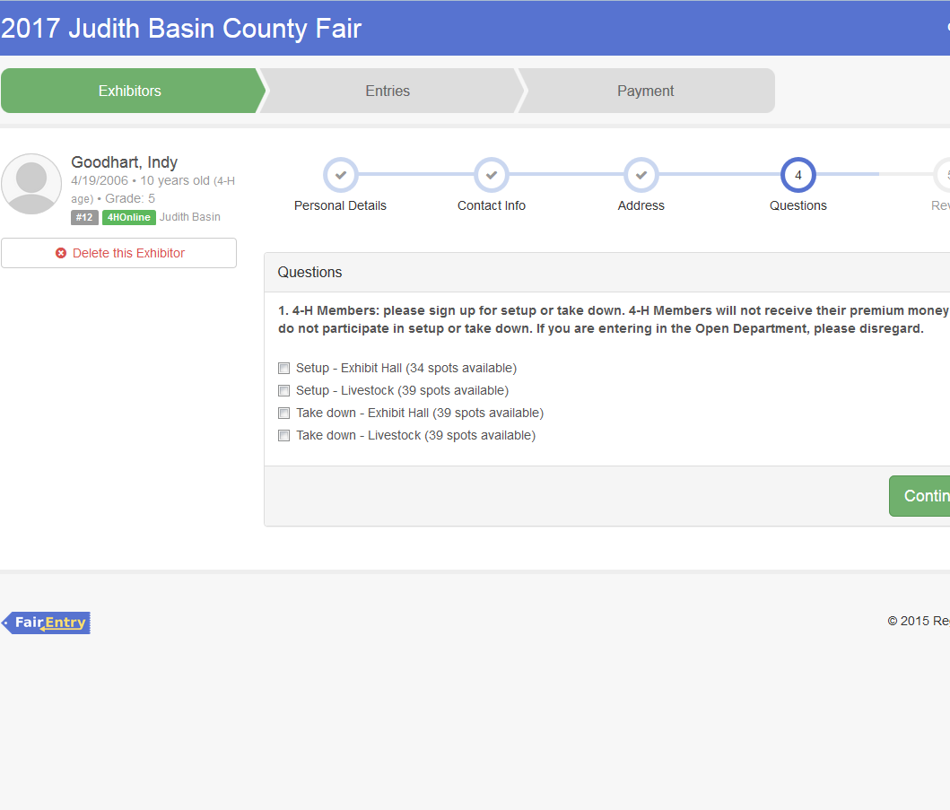  Johnny Doe
- Review your exhibitor information. If any information is incorrectly, click the green Edit button in the appropriate group to change it. When all information is correct, click Continue to Entries. | 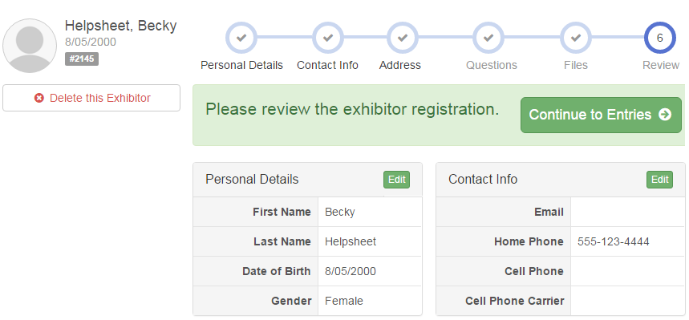

Creating Entries

Each exhibitor can have multiple entries. One entry must be made for each item, animal, class, etc. For example, if an exhibitor is bringing 2 photographs, two entries into the photography class must be created. If an exhibitor is showing one horse in 5 events, five class entries must be created. Once all entries have been created for the first exhibitor, you have the choice of creating another exhibitor in this family (and entries) or proceeding to check-out (submitting the entries, whether or not fees are charged).

- Click Add an Entry beside the correct exhibitor. | 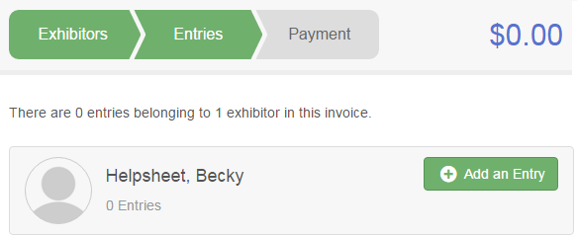
- Click Select beside the first department you wish to enter. Any departments that are not available for entry will be noted as “Not Available” with a short explanation.  - After you select a department, you will see a list of divisions to select from, and then a list of available classes. Also notice that there are blue “Change” links in case you mistakenly select an incorrect department, division, or class.  - You may check multiple classes in a Division at the same time! | 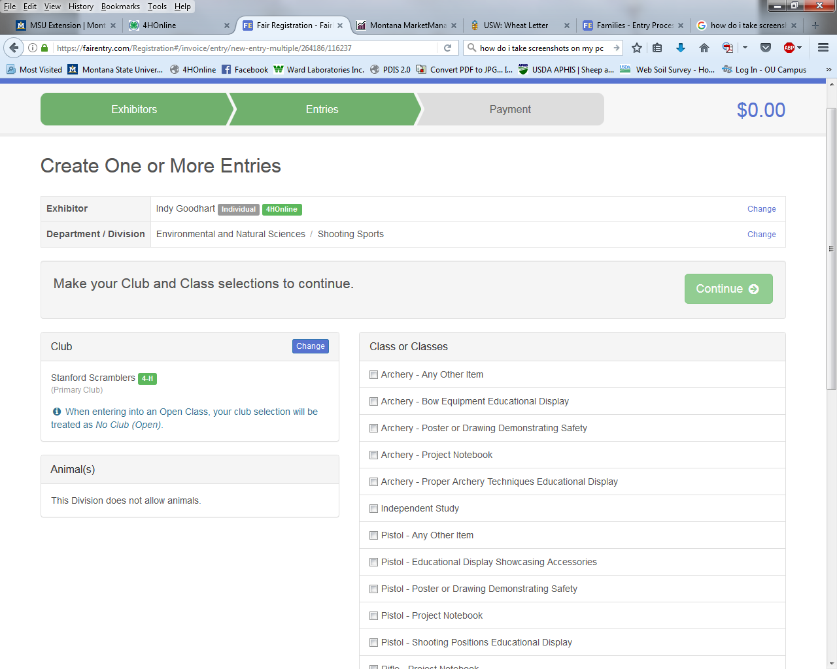
- If this is an animal class entry, you will be required to specify which animal will be exhibited in this class. You will see the option to “Add animal”.  - “Add animal from Scratch”. Fill in all of the fields with information about the animal you intend to exhibit. Click Create and Add Animal when finished.  - If the animal information was entered incorrectly, you have the option to either Remove From Entry (creating a new animal) or Edit Animal Details. When it’s correct, click Continue. | 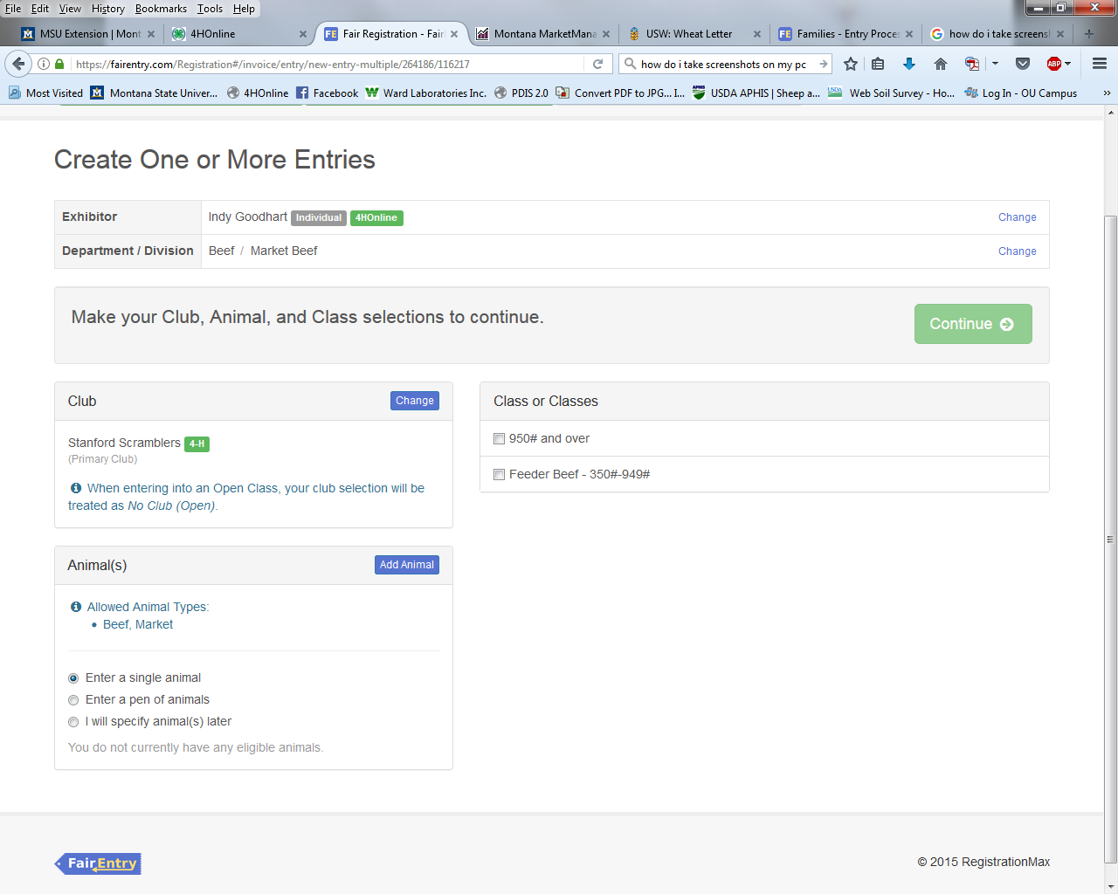

- The Review screen allows you to double check this entry for accuracy, and make any changes necessary. When the information is correct, click Continue and that class entry is complete.
- When each class entry is complete, you have 3 choices for what to do next:  - If all class entries have been completed for one exhibitor, you can Register another Exhibitor in this family.  - If this exhibitor has more class entries to make, you can Add another Entry for this Exhibitor.  - If all entries for all exhibitors in the family have been completed, Continue to Payment to finalize and submit your entries. | 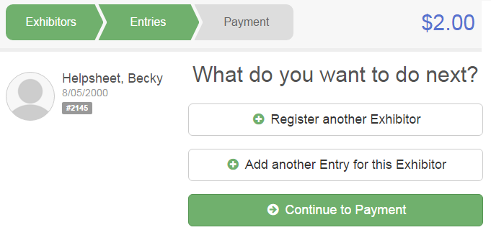
- Review your entries for completeness and accuracy. Notice the Summary and Detail buttons at the top of the list on the right. If there are errors, click on the green Entries section at the top of the page. Click Continue when all information is correct. | 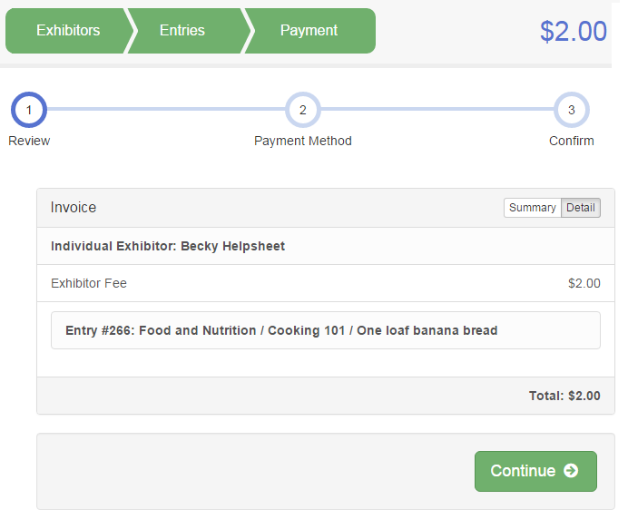

- There is no payment due, so click Continue

- Read the information in the “After you Submit” section. You may also have to check a box to “Agree to Terms”. Click Submit to finalize the entries for the exhibitors in this family.  - After you click Submit, no changes are possible to these entries.  - Enter all exhibitors before you click Submit. | 