Please return this form by January 1 of each year to your Region Director.
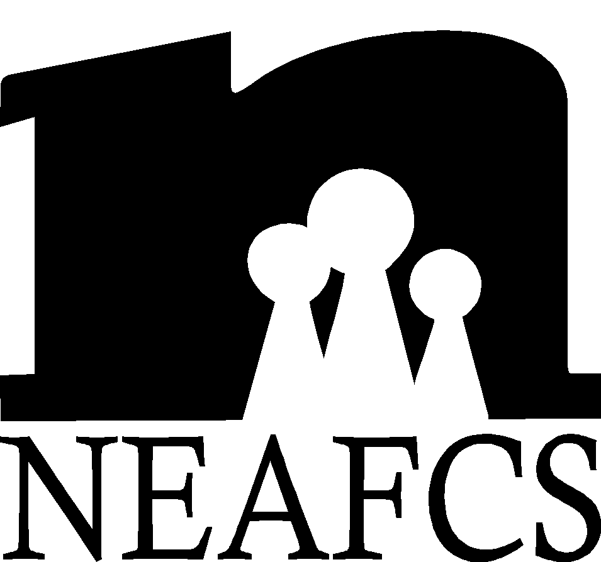 | Affiliate Annual Report Form

State/Territory: | Montana | Date:
Person Completing Form: | Katelyn Andersen | Phone: | 406-375-6611
Accomplishments: (Please list major accomplishments for the period of January 1-December 31)
- Please see awards and recognition
- MSU Extension has a new website for FCS: www.montanafamilies.info
Member Resources:
- Montana Affiliate has increased its membership this year to 28 members, up from 26. We have 4 life members.
- MEAFCS hosts a peer review presentation at our FCS update which serves as practice for applying to present or hold a poster session at a national conference. This allows an opportunity to receive a peer review for those who are on a promotion and tenure track.
Awards & Recognition:
      - Continued Excellence – Marsha Goetting, Ph.D., CFP®, CFCS
      - Distinguished Service – Jennifer Wells
      - Mary W. Wells Memorial Diversity – 1st Western Region – Marsha Goetting, Ph.D., CFP®, CFCS
      - Internet Education Technology – 1st Western Region – Marsha Goetting team
      - Radio – 2nd Western Region, 3rd National – Jane Wolery team
      - Written Press Release – 3rd Western Region – Jane Wolery

Public Affairs:
- MEAFCS continues to contribute money to the Montana Extension Day on the Hill where lunch is provided to state legislators and the public along with agent representation and displays.
- Extension FCS Program Leader, Dr.Michael Vogel continues to produce an FCS Extension Program Overview every other year to showcase accomplishments. Two Reports are now available and will be used to give to state legislatures, commissioners and constituents. These are available at: www.montanafamilies.info . Click on the “FCS Program Sampler” (12 page report) and on the “Native American Programs” (10 page report) to print copies.
- 20 radio public service announcements were created addressing issues related to housing, nutrition, economics and human development. These will be available at: www.montanafamilies.info in February.
- Three of our specialists are involved with eExtension communities of practice: Michael Vogel, Ed.D. as co-lead on home energy, Sandra Bailey, Ph.D., CFLE as content group leader for Raising Grandchildren under family care giving; Lynn Paul, Ed.D., R.D. as team leader for family food and fitness.

Other Special Projects: (Anything you would like to brag about):
- Montana Extension FCS continues to produce Alzheimer’s Caregiving at Home community toolkits that are distributed nation wide– this program won four national awards –contact Mike Vogel

Concerns from your State: (Concerns for the NEAFCS Board)
- MEAFCS continues to deal with financial concerns within our association
- Maintaining FCS FTE’s

The state of CES in your state:
- The funding for Montana State University Extension continues to be stable.
- Our state legislature meets every other year for four months and this is the 2009 legislative year. The state budget is a concern as is true of most of the nation.
- MSU continues to integrate its new logo and advertising campaign with Extension in order to unify and define the university’s image. Local county offices are creating marketing pieces in the form of an annual report to give to commissioners, legislators and constituents.

