Please return this form by January 1 of each year to your Region Director.
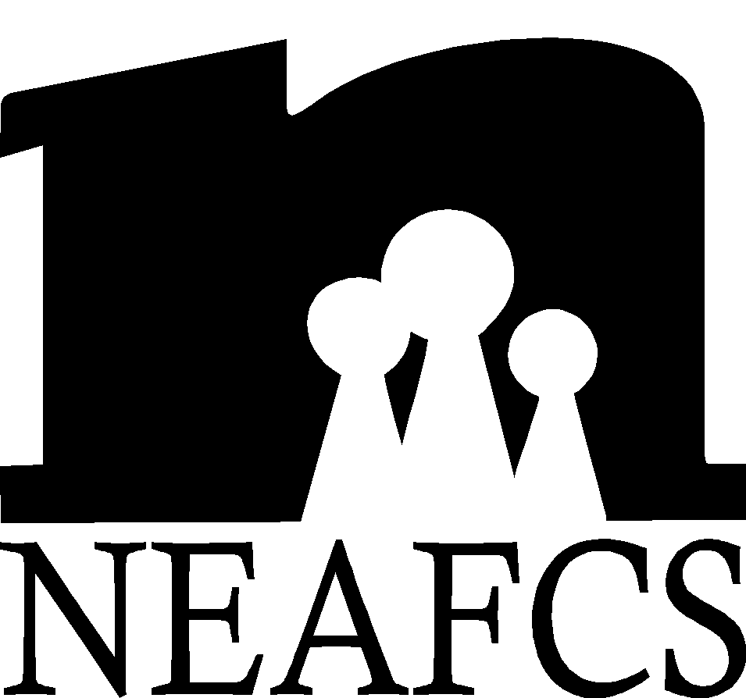 | Affiliate Annual Report Form

State/Territory: | Montana | Date: | 12/31/09
Person Completing Form: | Katelyn Andersen | Phone: | 406.375.6611

Accomplishments: (Please list major accomplishments for the period of January 1-December 31)
- Membership has continued to increase with MEAFCS! Extension Agents with FCS responsibilities saw positive benefits to becoming members of the organization. Some of these benefits included:
  - Participation in MEAFCS Peer Review Presentation
  - Eligible to submit curriculum to be peer reviewed and posted on MEAFCS website
  - Recognition for outstanding achievement through awards and recognition program
  - Financial support to obtain professional development

- MSU Extension has a new website for FCS: www.montanafamilies.info
Member Resources:
- Montana Affiliate has increased its membership for 2010 to one new member, 27 renewing members, and four life members.
- MEAFCS hosts a peer review presentation at our FCS update which serves as practice for applying to present or hold a poster session at a national conference. This allows an opportunity to receive a peer review for those who are on a promotion and tenure track.
Awards & Recognition:
- DSA – Denise Seilstad
Public Affairs:
- MEAFCS continues to contribute money to the Montana Extension Day on the Hill where lunch is provided to state legislators and the public along with agent representation and displays.
- Extension FCS Program Leader, Dr.Michael Vogel continues to produce an FCS Extension Program Overview every other year to showcase accomplishments. Two Reports are now available and will be used to give to state legislatures, commissioners and constituents. These are available at: www.montanafamilies.info . Click on the “FCS Program Sampler” (12 page report) and on the “Native American Programs” (10 page report) to print copies.
- 20 radio public service announcements were created addressing issues related to housing, nutrition, economics and human development. These will be available at: www.montanafamilies.info.
- All four FCS Extension Specialists are involved with eExtension communities of practice: Michael Vogel, Ed.D. as co-lead on home energy, Sandra Bailey, Ph.D., CFLE as content group leader for Raising Grandchildren under family care giving; Lynn Paul, Ed.D., R.D. as team leader for family food and fitness, and Marsha A. Goetting, Ph.D., CFP®, CFCS as a reviewer of material for Managing in Tough Times and Financial Security in Later Life.
Other Special Projects: (Anything you would like to brag about):
- Montana Weatherization Training Center – Recently opened a new training facility this past year
- What’s In the Can? A solid Waste Management Planning Kid for Montana Communities – A “How to Implement” Sold Waste Education Modules became available to communities in fall 2009.
Concerns from your State: (Concerns for the NEAFCS Board)
- MEAFCS continues to deal with financial concerns within our association
- Maintaining FCS FTE’s
The state of CES in your state:
- The funding for Montana State University Extension continues to be supported
- MSU continues to integrate its new logo and advertising campaign with Extension in order to unify and define the university’s image. Local county offices are creating marketing pieces in the form of an annual report to give to commissioners, legislators and constituents.

