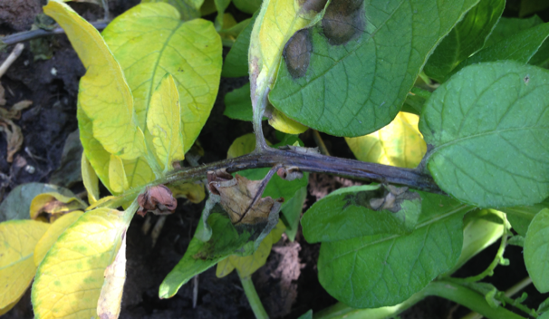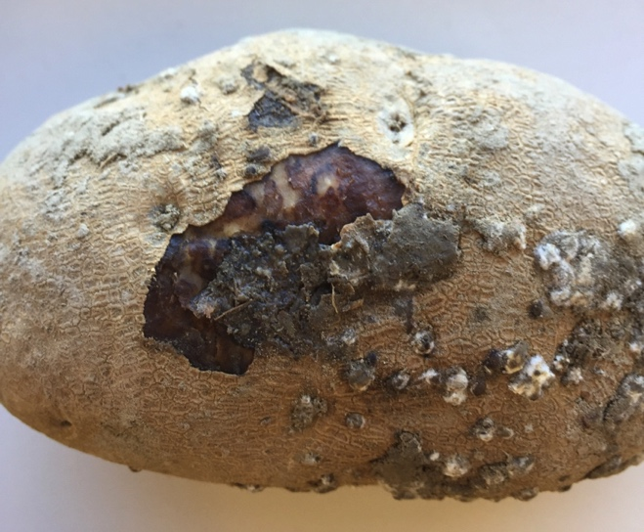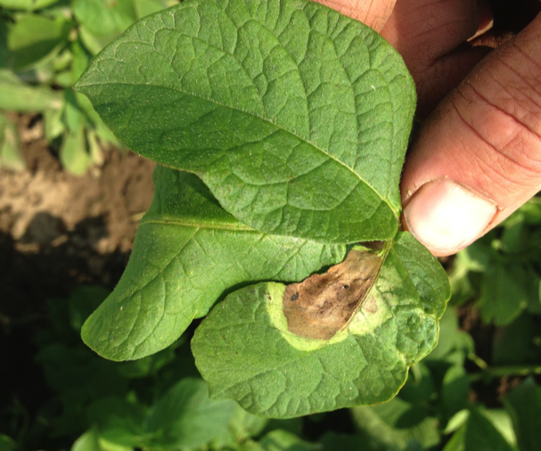

Early infection appears as a short pencil mark that rapidly expands into a grey-black lesion. During dry periods lesions can appear brown with yellow halos.

Potato tuber with late blight symptoms present.

Dark brown to black lesions on leaves stems.

*Disease Cycle:*

Asexual reproduction of the pathogen requires a living host. Without a sexual cycle, *P. infestans* is an obligate parasite. Therefore, survival between seasons is dependent on tubers. Spores are dispersed aerially from infected material present in storage, cull piles, and soil. Spores germinate within hours in the presence of free moisture. Lesions can result in secondary sporulation in as little as four days. The pathogen prefers moderate temperatures from 60-80 F with leaf wetness 10 hours a day. Tubers can become infected at any time from planting through harvest. Sporangia can be washed downward into the soil from the surface.

*Foliar Symptoms*:

On very young leaves, irregular, water-soaked lesions appear. Lesions are dark brown to black, and can appear small at first. A yellow halo often appears around the lesion. Left untreated, lesions enlarge into circular necrotic patches.

*Tuber symptoms*:

Tuber infection is characterized by brown, dry, and granular regions that begin superficially, but can then extend deeper into the tuber tissue. Upon peeling back tuber epidermis, reddish brown to dark brown, granular tissue is apparent. Infection often appears to be quite dry.

*General Information*:

Late blight is a disease of great concern. The organism responsible for late blight, *Phytopthora infestans*, is known as the “plant destroyer.” Late blight has the potential to be found anywhere potato is grown. All parts of the potato plant are susceptible to late blight. The disease often appears following periods of very wet weather.

**2016 Montana Seed Potato Late Blight Quick Reference Guide**

**Jessica Rupp and Nina Zidack**

*Management*:

Late blight is one of the most studied diseases of any crop, therefore intensive integrated management tactics exist. No varieties have resistance to all late blight strains, but some have resistance to individual strains. Good field drainage and proper plant spacing for optimal air movement are desirable. Proper sanitation is necessary: destroy cull piles, volunteers, and any infected material. Bury cull piles 2-3 feet deep at a minimum. Seed treatments containing mancozeb are effective at reducing late blight at emergence. The inclusion of a systemic is recommended if tuber infection has been documented. Deep hilling can be used to protect tubers from sporangia washing off leaves. Time irrigation so that leaves dry during the day. Avoid excessive fertilization to prevent canopy overgrowth. Infected vines can be destroyed by a dessicant or burning.

|  |  |  |  |
| --- | --- | --- | --- |
| **2016 Late Blight Seed Treatment Fungicide Quick Reference Guide** | | | |
| **Active Ingredient** | **Trade Name** | **Rate/CWT** | **Comments** |
| Fludioxonil -12+ Mancozeb-M3 | Maxim MZ | 0.5 lb | Excellent for seed-borne late blight. Do not use Maxim alone, it will encourage late blight. |
| Cymoxanil-27 | Curzate 60 DF | 0.25-1 oz | Excellent where seed borne late blight is suspected-use with maneb or mancozeb. |
| Thiophanate methyl B1+ Mancozeb M3+Cymoxanil 27 | Evolve | 0.75 lbs | Dust treatment where seed borne late blight is suspected. |
| Note: Everything should be treated with Mancozeb. If any late blight was observed use with Curzate. The potential for a section 18 Label by April exists for Revus Top. | | | |

*Fungicides:*

Fungicide application is considered an integral part of late blight management. Contact fungicides have proven particularly useful by coating the leaves to prevent pathogen development. Use at labeled dose and at recommended intervals. Systemic fungicides can be used with varied levels of success following infection. Fungicides selected after infection is detected must be strain dependent. Some strains have resistance to metalaxyl/mefanoxam. In situations where the strain remains unknown, use an alternate fungicide.

The Montana Seed Potato Certification maintains 10 weather stations throughout the state during the growing season.

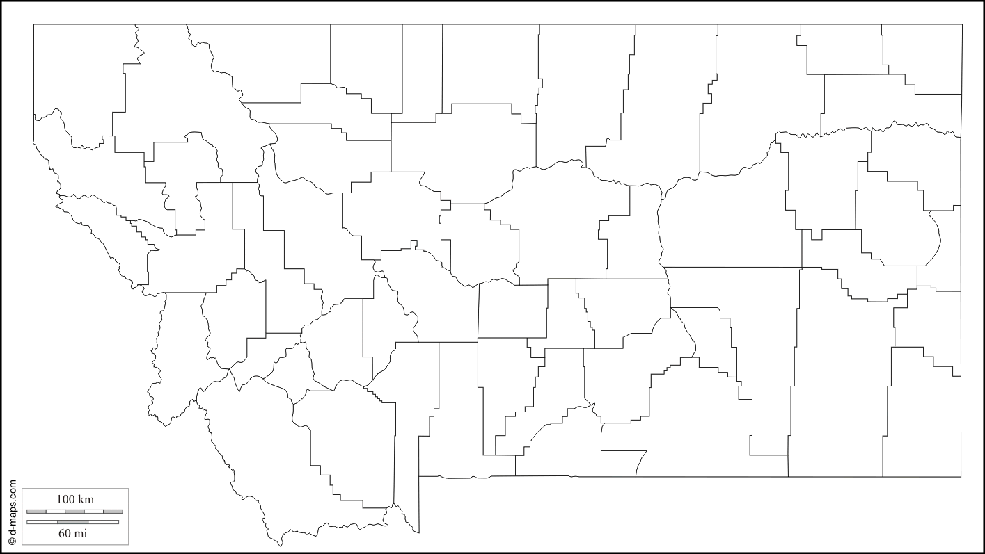

*Late Blight Modeling*:

Many tools exist to help make decisions regarding late blight. Weather-based modeling is the single most helpful means of assessing risk for the disease. Models such as Blitecast and Tomcast are available, as well as usablight.org. For Montana-specific risk assessments, please visit **montanaspud.org** for weekly weather reports for any of the 10 weather stations positioned around the state. Remember, in order for disease to develop, we need both the environmental conditions to be conducive, and inoculum to be present in the potato fields at the same time.

|  |  |  |  |
| --- | --- | --- | --- |
| **2016 Late Blight Fungicide Treatment Quick Reference Guide** | | | |
| **Active Ingredient (FRAC Group)** | **Product/Rate** | **PHI days** | **Comments** |
| Azoxystrobin (11) | Quadris, 12 fl oz/acre | 14 | For a 7-day schedule, apply Quadris at 12.0 fl oz/acre. Use no more than 2.88 qt/acre per season. Alternate away from Group 11 fungicides to manage resistance. |
| Azoxystrobin (11)+chlorothalonil (M5) | Quadris Opti, 1.6 pt/acre | 14 | Alternate away from Group 11 fungicides to manage resistance. Use no more than 3 gal/acre per season |
| Azoxystrobin (11)+difenoconazole (3) | Quadris Top, 8-14 fl oz/acre | 14 | Begin applications prior to disease development, continue on a 7-14 day interval. No more than 2 consecutive applications. The addition of a spreading/penetrating type adjuvant such as a non-ionic based surfactant or crop oil concentrate or blend is recommended. |
| Chlorothianol (M5) | Bravo: 2-1/2 to 4-1/4 pints/ acre, Equus: 1.125, then 1.5 – 2.25 pints/acre, Echo: 1 pint then 1 1/2 to 2 1/8 pints/acre, Initiate: 1 1/8, then 1 1/2 to 2 1/4 pints/acre, Orondis: *(new product*) 3/4 pints/acre, then 1 1/2 pints/acre | 7 | Many formulations, follow labels for specific rates and spray intervals, and maximum applications per season. |
| Cymoxanil+famoxadone (11) | Tanos, 8 fl oz/acre | 14 | Mix with M5 group fungicide, consult label |
| Fenamidone (11) | Reason, 5.5-8.2 fl oz | 14 | Do not exceed 24.6 fl oz/season, consult label |
| Fluoxastrobin (11) | Evito: 3.8 fl oz, Aftershock: 3.8 fl oz | 7 | Do not exceed 22.8 fl oz/season |
| Pyraclostrobin (11) | Headline, 12 fl oz | 3 | Do not exceed 2.25 qt/a per season |
| Pyraclostrobin (11)+metiram (M3) | Cabrio Plus, 2-2.9 lb/acre | 14 | No more than 2 consecutive applications. No more than 17.4 lbs/season |
| Metaconazole (3), Fluapyroxad (7)+ Pyraclostrobin (11) | Quash 2-4 fl oz, Priaxor 4-8 fl oz/acre | 1 | No more than 2 consecutive applications. No more than 16 oz/A/season. No more than two consecutive applications and no more than 3 applications (4-8 fl oz/A) or (24 fl oz/season). |
| Trifloxystrobin (11) | Gem: 6-8 fl oz, Gem 500SC: 2.9-3.8 fl oz-- use highest rate for late blight | 7 | Do not exceed 48 fl oz (23 fl oz-Gem 500SC)/ season |
| Maneb (M3) | Maneb 80 WP: 1.5 -2.0 lb Manex 4F: 1.2- 1.5 qt | 3 | Do not exceed more than 11.2 lb ai/season |
| Mancozeb (M3) | Dithane F45: 1- 2 lb/acre, Manzate: 0.4-1.6 fl oz/acre, Penncozeb: 0.5- 2lb/acre | 3 | Do not exceed more than 11.2 lb ai/season |
| Mandiproamide (40)+Difenoconazole (3) | Revus Top: 5.5-7.0 fl oz/acre | 14 | No more than 2 consecutive applications. No more than 28 fl oz/season |
| Difenoconazole (3) | Top MP: 5.5-7 fl oz/acre | 14 | No more than 2 consecutive applications. No more than 28 fl oz/season. Can tank mix with Omega for late blight. |
| TPTH-triphenyltin hydroxide (30) | SuperTin 4L: 4- 6 fl oz, SuperTin 80 WP: rate dependent on method of application, see label, Agri Tin 80WP: 2.5-3.75 dry oz/acre, rate dependent on method of application | 7 and 21 | Do not use more than 18 oz/season SuperTin4L or 11.25 oz/ season of 80WP formulations. Do not use with emulsifiable pesticides or MH30. Some phytotoxicity to Superior and Norland varieties. Note 24 hr reentry period. May be mixed with maneb or mancozeb products for improved early blight control. |
| Zoximid (22)+Mancozeb (M3) | Gavel, 1.5-2.0 lb/acre | 3 | Do not exceed 12lb/season. Note field workers should be advised that this fungicide is dermal and oral sensitizer |

*Action Points:*

* Use fungicide seed treatments
* Watch weather reports
* Be aware of what strain is present in neighboring states
* Prepare an action plan ahead of time
* Stay on an aggressive spray cycle
* Scout fields regularly
* Apply irrigation according to guidelines
* Consult 2016 Montana Seed Potato Disease Management Guides for more information

|  |  |  |  |
| --- | --- | --- | --- |
| **2016 Late Blight Fungicide Treatment Quick Reference Guide cont.** | | | |
| **Active Ingredient (FRAC Group)** | **Product/Rate** | **PHI days** | **Comments** |
| Metiram (M3) | Polyram, 1.5-2.0 lb/acre | 14 | No more than 14 lb/acre/ season. Do not feed treated potatoes to livestock |
| Cymoxanil (27) | Curzate, 3.2 fl oz/acre | 14 | Do not use alone, mix with FRAC M3, M5, 30 protective fungicide |
| Cyazofamid (21) | Ranman, 1.4-2.75 fl oz | 7 | No more than 27.5 fl oz/season. Note for crops not on label, 30 day limit before planting |
| Dimethomorph (15) | Forum, 4-6 fl oz | 4 | Tank mix with M class fungicide. Do not mix with mefenoxam or metalaxyl. Do not exceed 30 fl oz/season. May be used after vine kill to prevent tuber infection |
| Ametoctradin+Dimethomorph (15) | Zampro, 11-14 fl oz | 4 | Maximum 42 fl oz per season |
| Propamocarb hydroxide( 28) | Previcur Flex, 0.7-1.2 pt | 14 | Tank mix with M class fungicide. No more than 6 fl oz/season |
| Fluazinam (29) | Omega, 5.5 fl oz | 14 | Tank mix with M class fungicide. No more than 3.5 pt/season |
| Mandipropanid (40)+Difenoconazole (3) | Revus Top, 5.5-7.0 fl oz | 14 | Do not apply more than 28 fl oz/A/season. Can be used in place of the standard protectants when late blight pressure is high. Foliar applications of these products can be more effective in reducing the tuber blight phase of late blight than standard protectants. |
| Zoxamide (22) + Chlorothalonil (M5) | Zing!, 32-34 fl oz/acre | 7 | Apply on a preventative schedule. Use the maximum labeled rate at row fill. Do not make more than 2 sequential applications before alternating with a fungicide that has a different mode of action. Do not make more than 8 applications or apply more than 1.52 lb zoxamide and 8.88 lb chlorothalonil per acre per season. Excellent for late blight, can be used in place of standard protectants when disease pressure is high. Foliar applications of these products can be more effective in reducing the tuber blight phase of late blight than standard protectants. |
| Fenamidone (11) | Reason 8.2 fl oz | 14 | Do not exceed 24.6 oz/season. Consult label. |
| Note: When the potential of inoculum is present, a strong preventative program using good protectants such as Manzate or Bravo starting just before row closure with 6-7 applications ~$100/acre. In the Gallatin this year, use Omega for foliar program instead of Luna or Endura. For antisporulation, use mancozeb, polyram, or pennecozeb at die down. Miller Research has shown 7 treatments of Bravo result in no tuber blight. | | | |

*Storage recommendations:*

* Harvest during dry weather when pulp temperatures are 45-65°F.
* Provide adequate airflow through the storage (25 cfm/ton).
* Cool the pile to the final storage temperature as quickly as possible
* Monitor storages daily. Determine temperature of the piles at various depths and locations. Serious late blight problems usually show up within 6 weeks of storage.

PESTICIDE USE: Pesticide usage suggestions provided in MSU Extension materials are intended to serve only as a guide and are published for educational purposes. If any suggestions conflict with a product label, follow the product label instructions. Read and follow all product labels carefully.

*Website*: **msuextension.org/pspp** *Twitter*: **MtExtPSPP** *MSU’s Certification Website*: **montanaspud.org**