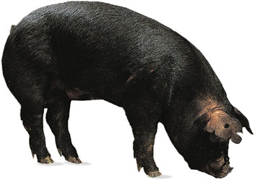2023 Valley County
4-H Swine Project and Breeder Information

Complete the breeder information and bring to office when picking up tags or
when you come to tagging day May 15.

4-H Members Name _______________________________________________

4-H Club _________________ TAG ## _________ _________

The breeder of my 4-H swine was:

Name _____________________________________

Street or Box # _____________________________

Town & Zip ________________________________

Phone # ___________________________________

