EPAF Instructions Draft 6/08/2022 MS
New Work Study Approval and EPAF Process
Financial Aid and Human Resources are pleased to announce that all on-campus Work Study student appointments will no longer be a paper-based process and will be done via EPAF starting in the fall 2022. EPAF processing instructions for regular student employment can be found here:
https://www.montana.edu/hr/EPAF/index.html#BZJBSU
Work study EPAF instructions are similar with these few modifications.
The approval category for work study EPAF’s is:
Financial Aid will send the student two emails once they have accepted their Work Study award via MyInfo. First, a welcome letter that gives them an overview of how to find a job, followed by a certificate that will contain key information for the employer to use for the EPAF, specifically:
- Start and end dates- Anytime you are entering in a date it must be in date format – mm/dd/yyyy or it will error out
- Work Study award amount
- Whether the award is Federal or State Work Study
  - Federal ID 421306 61226
  - State ID 439903 61228
- The labor distribution
  - Enter your departmental index, account code (same as WS account code) and percentage (25%)
  - Enter the award index, account code and percentage (75%)
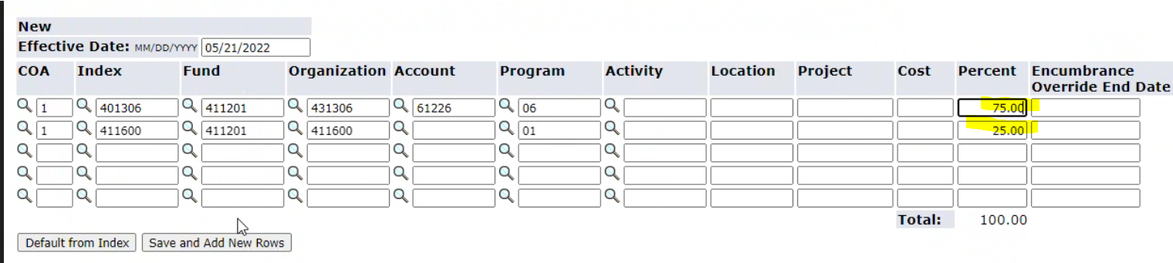
  - America Reads then it is the America Reads index at 100%
- The Suffix must start with 00 (zero zero) if you use O it will error out
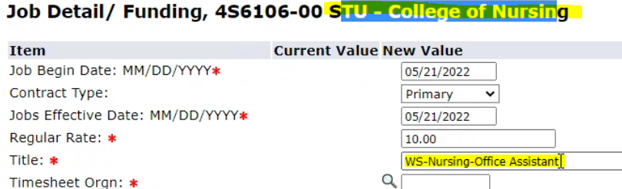
- When adding the title please put WS- your departments name for the title *note that the character limit is 30 characters
- In the comments of the EPAF please put in the job description of the Work Study job
- Whenever you make any changed to the EPAF please add a comment of what you do for audit reasons
- In the routing queue you will need to put in the BZFAIN BZ- Financial Aid, and then you can select Eryn Hoellein, required action is Approve

It is the responsibility of the EPAF originator to make sure the information supplied on the WS certificate is correctly entered into the EPAF. Financial Aid will carefully review the EPAFs for accuracy and will return any with incorrect information. Please keep an eye on your emails.

If a student approaches a department, stating they have WS funds, but they don’t have a certificate, please direct the student to accept their award in order to initiate the certificate process. If a student has not yet been awarded work study, please have them see the Office of Financial Aid. The student might be eligible for work study.

