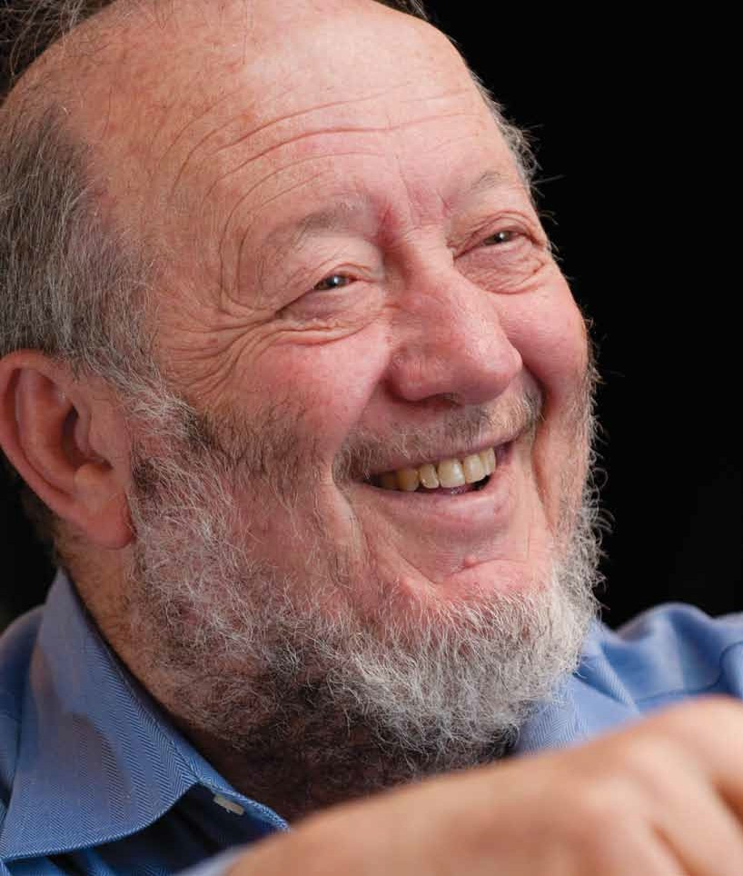
weissman · kelly gorham

ON THE EDGE by Anne Cantrell

Irving Weissman is an innovator in one of medicine’s most exciting and controversial disciplines. One key to his success stems from his Montana roots.

When he talks about science, Dr. Irving Weissman starts speaking slightly faster than he does when he’s talking about, say, growing up in Montana.
When he discusses his work, he sometimes speaks only the first part of the word, as though there is so much to say that he doesn’t want to waste time uttering the final syllable. A note of urgency comes into his otherwise soothing voice. It’s indicative of what perhaps drives Weissman the most: a belief that medicine should be based on science and advanced through constant research. And, that there is so much yet to be done.

A world-renowned stem cell researcher, Weissman is a pioneer at the forefront of a science that could change nearly everything about how we treat illness and disease, from heart disease to cancer. The director of Stanford University’s Institute of Stem Cell Biology and Regenerative Medicine, Weissman is also a member of the National Academy of Sciences—an elite group of only about 2,100—and his colleagues say that he stands above even the very best scientists.
r

phe a r g o t
o
ph
·
O
t O
h P
Yet, as essential as science is to Weissman, so are his roots. The native Montanan and Montana State
College graduate returns to the state as often as he can, giving lectures, serving on boards and fly fishing the state’s rivers.
His frequent trips home are a respite from some weighty responsibilities. As the immediate past president of the International Society for Stem Cell Research, he is immersed in one of the greatest ethical debates of this age, one that involves science, medi- cine, politics and religion. It is a debate in which he
is greatly invested, both professionally and personally, and the stakes are high.


fall 2010 47

———————————
Weissman’s work could, for example, result in a cure for cancer.
He knew nearly 15 years ago that he could isolate blood-forming stem cells from women who had breast cancer. Theoretically, these stem cells could be trans- planted back into a woman after she received a powerful, cancer-killing course of chemotherapy. A side effect of such chemotherapy was the destruction of those tissues that formed blood. The transplanted stem cells offered the solution of being able to regrow those tissues.
In 1996, for the first time, physicians transplanted cancer- free blood-forming stem cells into a breast cancer patient after she had completed a potent course of chemotherapy.
Weissman recalled the physicians telling him it was a hopeless case from the start. The woman’s cancer was aggressive, and as she was
is controversial, since creating an embryonic stem cell line for research requires starting with cells in an excess blastocyst stage embryo from an in vitro fertilization clinic. The debates have fueled pro-life advocates, who view an embryo as a person.

Despite his frustrations, Weissman feels a responsibility to overcome the hurdles. It’s work that has driven him ever since he was a young boy growing up in Montana. Work that he believes has the potential to improve people’s lives.
———————————
In an auditorium at Benefis Healthcare earlier this year in his hometown of Great Falls, Weissman explains
to a standing-room only audience that stem cells are characterized by their ability to renew themselves by dividing and differentiating into a diverse range of

undergoing chemotherapy, a
burst of cancer cells developed in her chest, indicating that the cancer had really spread.
“Nobody gets out of that one alive,” Weissman said.
Except that this woman

BEWARE OF ADVERTISED TREATMENTS WHERE ONE KIND OF STEM CELL IS USED TO REGENERATE ALL TI SSUE S. THERE IS NO SUCH THING IN ADULTS.
— IRVING WEISSMAN

did. The chemotherapy followed by the transplant of cells worked. Remarkably, the last report Weissman received—nearly 15 years later—was that the woman was living without cancer.
The results should have been a medical break- through and a tale of hope for cancer patients and their families. But politics and economics got in the way, Weissman said.
When a company that Weissman had formed to take the new treatment into clinical trials was taken over, the new company subsequently made a business decision to stop those clinical trials before complete results were known.
And national legislation on the use of stem cells has restricted his ability to conduct research. His work has made him the subject of hateful messages in the blogosphere and at least one death threat. In 2001, Weissman headed a National Academies panel on stem cells. Because embryonic stem cells could give rise to adult stem cells, the panel voted unanimously to accelerate the federal funding of that kind of research. Most embryonic stem cells are a few days old, derived from embryos that were artificially fertilized in a clinic and donated specifically for research. Still, stem cell work
specialized cell types—adult muscle stem cells can be- come muscle cells, adult blood-forming stem cells can regenerate blood, and nervous system stem cells can make all kinds of brain cells. They are entirely responsible for the origination of all body tissues and their regeneration throughout life. In a developing embryo, stem cells can potentially differentiate into any adult stem cell: adult stem cells repair the body, replenishing specialized cells and maintaining regenerative organs, such as blood, skin or intestinal tissues.
Following the lecture, one woman asks Weissman about potential stem cell treatments for her adult son’s spinal cord injury. Another wonders if treatments for juvenile diabetes and neonatal diabetes work in the same way.

“They don’t have stem cells for (every procedure),” Weissman cautioned. “Nevertheless, in animal experiments, human brain stem cells can repair many spinal cord injuries; blood-forming stem cells can block the progression of a diseased blood system to the disease, for example, in mice developing juvenile diabetes; blood-forming stem cells from a diabetes-resistant parent or sibling can permanently block progression to diabetes. But you should beware of advertised treatments where one kind of stem cell is
illustRatiOn · bridget ashcraft

POTENTIAL THERAPIES
One day, scientists say, stem cells may be used to repair or replace damaged cells and have the potential to treat conditions like cancer, Alzheimer’s, Parkinson’s disease, multiple sclerosis, inflammatory bowel disease and diabetes. In theory, any condition in which there is tissue degeneration could be a potential candidate for stem cell therapies.

STEM CELLS
Embryonic stem cells have the potential to develop into many different cell types in the
body during early life and growth. In many tissues stem cells also serve as a sort of internal repair system, dividing to replenish other cells. When a
stem cell divides, each new cell has the potential either to remain a stem cell or become another type of cell
with a more specialized function, such as a muscle cell, a blood cell or a brain cell.

CURRENT THERAPIES
Adult stem cell treatments have been successfully used for many years to treat leukemia and related bone/blood cancers through bone marrow transplants. Weissman’s laboratory was the first to identify and isolate the blood-forming stem cell from mice and from humans.

used to regenerate all tissues. There is no such thing in adults. “That’s why it’s so important to understand the science,” he added.
———————————
Weissman’s journey into understanding some of the most intricate science about the human body began in Great Falls. His grandfather arrived as an
immigrant at Ellis Island in the early 1900s and then headed west, settling near Great Falls. He worked as a junk man and fur trader and later owned a second- hand auto body parts store, eventually also working in steel supply, plumbing supply and hardware. Weissman’s father later took over the business.
Weissman, who is now 70, said his interest in science began when he was 10 and read a book about the lives of scientists, including Robert Koch, a Ger-man physician who developed criteria to establish a causal relationship between a microbe and disease.
“How do you know something causes a disease? This discovery by Koch dramatically changed things, for everybody,” Weissman said. “And for me, reading about it the first time and seeing that connection between science and disease—I wanted to be able to do that.”
About five years later, Weissman approached Ernst Eichwald, a Great Falls scientist, to see if he could work in his Great Falls laboratory to learn more about research. Eichwald quickly became a mentor.
Weissman remembers how, early in his career when he was working in Great Falls, he encountered in a room near the lab in Deaconess Hospital a tod- dler who had leukemia.
“That combination, working in the lab, watching this poor 18-month-old child die because there was no therapy, all added up to plenty of motivation for me,” Weissman said. “Not only to do research, but to take the research as far as possible (and) to apply it to medicine. Not just publish a great discovery

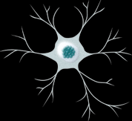
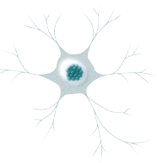
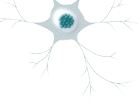
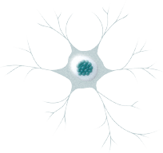
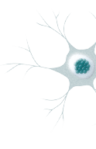
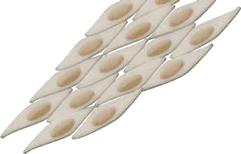
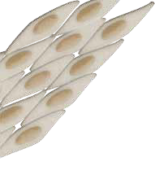
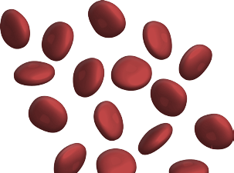
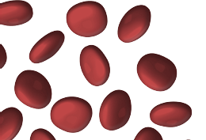

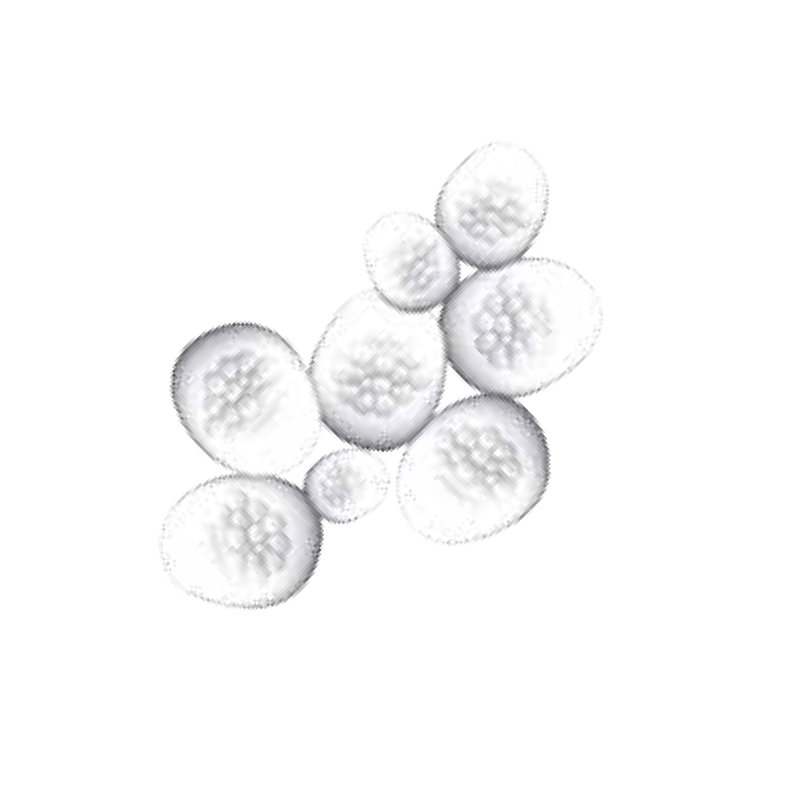

(or a not so great discovery), but to try to translate it into medicine.”
However, Weissman is quick to point out that his grades were not exemplary. He never made it into the top 10 percent of his class in Great Falls.
“But I was also doing science,” Weissman said. “I won (a) grand prize at Billings in the 1957 Montana State science fair my senior year and had published two papers by the time I graduated high school.”
Weissman attended Dartmouth for two years.
“I could see that I wasn’t learning or doing science at Dartmouth,” Weissman said. “I also hated living in the East. I hated the traditionalism of the East.”
So Weissman left Dartmouth and enrolled at what was then Montana State College in Bozeman, where he met “some of the greatest scientists and teachers—of- ten better than I had at Dartmouth.”
As an undergraduate student at Montana State, Weissman learned the importance of reading others’ research experiments thoroughly and evaluating their methods and analyses.
Montana State geneticist Palmer “Dave” Skaar was particularly important to Weissman.
“Dave Skaar brought me into a whole different world, a very advanced world,” said Weissman, who took six courses with Skaar during the year he was at Montana State. “He taught by analyzing the great genetics experiments of the day, and he related them to problems in both evolution and population biology.”
Skaar’s courses helped Weissman embrace a philosophy that learning must be done in a lab. Weissman’s advice for people interested in pursuing careers in research stems from that philosophy.
“There’s no predicting from the grades you’ve got whether you’re going to have the talent (to go into research),” Weissman said. “And you also have to have the desire to look at medical issues, from fundamental science where you’re asking questions, devising experi
ments to answer the questions, and then the whole deal of making it real. So the only way you get that is working in a lab, and the sooner you start, the better.”
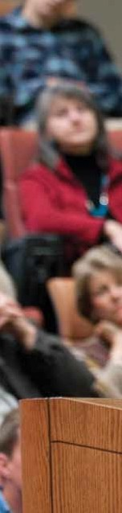
In the fall of 1960, Weissman entered a special
five-year research and medicine program at Stanford, allowing him—in conjunction with his coursework at Dartmouth and Montana State—to receive a bachelor’s of science in pre-medicine from Montana State College in 1961, after just one year at Montana State. Weissman earned his M.D. at Stanford in 1965. He has been there ever since.
While some call Weissman’s time in Montana an unlikely start to a prominent career in stem cell
research, Weissman says his Montana background was crucial to his success.
“One of the things about growing up in Montana, compared to the East, is that you’re less constrained by tradition and convention, so you can think creatively,” Weissman said. “You are more likely to question authority. And that’s a good thing.”
Weissman’s colleagues also note that his path illustrates his love of learning and desire for knowledge.
“Irv exhibits a deep and burning intellectual curiosity. That is fundamental to good scientists,” said Leroy Hood, Weissman’s long-time friend. Hood is also from Montana and co-founder of the Institute for Systems Biology in Seattle, which pioneers systems approaches to biology and medicine. “Irv is deeply curious and wants to understand in depth how things work. I think it’s very much a part of his approach to the world, understanding how the world works.”
———————————
Though he would rather be conducting research or fly- fishing, Weissman’s work also demands his full involvement in a world of politics and economics. And, traits that make him a good scientist seem to serve him equally well as he navigates those waters. His methodical reasoning, calm demeanor and ability to communicate scientific

ONE OF THE THINGS ABOUT GROWING UP IN MONTANA... IS THAT YOU’RE LESS CONSTRAINED BY TRADITION AND CONVENTION, SO YOU CAN THINK CREATIVELY. YOU ARE MORE LIKELY TOQUESTION AUTHO RITY—AND THAT’S A GOO D THI NG.
weissman · kelly gorham
— IR V I N G W EI S S M A N

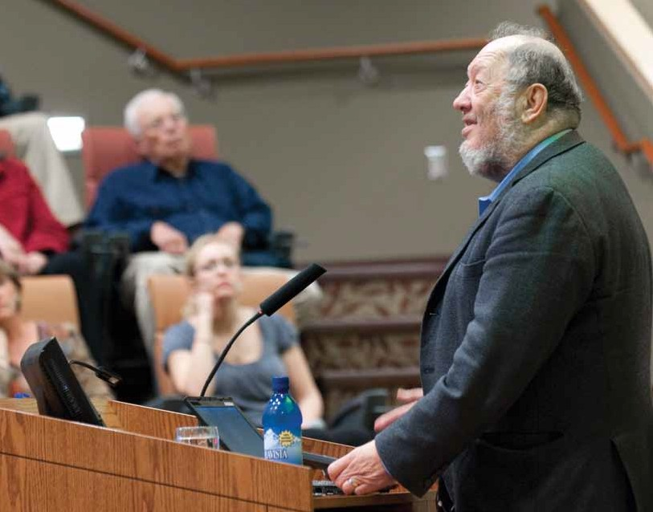
Weissman addresses an audience in his native great falls this summer.

relevance to a lay audience have been important assets as he testifies at hearings and debates the issues about stem cells, including hearings before the U.S. Congress.
Still, Weissman says that politics and economics are often the most frustrating aspects of his job.
In 2001, President George W. Bush limited federal funding for embryonic stem cell research to the stem cell lines then in existence, arguing that extracting the stem cell destroys the embryo and its potential for life. President Barack Obama lifted the ban last year, only to be reversed in August 2010 by a federal judge, who said an expansion of embryonic stem cell research violated a
ban on federal money being used to destroy embryos. An appeals court lifted the resulting temporary injunction
barring the federal government from funding research involving human embryonic stem cell research, but the implications of the judge’s ruling were still being determined, and Weissman said he hoped it would be overturned.
“(President) Bush, and (Sam) Brownback in the (U.S.) Senate, and (Dave) Weldon in the (U.S.) House, and the Catholic Church, and the Pope—who I eventually met—all opposed this kind of stem cell research, some equating it to murder,” Weissman said. “And I said, ‘Well, which of these diseases do you think we shouldn’t pursue just as hard as we can? Stopping stem cell research stops an important path to understand and treat these diseases.’”
To respond to the ban, Weissman was important

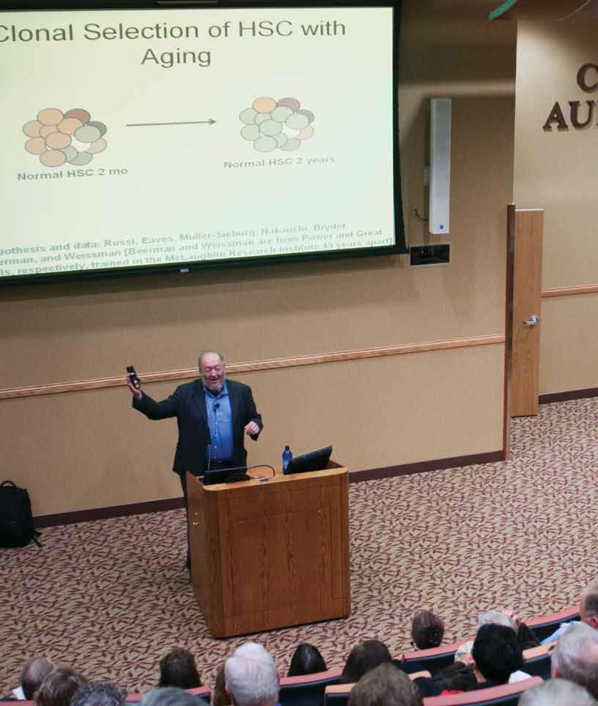

Irving Weissman was inspired to become a scientist at age 10 when he read a biography about scientist Robert Koch and others. recently Weissman, regarded as one of the foremost researchers working on stem cells, won the Robert Koch prize, the top international scientific prize in microbiology. Here he speaks to an audience in his native great falls.
r

phe a r g o t
o
ph
·
O
t O
h P

IT’S INCREDIBL E TO SEE A PIECE O F DATA COMING FROM A THOUGHT YOU HAD, AN EXPERIMENT YOU
DESIGNED. YOU’RE THE FIRST PERSON ON EARTH TO
KNOW AND UNDERSTAND WHAT IT IS.
— IRVING WEISSMAN

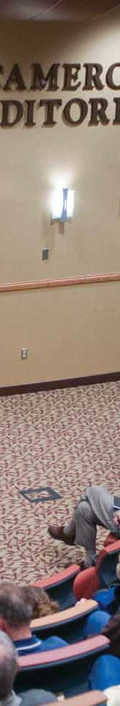
in the writing and passage of California’s Proposition 71, which protected the research as a state right and allocated $3 billion in state funds over 10 years. The measure put California at the forefront nationally of the field of stem cell research.
Weissman recognizes communication about stem cells can be polarizing, weighed down by people’s perceptions. “I realized that even when I said the word ‘embryo,’ if
I said it to people who weren’t even in the field, ‘Draw an embryo,’ inevitably they’d draw a fetus. So I’d say, ‘How can we talk to each other?’ If I say ‘embryo,’ and I know it’s some cells that are in a dish, and you think of a human fetus, then already it’s been polarized and politicized, and whatever religious or political group got to you first might have influenced your way.”
———————————
In addition to his membership in the National Acad-emy of Sciences, which is considered one of the highest honors that can be given a scientist or engineer, Weiss- man has received numerous awards. Among them are California Scientist of the Year in 2002 and, in 2008, the prestigious Robert Koch Prize, which is widely regarded as the leading international scientific prize
in microbiology. Some people speculate that he may someday win the Nobel Prize, as many recipients of the Robert Koch Prize have.
“Irv stands above most scientists,” said George Carlson, director of the McLaughlin Research Institute in Great Falls, of which Weissman is a board member. “He’s defi- nitely in the top 1 percent of scientists. It’s not a trivial thing to get into the National Academy (of Sciences).”
Throughout his career, Weissman’s love for Montana has been evident. He travels back to the state multiple times each year, sometimes to lecture or to raise funds for the McLaughlin Research Institute.
“Irv is exceptionally generous,” Carlson said. “He just wants to give back the opportunities he was given.”
r

phe a r g o t
o
ph
·
O
t O
h P
Carlson believes Montana is important to Weissman for another reason.
“He knows where he came from, and I think things like the work ethic play a big role in his success,” Carl-
son said. “And of course, he loves to fish.”
In fact, it doesn’t take long for fishing to come up in a conversation with Weissman. One fishing story he shares involves his 17-year-old daughter, Rachel.
“She is a great caster,” Weissman said. “If I float, as
I will, with her down the Bitterroot or the Missouri … usually I sit in back and she sits in front. And so you’re looking for the spot where the trout might be. And you cast your fly. Inevitably now, I see the spot, I do the cast, and hers lands just in front of mine.”
———————————
Weissman says he remembers every discovery he’s ever made, from his early experiments as a 16-year-old boy in Great Falls to breakthrough research he performed as an adult, including isolating blood-forming stem cells in mice and humans.
And, the process of discovery feels the same every time. Sometimes Weissman celebrates discoveries with other members of his research team, but more often than not, the discovery itself is the celebration.
“The big celebration is the moment you see it, and usually you’re alone,” Weissman said. “It’s incredible, to see a piece of data coming from a thought you had, an experiment you designed,” Weissman said. “You’re the first person on Earth to know and understand what it is.”
Weissman admits that his is an exciting line of work, but it’s also frustrating to him when barriers arise.
“I don’t get to rest, and say, ‘Gee, that was great,’ because I see what I have to do next. It’s a responsibility, and sometimes you wish that you didn’t have to do all of those other things.”
Still, Weissman remains focused. What is even more important than the discovery, and all of the hurdles that come with it, is its application.

“If this translation doesn’t happen, or is delayed for 4–8 years while somebody dithers about the philosophy of it, or the political reality of it, some people will die who had a short window of opportunity,” Weissman said. “And I’m really cognizant of that.”

