This manual provides instruction on how to approve a job description in the Positions Management Module and how to approve the Recruitment Authorization Form (Posting) or Hiring Proposal in the Applicant Tracking System Module.

LOGIN (all users)

HR Webpage link to Login Page
- http://www.montana.edu/hr/index.html
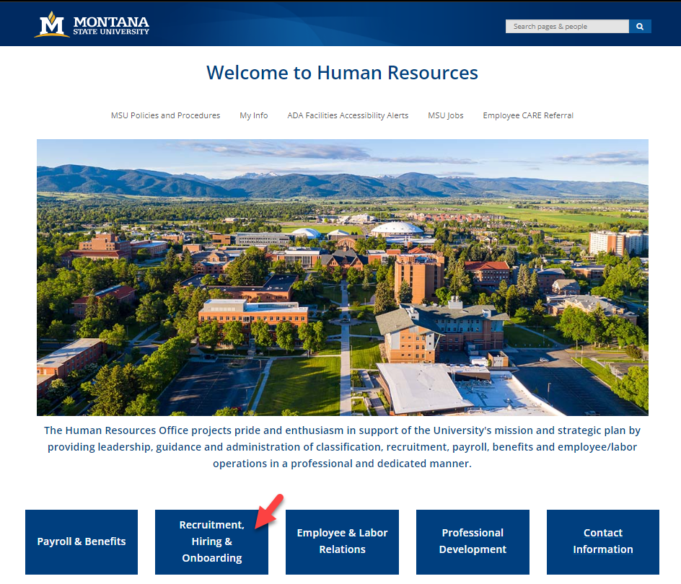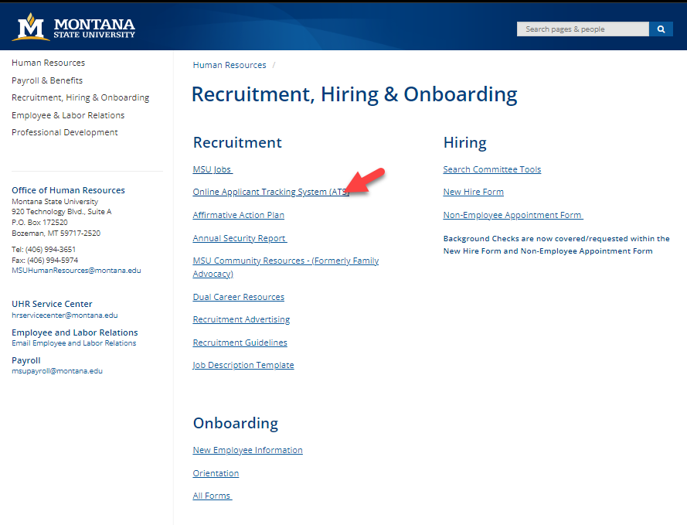
- https://jobs.montana.edu/hr

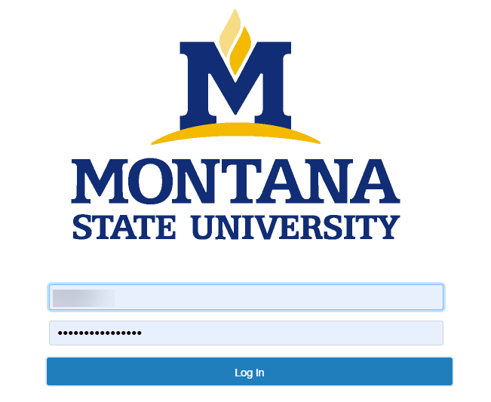
User Name: NetID
Password: password associated with NetID

*Error message of “LDAP Credentials Failed” go to the UIT link and update you NetID password, for the network: http://www.montana.edu/uit/ids-services/portal.html

NOTE: The platform works best with Chrome, Firefox, or Safari (5 or higher).
It is recommended that you utilize one of these Internet Options.

Inactivity of 15 minutes will time out the system and any unsaved data will be lost.
Clicking “Next” on any page will automatically save the page and move you to the next page. “Save” saves the current page without advancing to the next step.

FULL STAFF APPROVAL QUEUES
Position Approval Queue | Posting Approval Queue
Originator | Originator
Hiring Authority | Hiring Authority
HR for Classification | Director/Dept Head
Director/Dept Head | Dean/Associate VP
Dean/Associate VP | Budget
Budget | Office of Sponsored Programs
Office of Sponsored Programs | RED
RED | Comp SME for CAC
Comp SME for CAC | MUS Contracts Pres/Commission Approval
MUS Contracts Pres/Commission Approval | Pres/VP/Provost
Pres/VP/Provost | President
President | Human Resources
HR Review - Recruitment | Approve - Future Posting Date
Position Approved | Posted

- Current approvals must be completed on either the Positions or Hire module
  - Not required on both if within the same Fiscal Year or notation in Position history that approved for hire in next fiscal year
- Budget / Office of Sponsored Programs / RED are dependent on types of funding
- Workflow states that don’t apply to a position/posting due to contract type are either set as optional transitions in the system or can by skipped by HR

ACCESSING ACTIONS FROM HOME SCREEN
Make sure you are in the correct role, by using the dropdown towards the top of the screen.
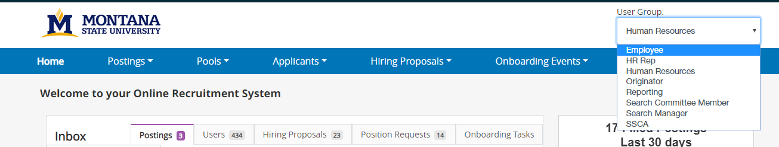
- System will automatically refresh giving your correct view.
The inbox shows any actions that require attention and the User Group assigned to. The system allows the user to see actions based on User Group authority. For optimal results log in with the highest authority level.
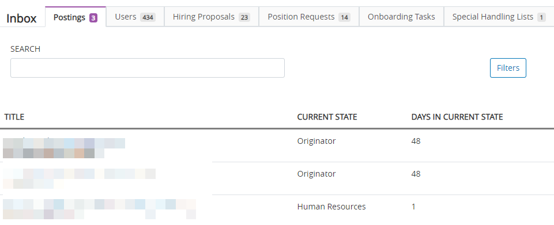
User Group
Tabs indicate the form that requires an action and the number of actions assigned to your user groups
Posting
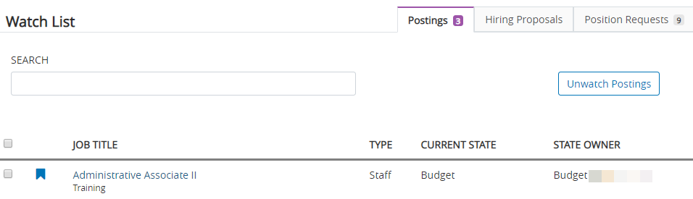

- To access the item requiring action click on job title. This can all be done from the Inbox or Watch box.
Warning: Inbox link will change your User Group to the User Group listed under Current State!

HOME SCREEN -
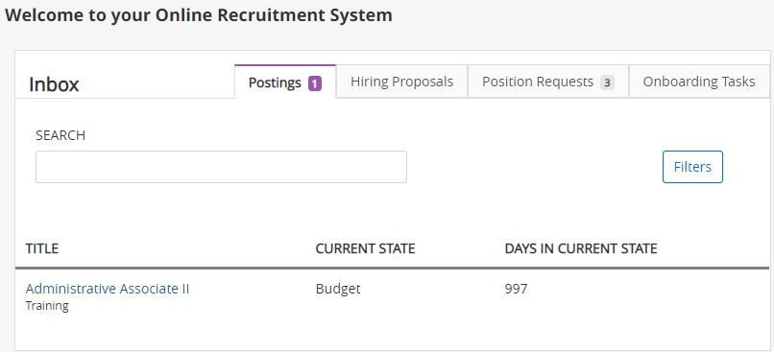
Awaiting Action or Approval
Awaiting Action or Approval
- Inbox should show all form types that need action
  - Budget has an additional filter to only show to the budget individual named
- Select the appropriate tab (either Postings or Position Request in example above)
- Select Title to open action for review or approval
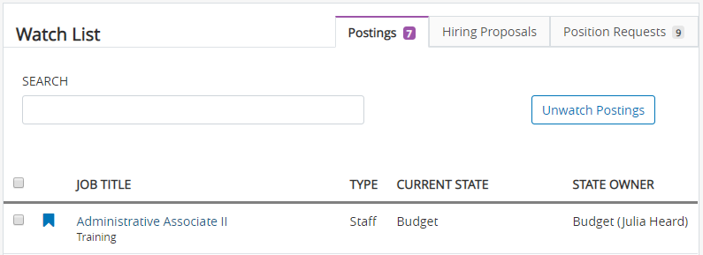
- Watch List would specify who in Budget action was routed to for approval
- If an action is added to Watch List, it will show regardless of who owns Current State
  - Good option for keeping track of where an action is in its workflow

POSITION REQUEST – APPROVAL
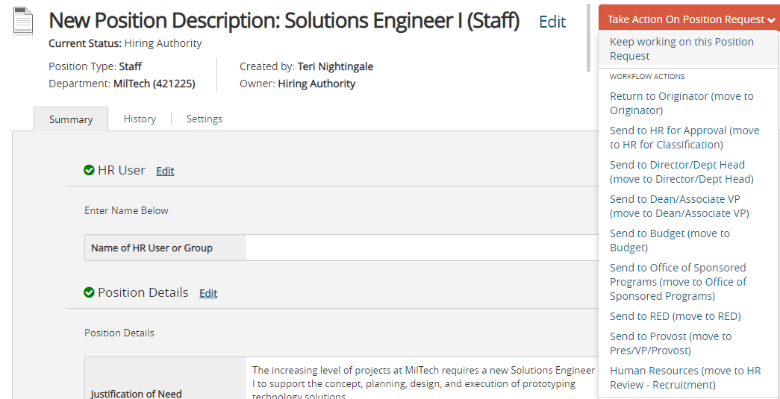
- When selecting an action from the home screen the color bar doesn’t matter it will always go to the correct form
- All entered fields can be seen from the summary tab
- Select Edit to open the form if wanting to make corrections
- Select Take Action On Position Request either return to an earlier state for correction or send to the next approval in queue
- Users may have several roles in the system, depending on their position with the University.
  - click the drop-down for User Group and select next user group you need to use for Approval
    - Example: If serving as Hiring Authority & Department Head approve 2x then send to HR for Classification or Approve as Hiring Authority send to HR then HR will send to you as Director/Dept Head after classification.

BULK APPROVING
If needing to approve several positions/postings/hiring proposals the system does have the ability to bulk approve. Pick the form that you will be dealing with then use the More Search Options and Add Column to create your customized view of important information. ATShelpdesk@montana.edu or 994-4314 can help with personalized saved searches.
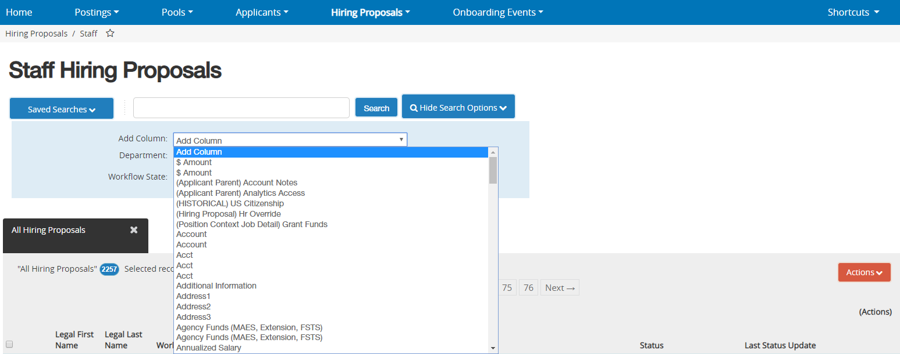
- Add Columns until view is correct to see the important parts needing to approve.
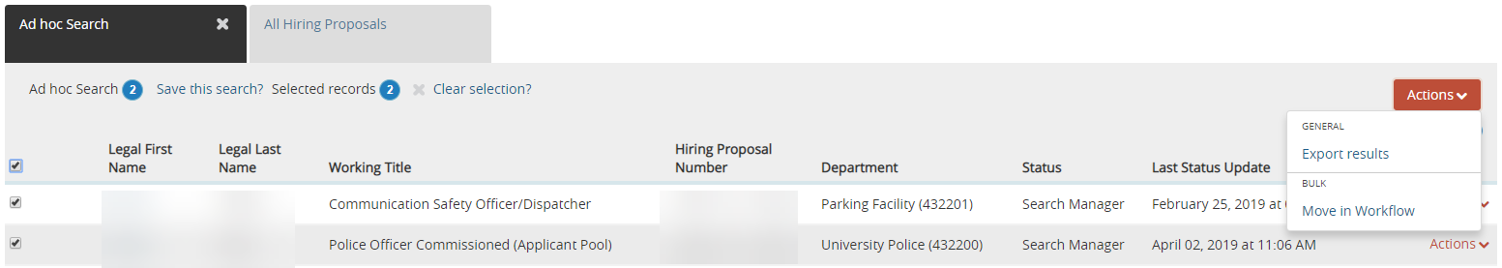
- Check box on left to select lines ready to be approved
- Use Actions button to select Move in Workflow
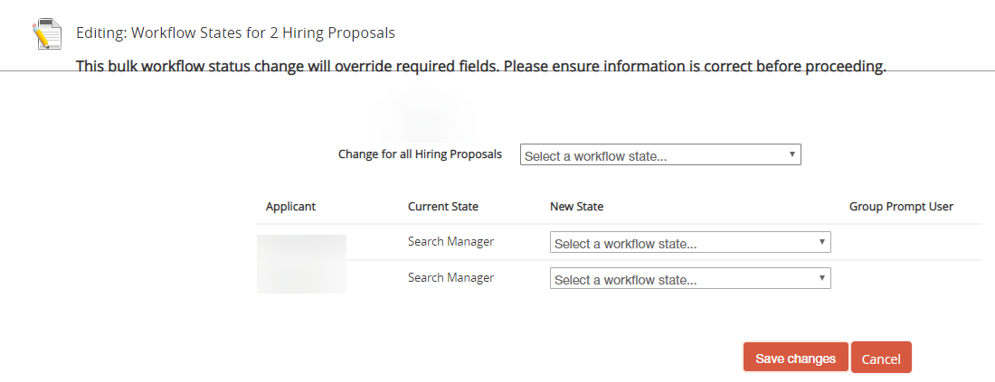
All the same Workflow
Different Workflow
- Select the correct workflow state
  - If all get the same use the option at the top otherwise can be picked individually.

