* Go to Reports Web <http://www.montana.edu/uit/esg> and choose “Reporting: Reports Web”

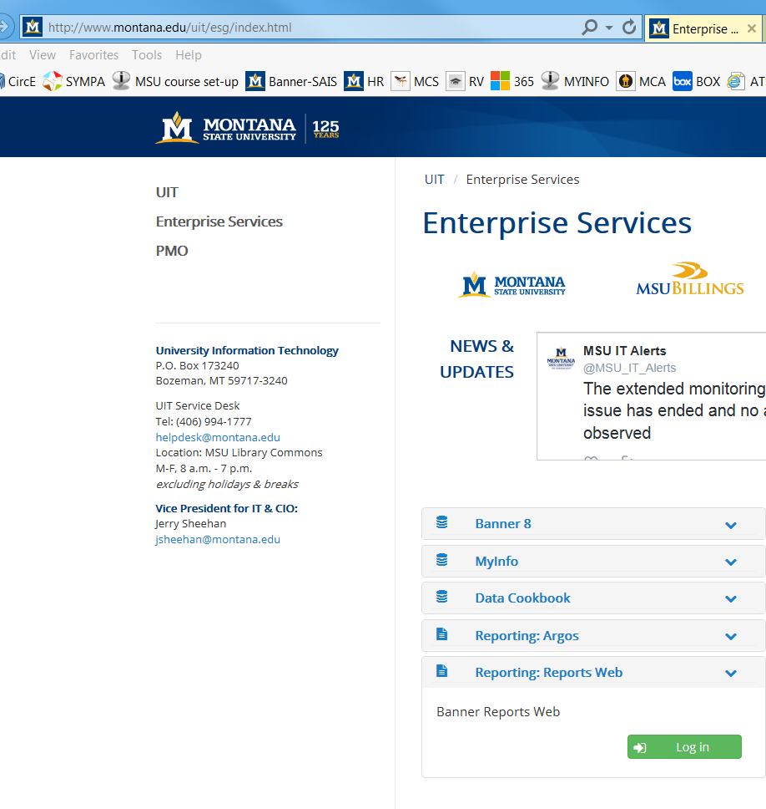

#2

Log in here

#1

Click Here to expand

* Log in with your Banner username/password

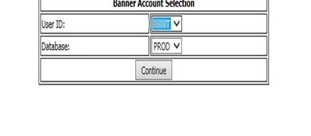

* Then choose “Banner Reports V8.9 Banner Reporting Web”.

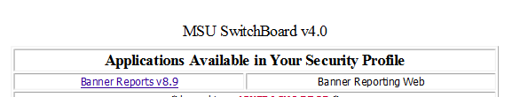

Choose “HR Dept Payrolls”.

There are two reports that you will need for this:

* ***Payroll Earnings and Labor Distribution by Employee*** *(This report shows you each employee and their earnings broken down by earnings code.)*
* ***Payroll Earnings and Labor Distribution by Employee (Leave Pool)*** *This report shows you each employee and their earnings broken down by earnings code and includes those employees with grants whose annual/sick leave that will override to the Leave Pool Index..*

* Click on one of the two reports to run it. A box will pop up on the right asking for parameters.

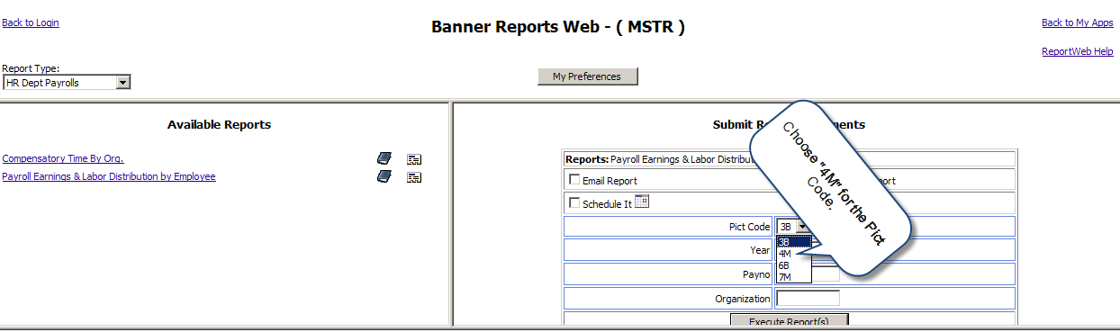

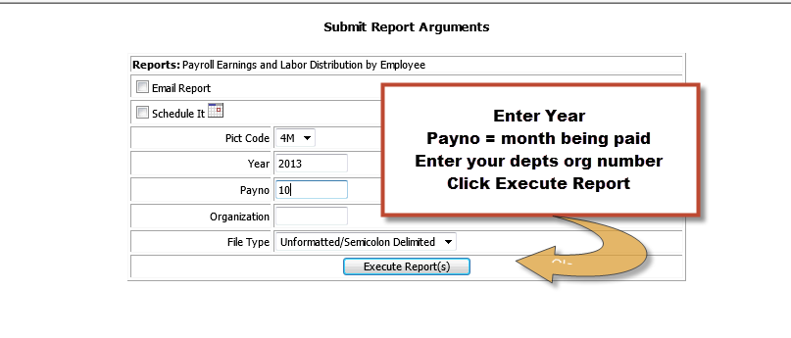

OR

* Your report is now running.

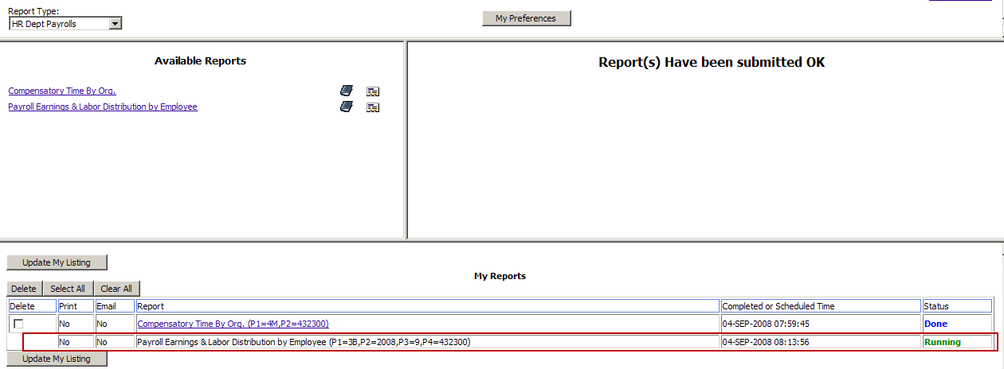

* Click the “Update My Listing” button.
* When your report is complete it will have a Status of “Done”.
* Follow the instructions for importing the report output into an excel document.  