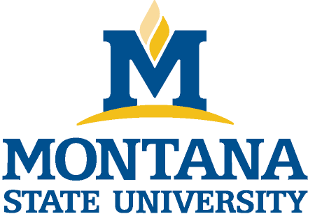
Montana State University
Employee Performance Evaluation

Employee Name |  | GID (last 4 digits)
Position Title |  | Position Number
Supervisor Name |  | Date of Review
Department |  | Period Covered | July 1, 2021 – June 30, 2022

Summary Evaluation
Consider the employee’s demonstrated performance in each of the criteria on the evaluation form and select the description which most appropriately summarizes this performance evaluation as a whole. Ratings must include supporting evidence justifying each rating. Please consult with your HR Business Partner before giving a rating of “unacceptable performance.” All performance evaluations should be completed by June 30.

Employee: Please check one “E” box in each area to reflect your performance. Manager: Please check one “M” box in each area to reflect employee performance.

Unacceptable Performance  E M  ☐ ☐  Performance does not meet expectations and must be improved. | Below  Expectations  E M  ☐ ☐  Certain aspects of the performance do not meet expectations and could be improved. | Acceptable Performance  E M  ☐ ☐  Meets all expectations of the role and is a valued contributor to the success of the department’s mission. | Strong  Performance  E M  ☐ ☐  Performance is strong and contributes significantly to achieving the department’s mission. | Exemplary Performance  E M  ☐ ☐  Unequivocally superior performance.

Note: By signing this form, the employee acknowledges only that this evaluation was discussed, and a copy has been received by the employee but does not necessarily indicate his/her agreement with the contents.

Employee’s signature Date

Manager’s signature Date

After conducting the evaluation the supervisor should upload the completed document named ““EMPLOYEE LAST NAME_FIRST NAME_EVAL.2022” into DocuSign and route for signatures to the Employee (“Needs to Sign”), Supervisor (“Needs to Sign”) and a copy to “HR Performance Evaluations 2022” – address will auto populate (“Receives a Copy”). For assistance, contact your HRBP.

Employee and Manager should keep a copy of all completed evaluations. Last update: February, 2022

PART I – INSTRUCTIONS
This evaluation form is based on the following four areas: (1) positive areas of job performance, (2) challenging areas, (3) feedback for supervisor or department in general, and (4) goals for next year. The goals you set for next year will be part of your next annual review.

Employee: Please complete the following evaluation form by responding to each section. Use the questions listed as a guide to your responses and provide any additional information you wish to share that is not specifically addressed. Send the completed unsigned electronic form to your manager, who will add his or her responses for discussion. A copy of the combined responses will be provided to you as well as kept in your personnel file.

Manager: Please add your own responses to each area and prepare to discuss your responses with the employee. During the discussion, you may change or add to your responses. Employee and Manager should agree on the proposed goals for the upcoming year, which will form a basis for the next annual review. After conducting the employee meeting, please upload the complete document into DocuSign and route for signatures (Employee, Supervisor and cc: to HR).

PART II – RESPONSES

POSITIVE AREAS OF JOB PERFORMANCE:
Summarize your accomplishments this year.
What do you like most about your job?
What parts of your job do you feel strongest in?
What were some of your “uppers” this past year?

Employee comments

Manager comments

CHALLENGING AREAS:
What parts of your job do you feel less confident about?
What do you like least about your job?
What frustrates you or has made meeting goals difficult?
What were some of your “downers” this past year?
Summarize any goals that are not yet fully accomplished.

Employee comments

Manager comments

FEEDBACK FOR SUPERVISOR OR DEPARTMENT IN GENERAL:
Is your current type and level of supervision meeting your needs? How could it be more advantageous to you?
How well is teamwork going for you?
What do you still need to learn?
What resources would help you do a better job?
How are you and the department demonstrating a commitment to compliance and safety in your working environment?
Do you have any ideas for the department to consider?

Employee comments

Manager comments

GOALS FOR NEXT YEAR:
What are the major points of focus for you in the next 12 months?
In what areas are you interested in developing new or greater expertise?

Employee comments

Manager comments

