[Name of School District]

BEEF TO SCHOOL

INFORMAL PROCUREMENT

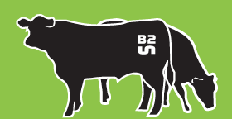
REQUEST FOR QUOTES

This institution is an equal opportunity provider and employer.

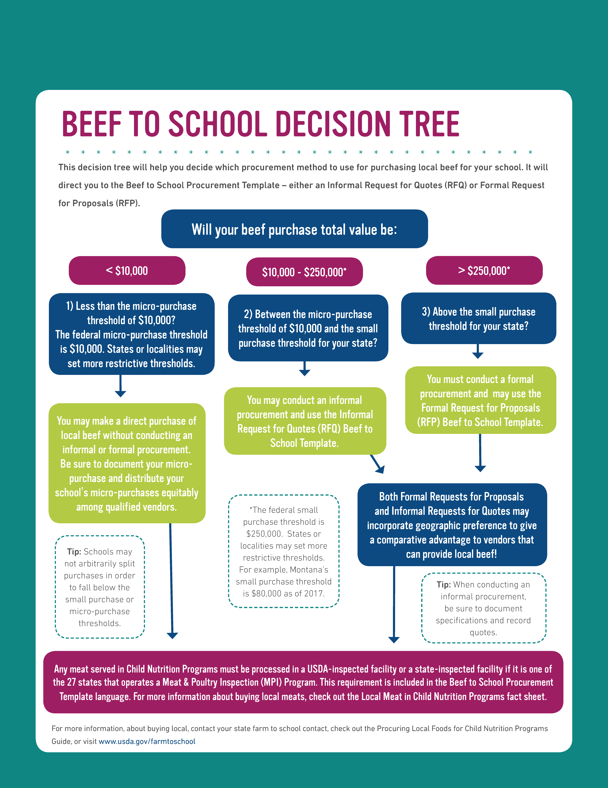
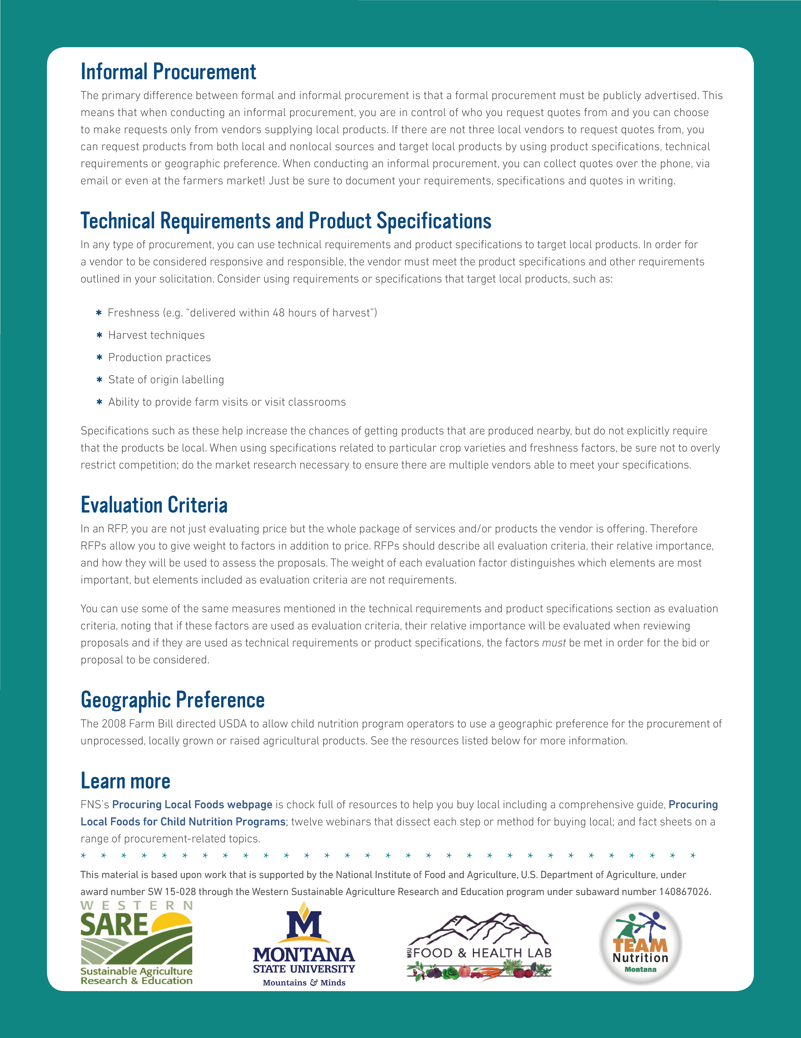

INSTRUCTIONS
This document is a template to help you create a Request for Quotes (RFQ) using the informal procurement procedure to purchase local beef at your school.
STEP 1: Review the decision tree above to confirm that the informal procurement method (RFQ) is the correct method for the beef purchase(s) your school plans to make.
STEP 2: Conduct market research. Get to know the beef market in your area to create specifications that are reasonable and encourage competition. For example, know when beef is available and how far in advance contracts should be established to ensure adequate supply. This will give you information about when to start your procurement process.
STEP 3: Review the RFQ template below and edit the product specifications and vendor requirements to meet your school’s needs. The formatted [red italicized bracketed text] are instructions or sample language that your school may want to consider. Edit, re-format or delete the red bracketed text and this instruction page before disseminating this RFQ. There should be no red bracketed text remaining on your school’s personalized RFQ when it is complete and ready to use!
STEP 4: Review the final RFQ carefully and be sure that it is clear, meets your needs, follows your school’s purchasing procedures, and meets any state and/or local requirements. If you need assistance, talk with your State Agency Child Nutrition Programs representative. You can also use this map to find a farm to school point of contact in your state: https://www.fns.usda.gov/farmtoschool/farm-school-contacts.
STEP 5: Contact vendors and gather price quotes. The informal procurement method requires a school to simply gather price quotes from qualified vendors (rather than soliciting vendor proposals or sealed bids in a formal process). Gathering quotes can be conducted over the phone, by email, using price lists, or by other methods that can be documented. Provide the product specifications and vendor requirements to vendors. Obtain an adequate number of quotes (two or more) from qualified vendors. Schools may choose which vendors to contact, and therefore may choose to contact only local vendors to obtain quotes. Be sure to document the price quotes using either your school’s own established method or the Quote Documentation Form below.
STEP 6: Select and notify the vendor that provides the lowest price quote while meeting all the product specifications and vendor requirements. Quotes that do not meet specifications or requirements may not be considered. If a vendor asks a qualifying question or requires additional information, the same information must be provided to each vendor. Schools may use a Geographic Preference and offer a price discount to local vendors for the purpose of comparing quotes. For more information on Geographic Preference, see https://www.fns.usda.gov/sites/default/files/f2s/FactSheet_Geographic_Preference.pdf.
STEP 7: Begin buying local beef! It doesn’t stop there--be sure to keep in good communication with the selected vendor and make sure that they follow through on the expectations of the RFQ. Be sure to maintain records sufficient to detail the history of the procurement (the solicitation, quotes from qualified vendors, selection notices, invoices, etc.)

[SCHOOL DISTRICT NAME]
Beef to School
Informal Solicitation - Request for Quotes

PRODUCT SPECIFICATIONS AND VENDOR REQUIREMENTS
[Listed below in red are sample product specifications and vendor requirements. Change, remove, or add specifications to meet your school’s needs, and remove this paragraph! Clearly describe what product(s) you need, how they should be packaged, and how and when they should be delivered. If you are flexible on certain specifications, then list acceptable substitutions or keep the description general to allow for options. Remember, quotes that do not meet specifications cannot be considered.]
Product Overview: | [100% beef burger patties, 100% raw ground beef]
Product Description: | [80/20 fat content  Fresh or IQF Frozen  No additives, preservatives or flavors. List acceptable specific additives or fillers, if any.]
Cattle Requirements: | [Pastured cattle, fed hay in winter is allowable  Use of sub-therapeutic antibiotics or hormones is prohibited]
Traceability Requirements: | [Must be able to trace each case of product back to specific cattle/ranch]
Portion/Unit Size: | [2 oz. patties (6/1 lb)]
Case Size and Packaging: | [10-40 lb (20 lb cases preferred)]
Estimated Quantity: | [300 lb/week (15 x 20 lb cases) throughout school year  Total annual volume: approximately 12,000 lb]
Delivery/Receiving Requirements: | [Price quoted must include delivery  Delivery must be made using mechanically refrigerated delivery vehicle  Fresh – held below 41 degrees F. at all times  Frozen – held below 0 degrees F. at all times]
Delivery Locations: | [List name(s) and address(es) of delivery sites]
Delivery Schedule: | [Product to be delivered from August through May during the 2017-2018 school year  Deliveries must be made between 7:00-8:30 am  Fresh – Deliver once or twice per week  Frozen – Deliver once or twice per month]
Shelf Life Upon Receiving: | [Fresh – at least 3 Days  Frozen – at least 3 Months]
Vendor Requirements: | Must provide proof of product liability insurance  Must provide current state or USDA certification  [Daily inspections/testing required]  [Must allow initial and annual inspection of processing facility for cleanliness conducted by school staff]  [Must have strong record of good customer service]  [Must provide references upon request]

QUOTE DOCUMENTATION FORM
[To be filled out by school upon receiving price quotes from at least two qualified vendors.]
Vendor | Date Received | Quote Method  (In-person, Phone, Email, etc.) | Able to Meet Specifications and Vendor Requirements?  (yes/no) | Price quote per pound  (delivery included)

BUY AMERICAN PROVISION [Be sure vendors understand this provision.]
As a sponsor of the National School Lunch and School Breakfast Programs, the District will consider only applicable products which comply with the requirements of the “Buy American” Act. Section 104(d) of the William F. Goodling Child Nutrition Reauthorization Act of 1998 requires schools and institutions participating in the NSLP and SBP in the contiguous United States to purchase, to the maximum extent practicable. Domestic commodities or products for use in meals served under the programs. The legislation defines “domestic commodity or product” as one that is produced in the United States and is processed in the United States, substantially using agricultural commodities that are produced in the United States. The report accompanying the legislation stipulated that “substantially” means over 51 percent of the final processed product consists of agricultural commodities that were grown domestically. Exceptions to the Buy American provision should be used as a last resort if competition reveals the cost of domestic products are significantly higher than non-domestic foods. An alternative or exception may be approved upon request. Alternative substitute(s) must be documented. Documentation must include 1) price of the domestic food alternative substitute(s); 2) Availability of the domestic alternative substitute(s) in relation to the quantity ordered; 3) Reason for exception: limited/lack of availability or price (include price); Price of the domestic food product; and Price of the non-domestic product that meets the required specification of the domestic product.

