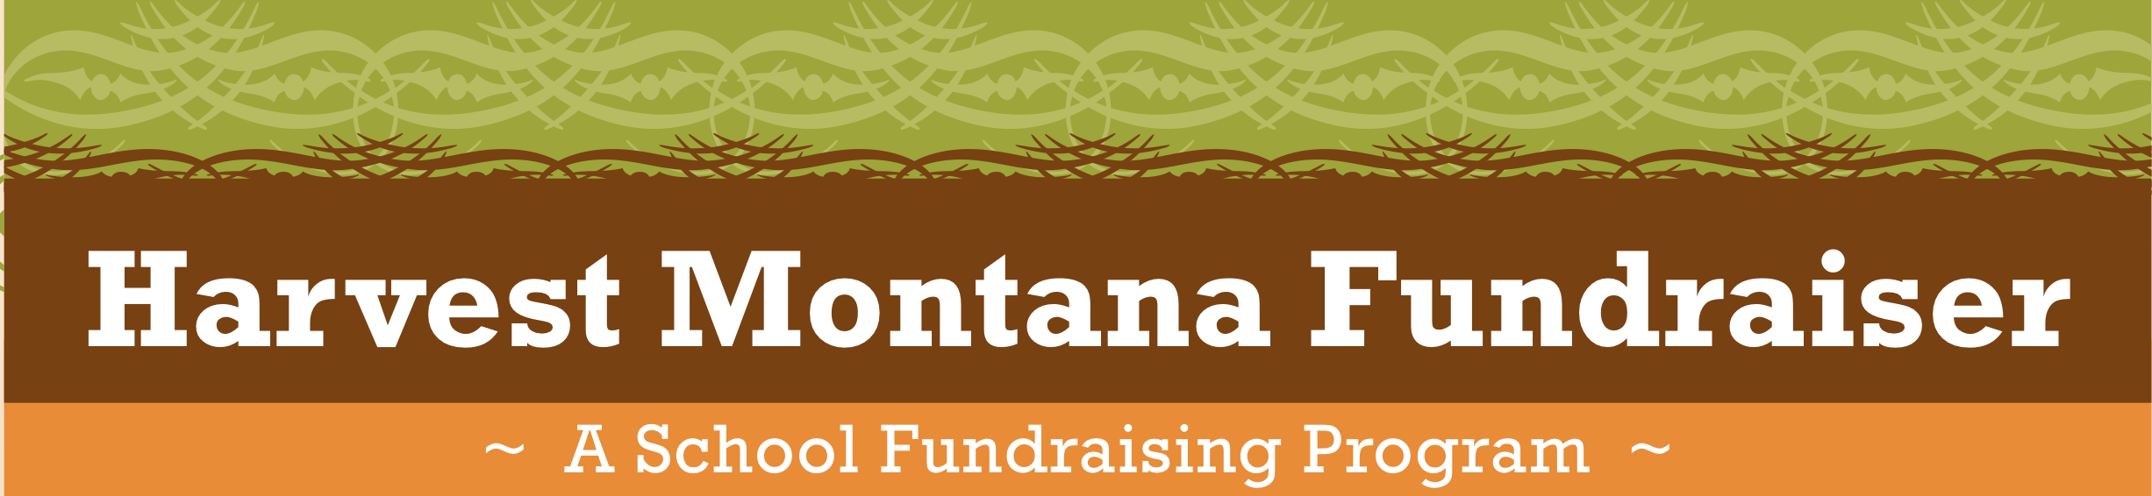
~ Instructions ~

WHY participate in the Harvest Montana Fundraiser:
- Raise money for your school or group.
- Support Montana farmers and food producers.
- Improve the health of children and families.
- Increase awareness and support.

Here are some important things to know before you sell:

- All of the products offered are Made in Montana.
- Collect payment from the customer at the time the order is placed. All checks should be made payable to _____________.
- Turn all order forms into your teacher no later than _________. Be sure to turn in checks with your order form.
- 40% of each item’s price goes to your school or group. The producer receives 50%, and {school name} receives 10% to cover printing and administration costs.
- All items, except the roast will be delivered by you (the seller) to the customer (the buyer) during the week of November 14th.

- Customers who buy the roast will receive a voucher when you deliver their order. The customer can redeem this voucher at the Bozeman Community Co-op store at 908 West Main anytime until January 31st, 2012.

Every student who sells at least one item will be entered in a lottery to win day passes to Bohart Ranch Cross Country Ski Center. In addition, the student who sells the most (dollar amount) of all the participating schools will receive day passes to Bridger Bowl.

Who is {School Name}?

{School/organization description}

October is National Farm to School Month!

What is Farm to School? Farm to School programs across the country connect schools (K-12) and local farms with the objectives of serving healthy meals in school cafeterias; improving student nutrition; providing agriculture, health and nutrition education opportunities; and supporting local and regional farmers. Farm to School programs are based on the belief that students will choose healthier foods if products are fresh, locally grown, and picked at the peak of their flavor and if those choices are reinforced with educational activities.
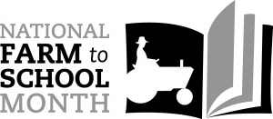
In November 2010, Congress approved a resolution introduced by Representative Rush Holt (NJ) to officially designate October as National Farm to School Month. Its passage demonstrates the growing importance and role of Farm to School programs as a means to improve child nutrition, support local economies and educate children about the origins of food.

Here are some ideas to help you dig in and celebrate!
- Visit your local farmers’ market. Buy something you’ve never tried before, cook it and share with your family and friends. Remember that Bozeman has Winter Farmers Market!
- Host a “harvest feast potluck” with your friends and family and encourage everyone to bring along a dish made with as many local and seasonal ingredients as possible!
- Create an outdoor garden plot or a container garden.

Have any questions?

Contact Information

