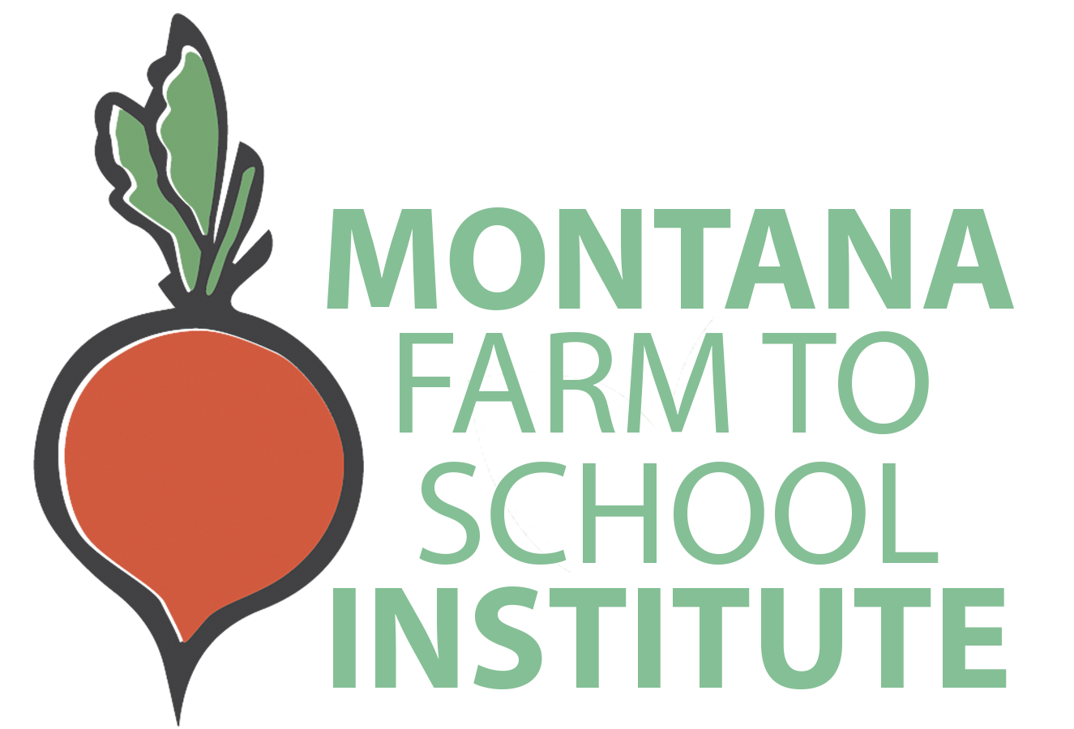
Sponsorship Opportunities

Montana Farm to School Institute
Media Kit

Congratulations on being selected for the Montana Farm to School Institute! As one of three inaugural participating schools, your team will be helping lead this important movement, being among the growing number of Montana communities engaging in farm to school (F2S) activities.
This media kit will help you spread the word about your school’s plans, activities, and your selection for the Montana Farm to School Institute. Publicizing your participation in the Institute through local press and other various communication channels will help build support for your farm, food, education, and nutrition work—now and long-term.
In this kit you’ll find tips for media outreach and social media as well as a press release template. Please use and adapt them as you need!

Announcing Your Selection
Throughout this year, you’ll learn critical skills and practices that will help your students make healthier choices, increase local foods in the cafeteria, and draw innovative connections between classrooms, the cafeteria, and the community. We also want to help you grow your communications capacity which is a critical part of successful programs. Publicity helps keep the community involved and informed, and media coverage demonstrates support for your project—both critical pieces of gaining broad-based community support and securing future funding opportunities.
Consider announcing your good news in the following ways:
- Send a press release to local media outlets (see following template).
- Share the news on Facebook, Twitter, Instagram and/or other social media avenues used by your community.
- Post a message on local listservs.
- Place an announcement in a community or school newsletter.

5 Tips for Getting Press Coverage

Get to Know Your Local Press
Read your local paper and other media outlets to get a sense for what types of stories they cover. Find ways to connect your story to big local issues and themes. Learn your paper’s editorial calendar and find out how far in advance (often three weeks) they need to know about stories or announcements.

Get to Know Local Reporters
Find out who covers the news for your town or school and reach out with an email or phone call. Meet up for coffee and tell reporters about your program or invite them for a tour of the garden and lunch at school. Make yourself available to answer questions.

Offer Great Content
Reach out with great stories or events and include a “hook” to draw in the reader. Share photographs and multimedia. Send copies of posters, fliers, and other materials. Develop an elevator pitch and prepare yourself with great stories about impact and results.

Develop a Media Kit
Make it easy for the media to cover your project by developing a simple media kit. Pull together basic information about your project (include key quotes and stories to illustrate the importance of your program), photographs, logos, and contact information. Have it ready to send out at a moment’s notice or post it online so reporters can find it easily.

Share the Love
Share your news and encourage others to do so. Have students, community members, and project participants write stories or editorials and contact the paper. Tell the world about the coverage you have received! If you get press coverage, please share it with your coach and Aubree Roth so that we can help spread the good word. If you are sharing on Facebook or Instagram, please tag the Montana Farm to School accounts and use the hashtag #MTFarmtoSchool.
@Montanafarmtoschool

@Mtfarmtoschool

Sample Media Verbiage
Feel free to use and edit the sample verbiage to share about your participation in the Montana Farm to School Institute. You are not required to use these templates and we encourage you to personalize your media content. The {red bracketed} text indicates information you should insert about your school. Be sure all the {red bracketed} text is updated before sending or posting. Including photos with your social media posts, announcements, or press releases helps attract attention. Feel free to include the Montana Farm to School Institute logo in your announcements, but please do not alter the logo.

Social Media
Exciting news! We've been selected as a 2022 Montana Farm to School Institute team! Learn more at: https://www.montana.edu/mtfarmtoschool/institute.html #MTFarmtoSchool
We've been selected as a 2022 Montana Farm to School Institute! We are excited to dig in and grow our farm to school projects! Learn more at: https://www.montana.edu/mtfarmtoschool/institute.html #MTFarmtoSchool

Newsletters + Listservs
Subject Line/Title: {School District Name} selected for the first Montana Farm to School Institute

{School District Name} was among three Montana school districts chosen for the first offering of the Montana Farm to School Institute, hosted by Montana Team Nutrition Program at Montana State University, the Montana Office of Public Instruction, and program partners. The Montana Farm to School Institute is a year-long program is intended to ignite, grow, and sustain farm to school action within Montana schools and communities by providing training and support, and facilitating team building and action planning. The three selected teams will develop and implement action plans that encompass goals, activities, and timelines for their farm to school programs at a three day in-person Summer Retreat. Following the retreat, the farm to school team at {School District Name} will work to implement the goals as created in the farm to school action plan. Follow our progress at {where will progress be shared—school social media account, website, etc.}.

Press Release
Contact:
{Name}
{Title}
{Organization}
{Email}
{Phone}

Suggested Title: {School District Name} selected for the first Montana Farm to School Institute

{City, MT - School District Name} was among three Montana school districts chosen for the first offering of the Montana Farm to School Institute, hosted by Montana Team Nutrition Program at Montana State University, the Montana Office of Public Instruction, and program partners. This yearlong program intends to ignite, grow, and sustain farm to school action within Montana schools and communities by providing training and support and by facilitating team building and action planning.
{Add “about us” language about your school and a quote from a farm to school team member, principal, administrator, student, or parent}
This program will kick off with a three-day Summer Retreat, where the three school district teams will develop one-year farm to school action plans to be implemented during the 2022-2023 school year. Action plans will encompass goals, activities, roles, and timelines focused on the three core elements of farm to school: local procurement, education, and school gardens/farms. Each team will be assigned a Farm to School Coach who will support the team with development and implementation of the action plan.
The Farm to School Institute model was developed by Vermont FEED using evidence-based best practices in professional learning. The Montana Farm to School Institute is supported by the Food and Nutrition Service, U.S. Department of Agriculture, Farm to School Grant awarded to Montana Office of Public Instruction and by program sponsors.
For more information about the Montana Farm to School Institute, visit: https://www.montana.edu/mtfarmtoschool/institute.html
-end-

