Program Assessment Overview

November 14, 2011, R. W. Larsen
Updated November 14, 2017 R.E. Anderson

Assessment is good educational practice because it demonstrates what you are already doing, improving your program through continual monitoring of student learning. Although part of the accreditation process, the ability to demonstrate continued quality improvement and the utilization of assessment outcomes for planning and budget is critical to a healthy program. The process is also part of the NWCCU’s Accreditation Process.
Standard Four – Effectiveness and Improvement:
4.A.3 The institution documents, through an effective, regular, and comprehensive system of assessment of student
achievement, that students who complete its educational courses, programs, and degrees, wherever offered and however delivered, achieve identified course, program, and degree learning outcomes. Faculty with teaching responsibilities are responsible for evaluating student achievement of clearly identified learning outcomes.
4.B.2 The institution uses the results of its assessment of student learning to inform academic and learning‐support
planning and practices that lead to enhancement of student learning achievements. Results of student learning assessments are made available to appropriate constituencies in a timely manner.

The assessment process requires the participation of all instructional faculty members, and with a well designed assessment process not only is the time well spent, the information gathered is valuable and (even more important) useful to faculty. The purpose of this document is to provide an overview of the assessment process. The basic assessment process for a degree program is diagrammed below:
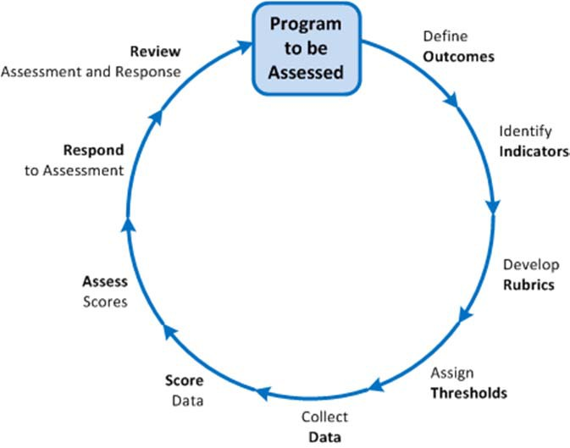

The process is designed around continuous improvement, and is based on an annual cycle (although not all outcomes need to be assessed every year). An ideal cycle is to parallel the program review, which is on a seven year cycle for most programs. The information gathered yearly in program assessment should culminate in the information required for program review. Consequently, annual assessment should be seen as documentation to make the process of program review more effective.

Learning outcomes can be written for a course, a program, or an institution. This document focuses specifically on learning outcomes for programs (e.g., degree programs). In many cases, these are easier to write than course learning outcomes, because they are typically less specific. However, well-designed outcomes should relate to each other.

Course Level – “Demonstrate an understanding of social psychology theories from a sociological perspective”
Program Level – “Sociological Concepts. Our students will demonstrate a knowledge, comprehension, and relevance of core sociological concepts.”
Institutional Level (General Education) – “Develop a critical appreciation of the ways in which we gain and apply knowledge and understanding of the universe, of society, and of ourselves.”

We don’t typically map our learning outcomes all the way up to Institutional Level (although programs that include Core courses may benefit from this activity). However, mapping course outcomes into program outcomes can be valuable in designing and evaluating outcomes.

Steps in the Assessment Process

Define Desired Program Learning Outcomes
At the program level, learning outcomes should be written as simple declarative statements. Overly complex or convoluted statements become very difficult to assess. Ideally, PLO’s should not exceed five (although some programs have external accreditation requirements that set the PLO’s). Also, the PLO’s should be program specific, general outcomes are covered in CORE 2.0 Assessment.
Program Learning outcomes are the characteristics or skills that each student is expected to acquire by completion of their educational program.

Focus on Student Learning

By starting program learning outcomes with phrases such as “students completing our program will” you help ensure that the focus is on student learning and abilities defined by the program.

PLO’s should focus on the expected capabilities of the students upon successful completion of the program (hence the “will” in the starter phrase), not on the actual performance determined at the end of the program.
Because PLO’s are much broader in scope than course outcomes, a common set of outcomes will include:

- An outcome related to having the requisite knowledge for a program, or related function of a professional in the program.
- An outcome related to critical thinking and higher‐lever cognitive skills as it pertains to use within the program.
- An outcome related to the ability communicate within the vernacular of the program.
- An outcome related to ethical decision making.

While programs are certainly not required to use these outcomes, they are very common in some form. You will notice that all of these outcomes can be assessed even in lower level classes, with possibility the exception of #1.
If this set were used, the program outcomes might be written as:
Students completing our program will
1) be able to analyze problems in their field and develop solutions or strategies to solve those problems.
2) be able to communicate effectively and accurately within the vernacular of the program.
3) be able to apply the discipline’s code of ethics when making decisions.
4) be able to design an experiment and analyze data.

The goal is to keep the number of program outcomes to a workable number, they have to be fairly general, but still pertinent to the program. The specificity comes during the assessment process, because the components of each outcome can be assessed separately.

Identify Indicators of Student Achievement
There are many was to define your indicators. Utilization of senior level or capstone classes is certainly one possibility. However, if only “mastery” level classes are assessed, are you really getting a full picture of program assessment?
Note: By choosing indicators primarily from upper‐division courses, you are focusing more on what the students have learned (somewhere), rather than on what is covered in a particular course.
By assessing classes that demonstrate “Introductory”, “Discovery” and “Mastery” levels, a program may better identify possible concerns in their curriculum pathways.

- Develop Scoring Rubrics (when needed)
Scoring rubrics are used to identify desired characteristics in student examples, and assign numerical scores to the indicators. For example, common characteristics associated with written communications include organization, clarity, grammar, and punctuation. The grammar and punctuation category might have the following options:
  - Unacceptable (0) – Five or more grammar or punctuation errors per page.
  - Marginal (1) – Three or four grammar or punctuation errors per page.
  - Acceptable (2) – One or two grammar or punctuation errors per page.
  - Exceptional (3) – Very few grammar or punctuation errors in the report.
OR
- Unacceptable (0) – Five or more grammar or punctuation errors per page.
- Introductory (1) – Three or four grammar or punctuation errors per page.
- Developing (2) – One or two grammar or punctuation errors per page.
- Mastery (3) – Very few grammar or punctuation errors in the report.

When developing the scoring rubrics, it is important to consider the skill level that you expect your students to achieve in your program. Typically, students completing college programs should have attained a high level of performance in most of the program learning outcomes. That is, they should have a well‐developed cognitive skill level in most areas.

To think about cognitive skill level, consider this abbreviated table of (old) Bloom Taxonomy1 verbs:
 | I: Introductory Level |  |  |  | D: Developing Level |  |  |  | M: Mastery Level
 | Knowledge | Comprehension |  |  | Application | Analysis |  |  | Synthesis | Evaluation
 | defines | comprehends |  |  | applies | analyzes |  |  | categorizes | concludes
 | describes | distinguishes |  |  | computes | compares |  |  | composes | critiques
 | identifies | interprets |  |  | demonstrates | contrasts |  |  | creates | defends
 | knows | summarizes |  |  | prepares | distinguishes |  |  | devises | evaluates
 | lists |  |  |  | solves |  |  |  | designs | interprets
 | recognizes |  |  |  |  |  |  |  | modifies | justifies
Note: “Mastery” implies a level considered proficient at time of graduation.
1 Bloom, B. S., Engelhart, M. D., Furst, E. J., Hill, W. H., & Krathwohl, D. R. (1956). Taxonomy of educational
objectives: the classification of educational goals; Handbook I: Cognitive Domain New York, Longmans, Green, 1956.

Using the example above, students in introductory level freshman courses should be obtaining a level 1 to 2, whereas sophomore level students should be at 2 to 3, and junior and senior classes should be at 3 to 4. The way you demonstrate that students have the appropriate level skills is using the verbs in your scoring rubrics.

Assign Response Thresholds
Each program learning outcome will need to be assigned a threshold. The design of the threshold will depend on the nature of the rubric.
Common response thresholds might be: “80% of students will answer the embedded assessment question correctly” or “Students will demonstrate an average score of 2 on all learning outcomes”

The development of an effective threshold may take some adjustments, but should reflect the appropriate level of learning for all assessed courses.

5. Collect Student Performance Data
The indicators are typically related to:
  - Examples of student work from courses
  - Standardized questions embedded in examinations
  - Results of pre‐ and post‐testing
  - Performance data on professional examinations
Remember: Summative results such as scores on exams or course grades are not used as assessment indicators – but results on a specific question or small set of questions may be used.

6. Score the Data Using Rubrics
It is recommended to make use of samples of student work to control the time required to score the data. However, in small sized classes the whole class may be assessed. Population or unbiased sample of collected assignments are scored by at least two faculty members using scoring rubrics.
The faculty member that collects the samples of student work (from his or her course) should not also do the scoring. Other faculty members (or other qualified individuals) should score the student samples.

7. Assess the Scores
Scores are presented at a program/unit faculty meeting for assessment. Faculty will then review the assessment results, and respond accordingly. For example:
- If an acceptable performance threshold has not been met, possible responses:
    - Gather additional data to verify or refute the result.
    - Change something in the curriculum to try to address the problem
    - Change the acceptable performance threshold, reassess
    - Choose a different assignment to assess the outcome
  - If acceptable performance threshold has been met, possible responses:
    - Faculty may reconsider thresholds
    - Evaluate the rubric to assure outcomes meet student skill level (example – classes with differing learning outcomes based on student level)
    - Use Bloom’s Taxonomy to evaluate learning outcomes

Respond to the Assessment

In the next assessment cycle, demonstrate the impact of the assessment response. These reports are ongoing, they will reflect what has been done, and what will be done – ultimately showing progressive and continued improvement.

Review the Assessment and Response
These reports will be submitted annually to the Program Assessment and Outcomes Committee, which will review the faculty’s assessments and responses. The Assessment and Outcomes Committee leads and facilitates authentic assessment for all undergraduate and graduate degree programs. The committee reviews Annual Program Assessments that provide the strong foundation upon which Montana State University develops, identifies, and documents quality improvement plans and goals including providing the institutional reporting associated with the strategic planning objectives.

