CITI On-Line Responsible Conduct of Research (RCR) Course

MSU “Research” http://www.montana.edu/research/RCC/rcc%20index.html
- Research Compliance
  - CITI (RH Column) https://www.citiprogram.org/
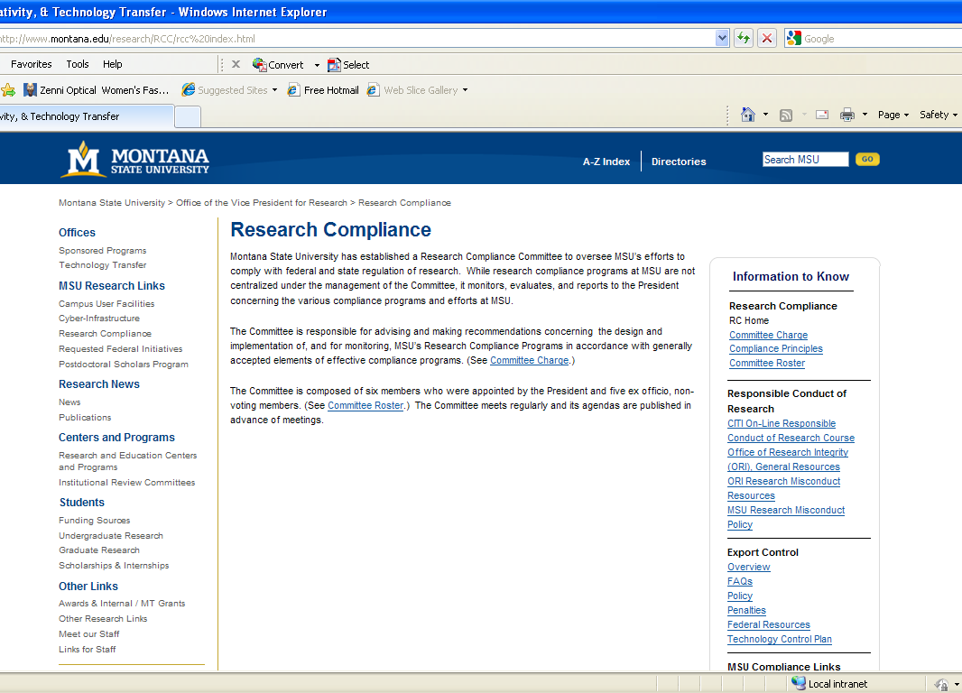

Responsible Conduct of Research (RCR) courses include:
- Research Misconduct
- Data Management
- Conflict of Interest
- Collaborative Science
- Responsible Authorship
- Mentoring
- Peer Review
- Lab Animals, and
- Human Subjects

Click on “New Users: Register Here”
- Choose your institutional affiliation
- Create your user name and password
- Create your security question and answer
- Enter your first and last name
- Enter your email address
- Answer CME/CEU credit request
- Course survey contact question.
- “SUBMIT”
Answer “CITI Course Enrollment Questions” about your research focus or research role so that the software will present you with the appropriate customized curriculum.
After you select the curriculum the software will present you with the “Learners Main Menu”
You will then “Click on this Grade book link to enter the course”.
The modules will then be displayed.

Complete The Integrity Assurance Statement before beginning the course. This attests that you are the individual taking the courses and then activates the links to the courses.
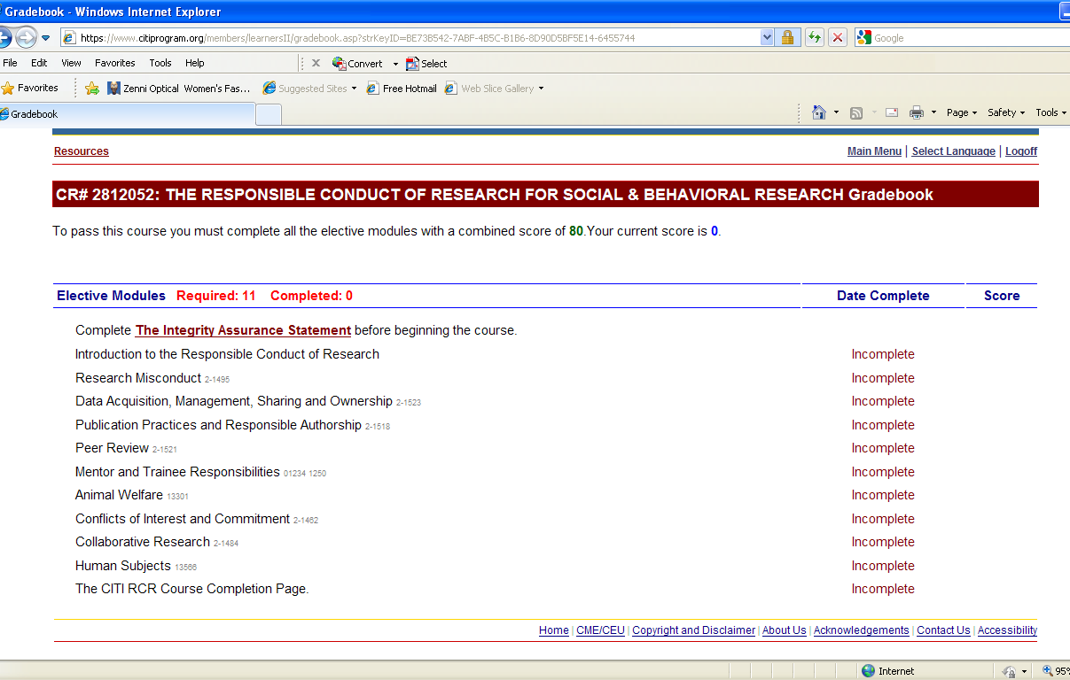

Each module typically contains:
- Intro
- Foundational Information/Learning Objectives
- Case Study
- Government Regulations
- Institutional Policies
- Personal Responsibility
- Questions for Discussion and Resources
- “Take the Quiz”
