About Filtering
Filtering is a quick and easy way to find and work with a subset of data in a list. A filtered list displays only the rows that meet the criteria you specify for a column. Microsoft Excel provides two commands for filtering lists:
- AutoFilter, which includes filter by selection, for simple criteria
- Advanced Filter, for more complex criteria
Unlike sorting, filtering does not rearrange a list. Filtering temporarily hides rows you do not want displayed.
When Excel filters rows, you can edit, format, chart, and print your list subset without rearranging or moving it.
AutoFilter
When you use the AutoFilter command, AutoFilter arrows appear to the right of the column labels in the filtered list.
Microsoft Excel indicates the filtered items with blue.
You use custom AutoFilter to display rows that contain either one value or another. You can also use custom AutoFilter to display rows that meet more than one condition for a column; for example, you might display rows that contain values within a specific range.
Advanced Filter
The Advanced Filter command can filter a list in place like the AutoFilter command, but it does not display drop-down lists for the columns. Instead, you type the criteria you want to filter by in a separate criteria range above the list. A criteria range allows for more complex criteria to be filtered.
Note: When evaluating data, Microsoft Excel does not distinguish between uppercase and lowercase characters.

Filter a list
You can apply filters to several lists on a worksheet at a time. Keep in mind, if you turn on a filter in a particular column, if you do a second filter, it will filter only the data that remains from your first filter. For example, on the list below, if you filter on Orgn Number for 415300, then if you do an additional filter on Agency (i.e., MDOT), then the agency will only done on the agency MDOT that also is within the Orgn number
- Click a cell in the list you want to filter.
- On the Data menu, point to Filter, and then click AutoFilter.
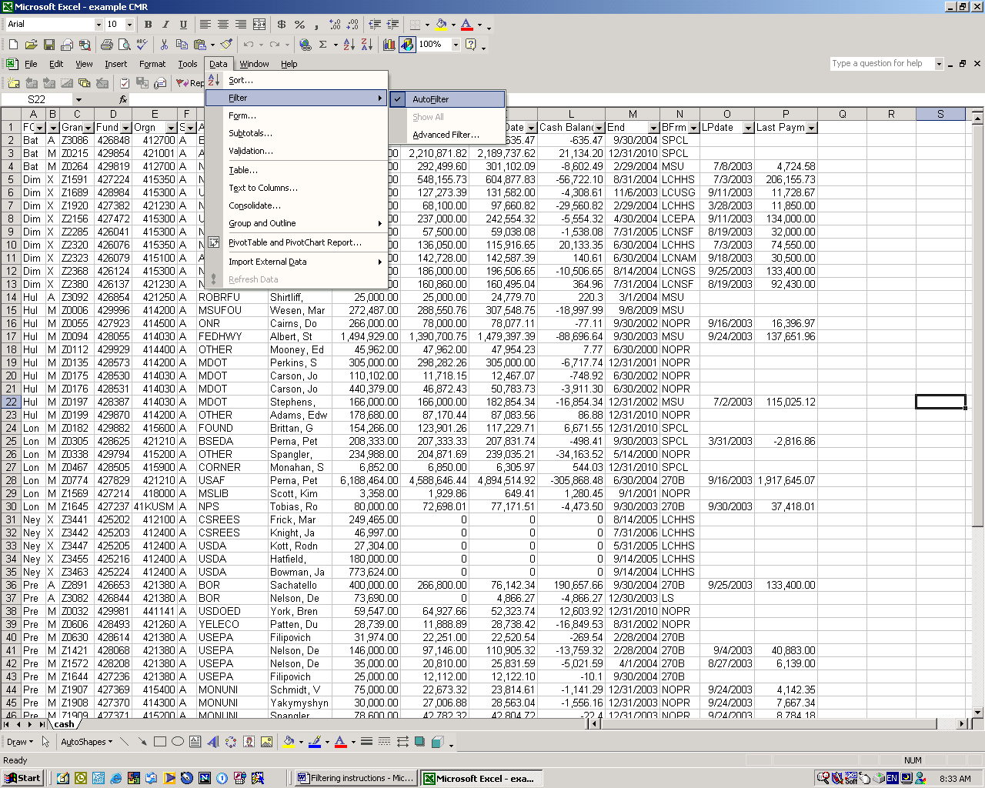

To Filter a list for rows that contain specific text
- Use the drop down menu to choose the value you want (i.e., all grants for Dickensheets).
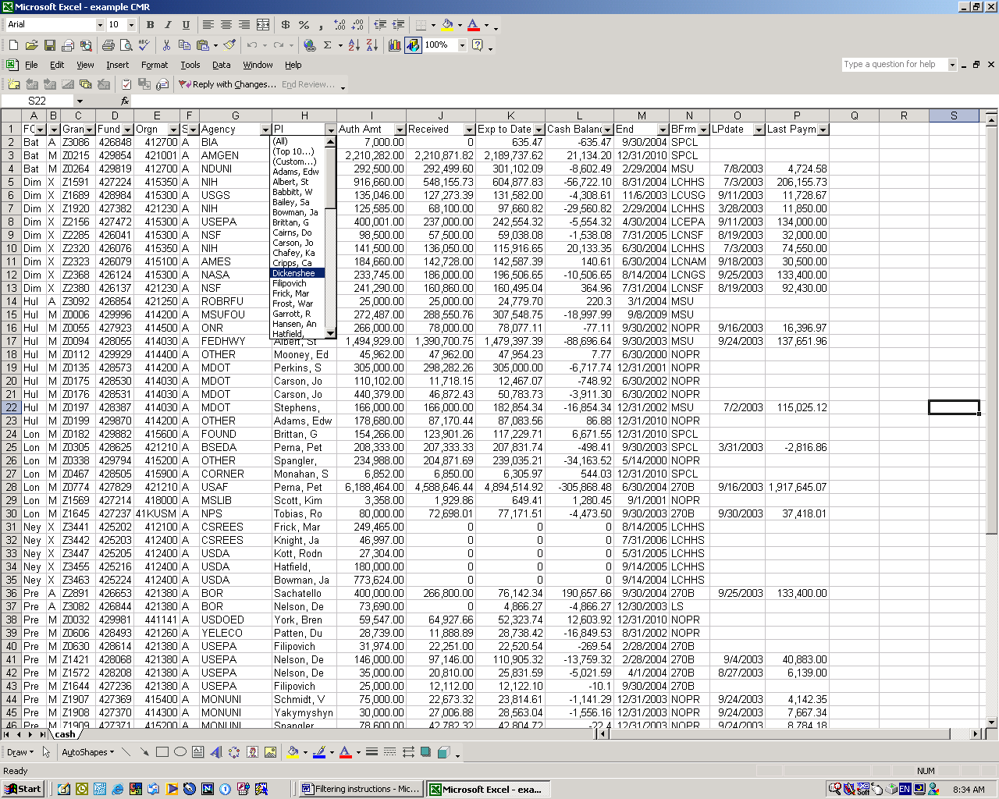

You can filter any of the columns. An example when this would be useful: searching the Cash Management Report by Fiscal Manager, Principal Investigator, Agency, Organization Number, Grant Number, and Bill Format Type.
Once filtered, if you highlight a column (i.e., cash balance), it will give you a summation for the item you have filtered. In the example following, this is filtered on all the grants for a particular Fiscal Manger, then highlighted the cash balance column, you can quickly see what is the total cash balance for that Fiscal Manager.
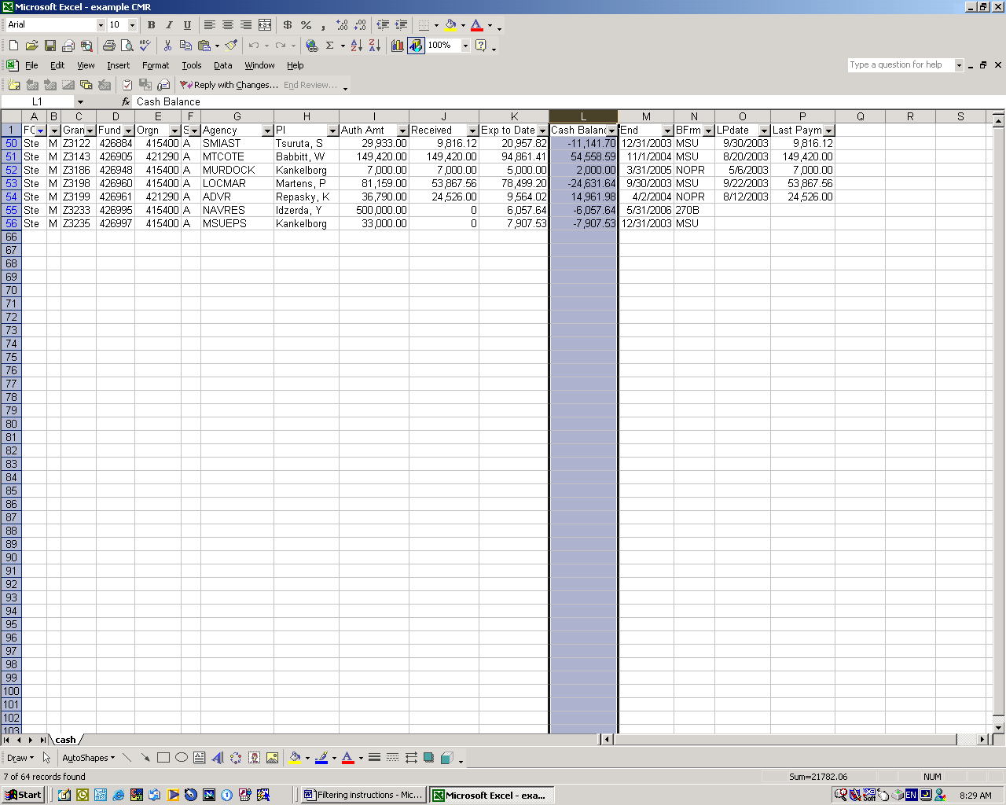

You can also use the custom feature to do a more sophisticated search.
  - Click the arrow in the column that contains the numbers, and click (Custom).
  - In the box on the left, click equals, or does not equal, contains, or does not contain.
  - In the box on the right, enter the text you want.
  - If you need to find text values that share some characters but not others, use a wildcard character.
  - To add another criteria, click And or Or, and repeat the previous step.
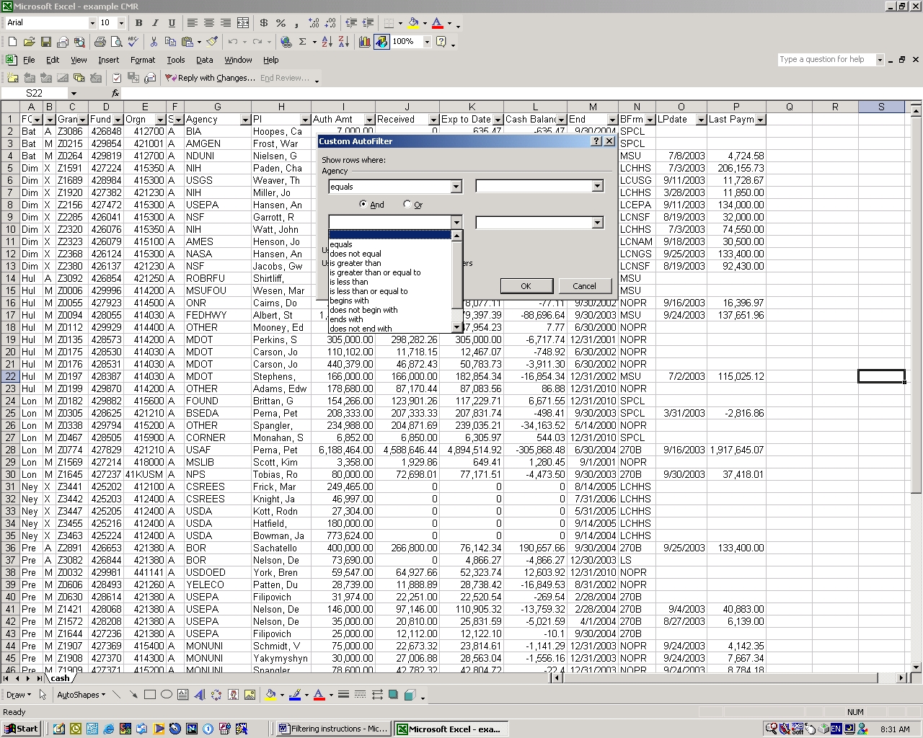

The following wildcard characters can be used as comparison for filters, and when searching and replacing content.
Use | To find
? (question mark) | Any single character  For example, sm?th finds "smith" and "smyth"
* (asterisk) | Any number of characters  For example, *east finds "Northeast" and "Southeast"
~ (tilde) followed by ?, *, or ~ | A question mark, asterisk, or tilde

Filter for blank or nonblank cells
Click the arrow in the column that contains the numbers, then click (Blanks) or (NonBlanks).
Note: The Blanks and NonBlanks options are available only if the column you want to filter contains a blank cell.

Sorting list
Sort rows in ascending order (A to Z, or 0 to 9) or descending order (Z to A, or 9 to 0)
- Click a cell in the column you would like to sort by.
- Click the shortcut key Sort Ascending or Sort Descending or choose Data/Sort.
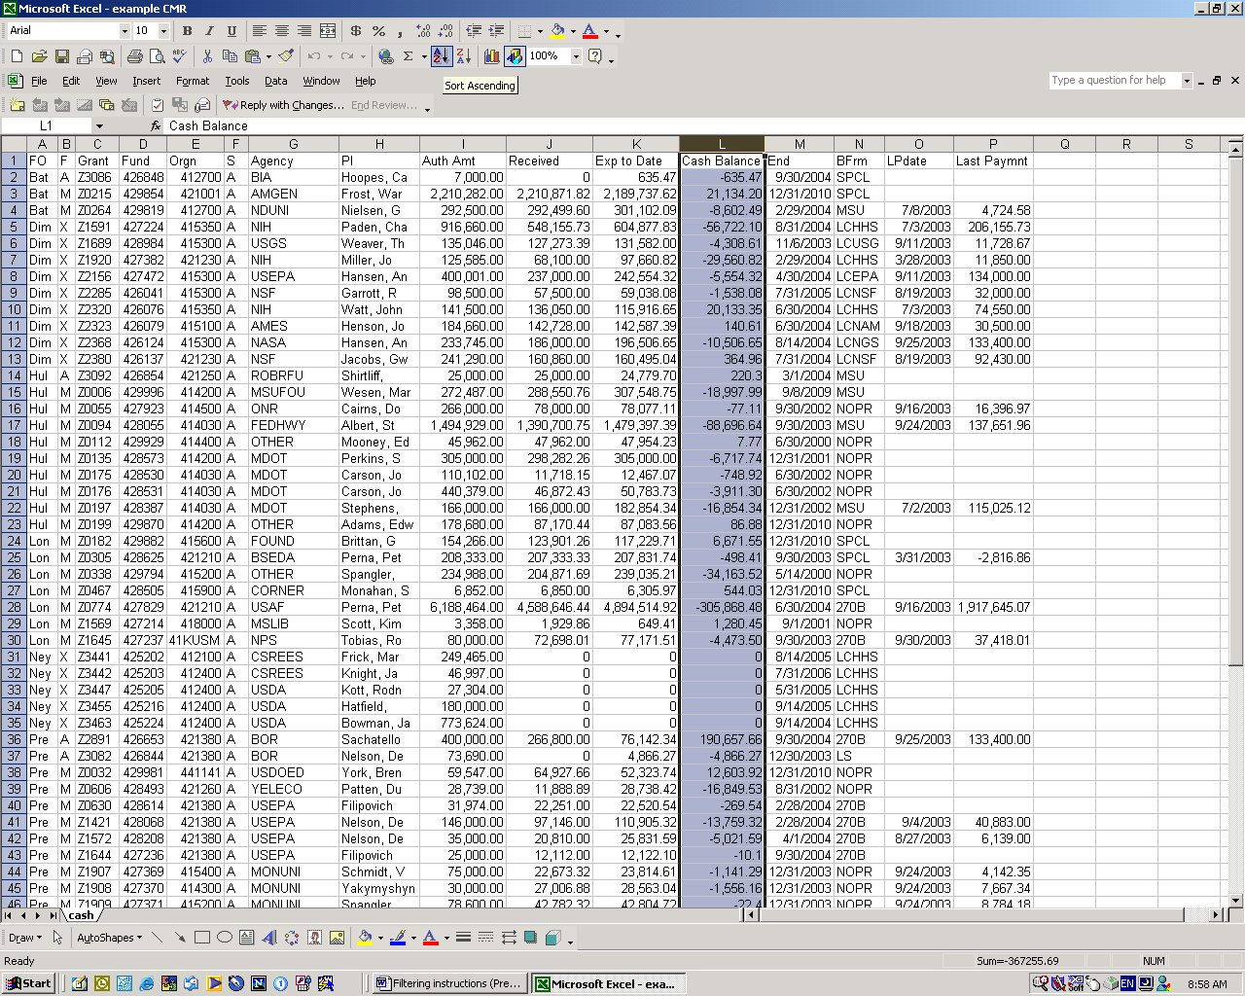

Caution: if you receive the following message, choose expand the selection, otherwise you will only sort the column and the rest of the rows will remain unsorted.
