|  |
| --- |
| Creating a Culture of Service Excellence |
| MANAGER’S TOOL KIT |
|  |
|  |
|  |

Based on the materials in *Unleashing Excellence - The Complete Guide to Ultimate Customer Service*

For Internal Use Only

## Introduction

Greetings and welcome to the OpenMSU Service Excellence initiative at Montana State University. This Manager’s Tool Kit has been prepared for you to assist in the implementation of Service Excellence in your department or unit at MSU.

During the month of March 2014, Directors and Department Heads attended a full-day workshop on Service Excellence as leaders identified to drive the implementation of this initiative. This tool kit will provide some ideas and templates for ways you can incorporate Service Excellence. Each department or unit at MSU has unique characteristics and “no one size fits all” in terms of how to incorporate these ideas. You know your departments best. Involve your staff in identifying ways to achieve excellence.

Please invite us to one of your meetings. We are happy to go over the history and progress of this OpenMSU initiative. We can work with you to facilitate a discussion of ways to start with your own specific implementation and share examples of what other departments are doing on campus. Service Excellence should be a journey, not a destination, and it can be fun for you and your staff.

Best wishes in your journey to “enrich lives by building a supportive environment that inspires excellence in everything we do.”

____________________________ _________________________

Laura Humberger, Co-Chair Betsy Webb, Co-Chair  
Service Excellence Team Service Excellence Team

## TABLE OF CONTENTS

MANAGER’S TOOL KIT 1

Introduction 2

TABLE OF CONTENTS 3

MSU Service Excellence Team 6

Leadership Actions to Create and Sustain a Culture of Service Excellence 7

Service Excellence Staff Workshops 8

Service Map Example 9

Everything Speaks Checklist Example 11

Service Map 12

"Everything Speaks" Checklist 14

“Regular” Meetings and Service Excellence Integration 15

Continuous Service Improvement Meeting 16

Service Excellence – Language and Phrases 17

Three Steps to Coaching: 18

Performance Assessment Strategies: 19

Six Steps to Counseling: 20

Service Opportunity System 21

Recognition of Employees in Service Excellence 22

*“People will forget what you said, people will forget what you did, but people will never forget how you made them* [*feel*](http://en.wikiquote.org/wiki/Feel)*.”*

Maya Angelou from Wouldn't Take Nothing for My Journey Now (1993) p. 12

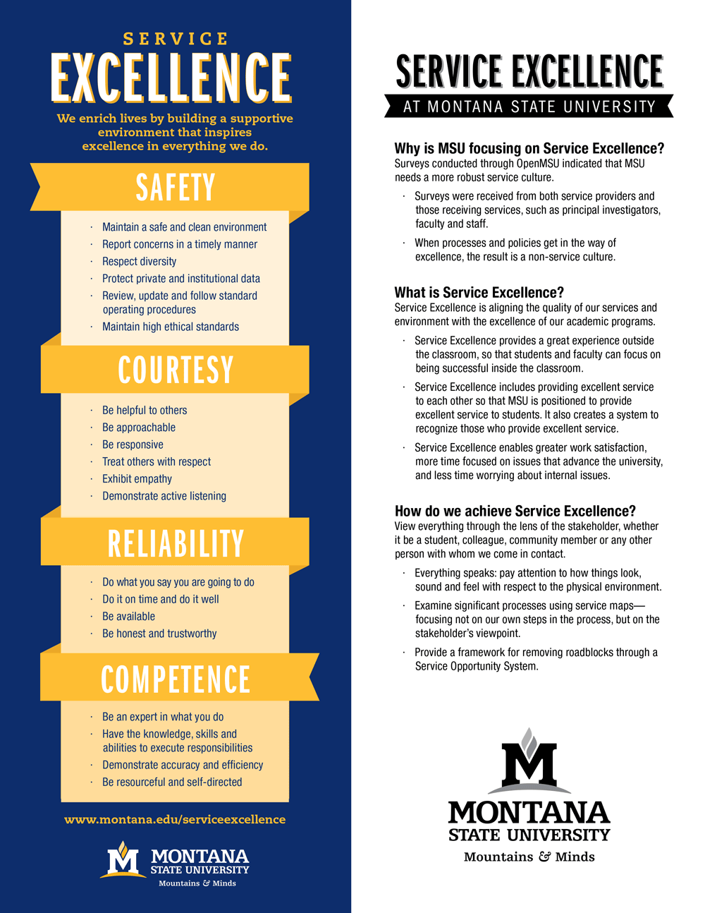

## MSU Service Excellence Team

|  |  |  |  |
| --- | --- | --- | --- |
| Chair | Laura Humberger | [LHumberger@Montana.edu](mailto:LHumberger@Montana.edu) | 994-4361 |
| Chair | Betsy Webb | [Elizabeth.Webb@Montana.edu](mailto:Elizabeth.Webb@Montana.edu) | 994-4275 |
| Service Excellence Administrator | Trevor Hildebrand | [ServiceExcellence@Montana.edu](mailto:ServiceExcellence@Montana.edu) | 994-7760 |
| Accountability | Kregg Aytes | [Kregg.Aytes@Montana.edu](mailto:Kregg.Aytes@Montana.edu) | 994-4423 |
| Communications | Anne Cantrell | [Anne.Cantrell@Montana.edu](mailto:Anne.Cantrell@Montana.edu) | 994-4902 |
| Everything Speaks | Jeff Butler | [JButler@Montana.edu](mailto:JButler@Montana.edu) | 994-7901 |
| Measurement | Ian Godwin | [IGodwin@Montana.edu](mailto:IGodwin@Montana.edu) | 994-2677 |
| Onboarding &  Training | Cathy Hasenpflug  Betsy Webb | [Catherine.Hasenpflug@Montana.edu](mailto:Catherine.Hasenpflug@Montana.edu)  [Elizabeth.Webb@Montana.edu](mailto:Elizabeth.Webb@Montana.edu) | 994-4284  994-4275 |
| Recognition | Becky McMillan | [BMcMillan@Montana.edu](mailto:BMcMillan@Montana.edu) | 994-6093 |
| Recruitment | Tricia Wimbish | [Tricia.Wimbish@Montana.edu](mailto:Tricia.Wimbish@Montana.edu) | 994-5527 |
| Service Opportunity System | Matt Caires  Justin van Almelo | [MCaires@Montana.edu](mailto:MCaires@Montana.edu)  [Justin.vanAlmelo@Montana.edu](mailto:Justin.vanAlmelo@Montana.edu) | 994-2826  994-7464 |
| General Information |  | [www.montana.edu/servicexcellence](http://www.montana.edu/servicexcellence)  [ServiceExcellence@Montana.edu](mailto:ServiceExcellence@Montana.edu) | 994-7760 |
|  |  |  | |

## Leadership Actions to Create and Sustain a Culture of Service Excellence

#### MSU Service Philosophy and Standards

“We enrich lives by building a supportive environment that inspires excellence in everything we do.”

Safety – Courtesy – Reliability – Competence

Communications ***–*** *Anne Cantrell –* [*Anne.Cantrell@Montana.edu*](mailto:Anne.Cantrell@Montana.edu) *– x4902*

Communicates through a multitude of avenues to Faculty and Staff the impact they have in creating satisfied, happy, loyal students and stakeholders. Shares success stories and best practices from throughout the University.

Accountability *– Kregg Aytes –* [*Kregg.Aytes@Montana.edu*](mailto:Kregg.Aytes@Montana.edu) *– x4423*

Develops and Implements mechanisms to ensure day-to-day use of our Service Standards and our Service Philosophy.

### **Everything Speaks** *– Jeff Butler –* [*JButler@Montana.edu*](mailto:JButler@Montana.edu) *– x7901*

Raises the awareness of the impact of the physical environment on the perception of our service. Uses a perspective of looking through the lens of the user of the process to identify more fluid and effective avenues to achieve the same, or better, outcome.

Measurement ***–*** *Ian Godwin –* [*IGodwin@Montana.edu*](mailto:IGodwin@Montana.edu) *– x2677*

Measures the current and past satisfaction data allowing for identification of opportunities to improve our processes and systems to meet and exceed objectives, both in local departments as well as globally across campus. Works with Communications to display this information in an easy to interpret and visually diverse way to disseminate the data.

Onboarding and Training*– Betsy Webb –* [*Elizabeth.Webb@Montana.edu*](mailto:Elizabeth.Webb@Montana.edu) *- x4275*

*Cathy Hasenpflug –* [*Catherine.Hasenpflug@Montana.edu*](mailto:Catherine.Hasenpflug@Montana.edu) *– x4284*

Leads the effort to build Service Excellence into every training opportunity for new and current Faculty, Staff and Employees. All training is tied back to our Service Philosophy or one of the Service Standards showing continuity of excellence in everything we do, providing better processes service to everyone.

Recognition*– Becky McMillan –* [*BMcMillan@Montana.edu*](mailto:BMcMillan@Montana.edu) *– x6093*

Creates recognition opportunities for individuals and groups that demonstrate our Service Standards and Service Philosophy.

Recruitment*– Tricia Wimbish –* [*Tricia.Wimbish@Montana.edu*](mailto:Tricia.Wimbish@Montana.edu) *– x5527*

Develops and maintains processes to locate and hire service-oriented personnel. Interview questions are tied back to the service standard and philosophy, and descriptions of the position are listed and described to communicate our service based culture.

Service Opportunity System ***-*** *Matt Caires –* [*MCaires@Montana.edu*](mailto:MCaires@Montana.edu) *– x 2826*

*Justin van Almelo –* [*Justin.vanAlmelo@Montana.edu*](mailto:Justin.vanAlmelo@Montana.edu) *x 7464*

Captures service opportunity improvements through a developed system to identify, resolve, and communicate these opportunities.

## Service Excellence Staff Workshops

**What**:

Workshops provided for every employee at Montana State University as part of the OpenMSU Service Excellence initiative.

**Workshop objectives:**

* Introduce and explain the MSU Service Philosophy and Service Standards
* Practice techniques and tools to improve service
* Reinforce each individual employee’s role in delivering Service Excellence
* Learn a common language of Service Excellence

**Workshop content:**

* What’s happened so far
* Why do customers leave?
* Service Philosophy
* Internal Service and Teamwork
* The Service Experience
* Lens of the Student/Stakeholder
* “Everything speaks”
* Create a wow
* Active listening
* Service Maps
* “Easy to do business”
* Service Standards – Safety, Courtesy, Reliability, Competence
* Summary and next steps

**How long**:

Three hours in length, offered in the morning or afternoon, or by shift as necessary.

**How to schedule**:

Contact Betsy Webb at 994-4275 or [Elizabeth.Webb@Montana.edu](mailto:Elizabeth.Webb@Montana.edu) to schedule a workshop in your department or to learn about open enrollment workshops available.

**How many can attend a workshop?**

Capacity for the workshops is 24 participants.

**Who provides the workshops?**

15 MSU employees have been certified to facilitate the workshops. For a list of facilitators, please contact Betsy Webb [Elizabeth.Webb@Montana.edu](mailto:Elizabeth.Webb@Montana.edu) or Trevor Hildebrand [ServiceExcellence@Montana.edu](mailto:ServiceExcellence@Montana.edu).

**Open enrollment workshops**:

Open enrollment workshops will also be offered. The workshops will be posted to the Service Excellence website.

## Service Map Example

Process Analyzed: Attend a Safety Training

Step 1: Describe each step of the process through the “lens of the student/stakeholder.”

**3**

**2**

**1**

The employee calls or emails Safety and Risk Management to locate training records and options.

The employee searches through personal records to see if training has already been completed.

The employee is told by supervisor that he/she needs to take safety related training.

The …

The …

The …

**6**

**5**

**4**

The employee attends training and receives completion email.

The employee goes to registration site and registers for the course.

The employee is told which trainings he/she needs and if he/she has completed them.

**9**

**8**

**7**

Step 2: For each block identified in step 1, describe what would be considered mediocre service and what would be considered excellent service.

|  |  |  |
| --- | --- | --- |
| Block  Number | Mediocre  Service | Excellent  Service |
| *1* | *Supervisor tells employee that he/she needs to take some training – find out which* | *Contact Safety and Risk Management at 994-7760 to identify trainings you need to take and go ahead and register for them. Trainings I know you need and I want you to take are… They also have all of the information on their website if you would like to do this electronically.* |
| *2/3/4/5* | *Employee has to look through various emails and record locations* | *Employee has access to central record system with University username and password, to enter new job function which will automatically populate training schedule and can display training history.* |
| *7* | *Process repeats* | *Central record system automatically emails when refresher course is needed.* |

Step 3: Choose one or two of the steps to focus on improving first, then move on to other steps that are determined to be areas of opportunity.

## Everything Speaks Checklist Example

**Date:**

**Conducted by:**

### Area:

|  |  |  |  |
| --- | --- | --- | --- |
| **Item** | **Satisfactory** | **Unsatisfactory** | **Action** |
|  |  |  |  |
|  |  |  |  |
|  |  |  |  |
|  |  |  |  |
|  |  |  |  |

**Additional Comments:**

### Area:

|  |  |  |  |
| --- | --- | --- | --- |
| **Item** | **Satisfactory** | **Unsatisfactory** | **Action** |
|  |  |  |  |
|  |  |  |  |
|  |  |  |  |
|  |  |  |  |
|  |  |  |  |

**Additional Comments:**

## Service Map

Process Analyzed: _____________________

Step 1: Describe each step of the process through the “lens of the student/stakeholder.”

**3**

**2**

**1**

The …

The …

The …

The …

The …

The …

The …

The …

The …

**6**

**5**

**4**

**9**

**8**

**7**

Step 2: For each block identified in step 1, describe what would be considered mediocre service and what would be considered excellent service.

|  |  |  |
| --- | --- | --- |
| Block  Number | Mediocre  Service | Excellent  Service |
|  |  |  |
|  |  |  |
|  |  |  |
|  |  |  |
|  |  |  |
|  |  |  |
|  |  |  |
|  |  |  |
|  |  |  |

Step 3: Choose one or two of the steps to focus on improving first, then move on to other steps that are determined to be areas of opportunity.

## "Everything Speaks" Checklist

**Date:**

**Conducted by:**

### Area:

|  |  |  |  |
| --- | --- | --- | --- |
| **Item** | **Satisfactory** | **Unsatisfactory** | **Action** |
|  |  |  |  |
|  |  |  |  |
|  |  |  |  |
|  |  |  |  |
|  |  |  |  |

**Additional Comments:**

### Area:

|  |  |  |  |
| --- | --- | --- | --- |
| **Item** | **Satisfactory** | **Unsatisfactory** | **Action** |
|  |  |  |  |
|  |  |  |  |
|  |  |  |  |
|  |  |  |  |
|  |  |  |  |

**Additional Comments:**

## “Regular” Meetings and Service Excellence Integration

* At weekly or monthly meeting with your teams, choose one of the four service standards (safety, courtesy, reliability, competence) and ask for examples of how these standards are being applied in the day-to-day settings of your unit’s positions. Ask for specific examples and recognize the staff that are performing the service excellence examples.
* If any of your employees has been recognized with a “Random Acts of Excellence” card, share the good news with the rest of your team in a meeting.
* Revisit the MSU Service Excellence Philosophy, “We enrich lives by building a supportive environment that inspires excellence in everything we do.” How do employees enrich lives? How are you building a supportive environment? What are you doing that inspires excellence in everything we do? Ask staff for specific examples and recognize those who are doing excellent work.
* Ask employees about ways they are providing service excellence, what examples do they see?
* If you have received feedback from any stakeholders (internal or external), share the feedback in regular meetings.
* If you would like to do any skill building or training in your meetings, invite an expert to your meetings to provide enhanced competence to the work you are performing.
* Ask staff members for their creative ways to incorporate Service Excellence into your regular team meetings.

## Continuous Service Improvement Meeting

1. Put employees at ease by holding the meeting in a distraction-free environment. Silence pagers, phones, etc.
2. State the purpose of the discussion: To identify obstacles that get in the way of delivering exceptional student/stakeholder service.
3. Re-emphasize that continuous improvement is not directed at blaming people, but at improving processes.
4. Establish a cooperative environment at the meeting, following the rules for successful brainstorming:

* Title flipchart: “What gets in the way of delivering exceptional service?”
* Set allotted time for brainstorming.
* Record obstacles on flipchart.
* Encourage participation, log ideas and avoid critical comments during brainstorming.

1. After discussion, select one or two obstacles that are a major source of student/stakeholder complaints and frustration.
2. Generate as many potential solutions to the obstacle as possible. Often, the solution will be generated on the spot. The key is to keep an open mind and build on ideas. While not every solution presented will be feasible, it’s important to respect the contribution.
3. For those solutions that will require time, study and resources to implement, discuss and agree on who will be responsible to work on a solution. Identify who else may need to be involved. The more involvement from the team, the greater the resulting buy-in.
4. Set a date to report back on status of obstacle and solution.
5. Thank employees for being honest in the session and express confidence in their ability to come up with solutions and your willingness to help them.

Note: The meeting should be kept short, positive, and to the point. Any promises made by management at the meeting should be kept.

## Service Excellence – Language and Phrases

* Look at the process through the “Lens of the Stakeholder”
* Put yourself in their shoes
* “Everything Speaks” – be aware of your surroundings as to what you see, what you hear, what you smell and what you touch. What does each of these say to the Stakeholder?
* Pay attention to the details
* Attitude does matter
* Active Listening
  + Focus
  + Acknowledge
  + Rephrase
* Trigger vs. Calming Phrases

|  |  |
| --- | --- |
| Trigger Phrases | Calming Phrases |
| I can’t do that | **Here’s what I can do…** |
| I don’t know | **I will find out…** |
| That’s what the policy says | **In order to protect you…** |
| I’ll transfer you to | **I’ll connect you with…** |
| That’s not my job | **Let me find out what needs to be done.** |
| You’ll need to call back later | **When would be a convenient time to get back to you?** |
| You have to… | **Let’s do this first… then we can…** |

* Safety: If people don’t feel safe on our campuses or in sharing their personal information with us, we won’t be able to function as an institution.
* Courtesy: People will remember how they were treated far more than anything else.
* Reliability: People expect us to follow-through on our word and promises; they count on us.
* Competence: If we don’t know our jobs well or have competence in what we were hired to do, then we fail everyone - our students, co-workers and other stakeholders.

## Three Steps to Coaching:

Coaching is used to reinforce behavior that you want to continue or increase. Use the Service Standards to support the behaviors you would like to see.

**Step 1: Set the Stage.** *Consider a specific employee who would be an appropriate coaching candidate and write down when, where and how you might coach this employee.*

**Step 2: Observations.** *Note specific behaviors you have observed and describe how they are consistent with the Service Philosophy/Standards.*

**Step 3: Reinforce Desired Behavior.** *Explain why you value this type of behavior. Be sincere, specific and brief.*

## Performance Assessment Strategies:

**Observation**

**of behavior**

**Assessment**

**of behavior based on**

**the Service Standards**

**Reinforce behavior**

**through coaching**

**Yes**

**Is behavior consistent with the Service Standards?**

**No**

**Let individual know; discuss behavior.**

**Does individual know behavior**

**is unsatisfactory?**

**Yes**

**Does individual know what**

**you or the University expects?**

**Explain expectations.**

**No**

**Yes**

**Yes**

**Are there obstacles beyond**

**individual’s control?**

**Remove obstacles.**

**No**

**No**

**Does individual know**

**how to do it?**

**Train**

**or provide practice.**

**No**

**Yes**

**No**

**Transfer or terminate individual**.

**Could individual do it if**

**he or she wanted to?**

**Yes**

**Redirect individual’s behavior through counseling.**

## Six Steps to Counseling:

Counseling is used to redirect or correct behavior that you do not want to continue, that which does not align with the Service Standards.

**Step 1: Set the stage.** *Consider a specific employee who would be an appropriate counseling candidate and write down when, where and how you might deliver a counseling intervention. State your opening line.*

**Step 2: Discuss your observations.** *Note specific behaviors you have observed and describe how they are inconsistent with the Service Philosophy or Service Standards.*

*________________________________________________________________*

**Step 3: State the behavior you want to see.** *Connect to Service Philosophy/Service Standard.*

**________________________________________________________________**

**Step 4: Listen to their response.** *Predict the person's defensive communication style.* ***(****Blamer, Reasoner, or Irrelevant)*

**________________________________________________________________**

**Step 5: Let employee develop solution.** *Ask employee to*d*escribe a possible solution (to be mutually agreed upon).*

**Step 6: Set follow-up.** *How and when will you follow-up on the success of solution?*

## Service Opportunity System

A system to identify, resolve, track and communicate Service Opportunities is currently being developed. Upon completion, the system will be introduced to the University community.

If you have a service opportunity in the meantime, please pass it on to us at [ServiceExcellence@Montana.edu](mailto:ServiceExcellence@Montana.edu). We will likely get back in touch with you when the system has been established to get more information to complete the process.

## Recognition of Employees in Service Excellence

A process of recognizing employees who integrate the Service Standards to support the Service Philosophy is currently being developed. “Random Acts of Excellence” will be broadcasted throughout the University and the process to submit will be detailed in that communication. Please let us know if you have additional recognition ideas! [ServiceExcellence@Montana.edu](mailto:ServiceExcellence@Montana.edu)

In the meantime, look at the rules and no cost ideas below to recognize an employee. If you provide employees with recognition that has cost associated, please ensure it is appropriate and contact HR if you have any questions regarding appropriateness.

**Rules of engagement:**

Be Specific

Point out the value added to the team/University

Tie the recognition back to a Service Standard or the Service Philosophy

Be timely with your recognition

Be sincere, say only what you mean

**No cost recognition:**

Verbal thank you (some individuals do not like public recognition, some do)

Email thank you

Hand written thank you

Have a director or your supervisor call or meet in person an employee to thank him or her

Share recognition feedback about employees in team meetings