Event Supervisor Event Scoring 2023

For a video tutorial by Monte Meyerink visit ES Event Scoring in Scilympiad (or scan the QR code)

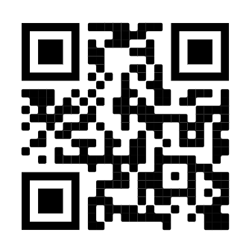

Instructions are also below

- Access the Montana Scilympiad website (https://scilympiad.com/mt).
- Click the “Log in” tab in the upper-right corner and log into your account.
- Click the “Event Supervisor” tab in the blue bar at the top. The event(s) you are attached to will show up as green boxes on the Tournaments page. If you are not attached to your events (and nothing shows up), please let us know right away!
- “Tournaments” page
  - Click the button for the event that you want to score.
This will only show up the first time you log in,

- “Event Supervisor Dashboard” page
  - Under the “Competition Day” heading, click the “Event Scoring” link.
    - Note: If you are doing more than one event, to switch events, click the light blue icon under the “Event Supervisor Dashboard” heading.
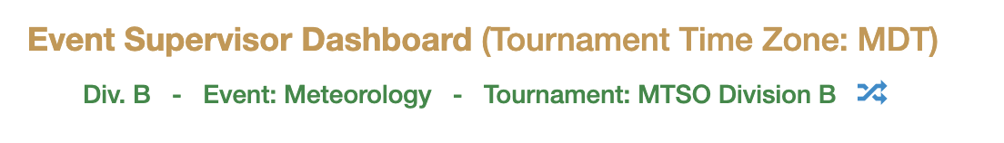
- “Event Scoring” page
  - For events that only report raw scores (most testing events) (“Team #” values are black):
    - Enter scores for each team in the “Score1” column and click the “Save changes” button in the bottom-right corner of the table.
    - If needed, enter additional points into the “Score2” and/or “Tie Breaker” column and click the “Save changes” button.
    - Several schools bring a varsity and a JV team; please be sure you are entering the score in the right column!
  - For events that utilize a score sheet (“Team #” values are orange):
    - In the table, click the Team # to enter scores for that team. You will have to click on each team, even if they did not show up.
    - From the drop-down menu, select:
      - “Competed” for teams that both competed in your event and were able to earn a score,
      - “No Show” for teams that did not compete in your event,
      - “Participation” for teams that competed in your event but were not able to earn a score,
      - or “Disqualified” for teams that were disqualified from your event.
    - For teams that are categorized as “Competed,” check/uncheck boxes and enter scores for each category of your event’s scoring criteria.
    - Once completed, click the “Save changes” button at the bottom of the page and repeat Step 6b for each team listed in the table.
- After scores have been entered for all teams and all ties have been broken, click the “Checkout” button at the top of the “Event Scoring” page. (To access this page, click the “Event Supervisor” tab and then click the “Event Scoring” link under the “Competition Day” heading.)
- “Event Scoring Checkout” page
  - Complete the event scoring checklist, enter your name, and click the “Submit” button.
    - Note: Complete this step for each event that you are supervising.
- After the event scoring checkout is completed, bring your scoring materials to the score room for auditing and verification (SUB 236).

