C:\Users\CSF699\Pictures\MTN logo.jpg
Montana Team Nutrition logo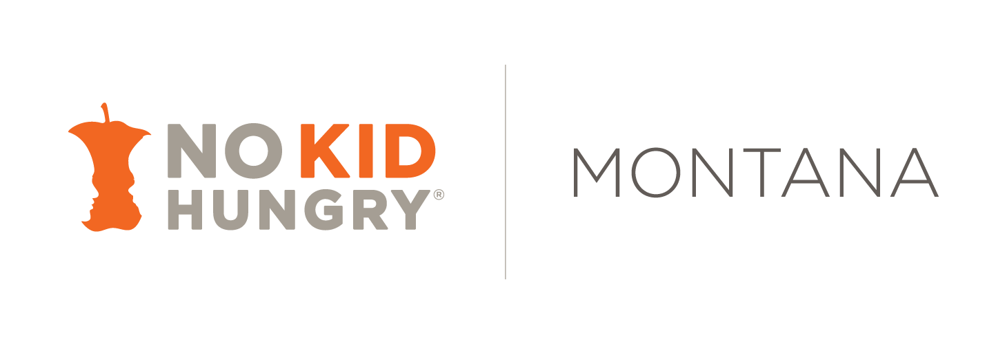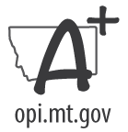

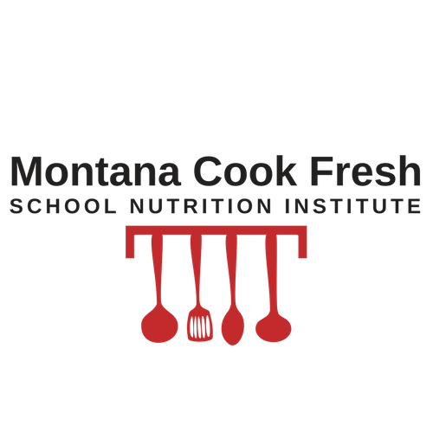

**TRAINING SUPPORT PROGRAM**

Funding is provided by the Montana No Kid Hungry Program and a 2017 USDA Team Nutrition Training Grant. The USDA is an equal opportunity provider.

325 Reid Hall   
P.O. Box 173370

Bozeman, MT 59717-3370

www.montana.edu/teamnutrition

Tel (406) 994-5641

Interested in improving your school meal program’s ability to serve more fresh foods and “from scratch” meals?

The Montana Cook Fresh Training Support Program can provide:

* On-site training and technical assistance to your staff to enhance their culinary skills, menu planning, recipe development, procurement methods, service and marketing of fresh wholesome foods to students.
* Experienced Montana School Food Service Peer Educators and/or trained chefs to work with the Food Service Director to create a plan that is designed specifically to meet your program’s goals.
* Financial support is provided to the school district and the Peer Educator. Funding is limited to four school districts so apply today!

**Examples of   
Montana Cook Fresh Training Support**

* Assessment of breakfast or lunch menus, recipes, equipment, and staffing pattern - with a tailored training plan to increase scratch cooking or service of whole fresh foods.
* Culinary training for staff which can include knife skills, cooking methods (roasting, blanching), flavor enhancements (use of herbs/spices), new recipe development, and record keeping.
* Enhancing breakfast program with more fresh foods, menu variety, and/or expanded service options.
* Salad bar and/or fruit and vegetable menu enhancements.
* Purchasing suggestions for including more fresh and local/regional foods.
* Marketing ideas to boost student engagement in to enhance menu, salad bar, and cafeteria atmosphere.

Montana Cook Fresh Training Support Program

+

# **On-site Training to Increase Scratch Cooking**

For More Information:

Katie Bark

Montana Team Nutrition

(406) 994-5641

kbark@mt.gov

Montana Team Nutrition Program