**MSU Rentals: Keys to Success!**

### **Sign up for Enterprise Plus!**

[Click here for a new Enterprise Plus profile!](https://www.enterprise.com/en/enroll.html?cid=XZ63MSU)

### **Use the MSU booking link!**

[Click here to access the MSU link](https://www.enterprise.com/car_rental/deeplinkmap.do?bid=028&refId=NEWMSUPT), and bookmark it for future use!

### **Book using Enterprise Plus account!**

A travel manager can book rentals on behalf of a traveler without their password!

### **Put your PCARD in Enterprise Plus!**

[Click here to sign into your profile](https://www.enterprise.com/en/account.html?icid=footer.enterprise.plus-_-account-_-ENUS.NULL#ep), and add credit card as a “Payment Detail”

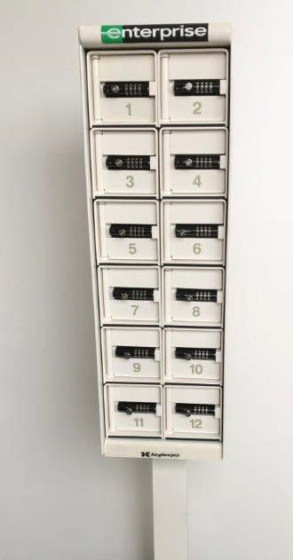

**Erin Kramarich**

Phone: 406-896-0752

[Erin.Kramarich@ehi.com](mailto:Erin.Kramarich@ehi.com)

**Local Bozeman Branch**

Phone: 406-586-8010

[EnterpriseRentACar-6313@ehi.com](mailto:EnterpriseRentACar-6313@ehi.com)

**Deliveries are available Monday thru Friday, 10:00 AM to 5:00 PM**. **Please reserve vehicles for when they must be delivered. 24-hour notice required for Motorpool deliveries**

**For early morning rentals (before 10:00 AM)**, reserve the vehicle for the night before (after 4:00 pm) for no extra charge. If you need the vehicle early on Monday morning, Enterprise will deliver the vehicle Friday evening for a $20 Early Start fee.

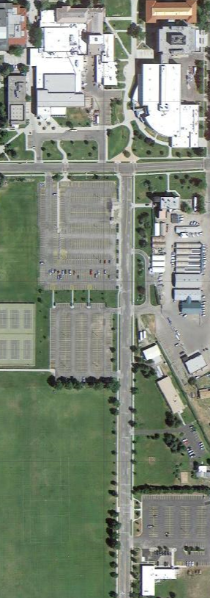

**Strand Union**

**University Police**

**MSU Motorpool**

**Motorpool Delivery Instructions**

**Please note:** Enterprise Plus is **required** for Delivery.

**Delivery Location:**

**MSU Motorpool**

**1501 South 7th Ave**

**At the time of rental:** The rental branch will call the phone number on your **Enterprise Plus** profile to provide a PIN to access the keys.

**When you are finished with the rental:** You can return the vehicle to the motorpool. Park the vehicle anywhere in the lot and put the keys in the Enterprise drop-box.

**After the rental:** A receipt will be emailed to your **Enterprise Plus** email address.

***Keybox for picking up keys***

If the website shows no vehicles available, or with any other questions or issues, contact: