womanifesto
Newsletter of the MSU-Bozeman Women’s Center April 2003

SHANNON WEATHERLY LECTURE PRESENTS:

Ordinary Women on an Extraordinary Journey: Frida Waara

The Women’s Center is pleased to bring Frida Waara, adventurer, skier and writer to the MSU campus for our 17th Annual Shannon Weatherly Memorial Lecture. Join us on Monday, April 7th, 2003 at 7:30 p.m. in SUB Ballroom A for this multi-media presentation.

In April 2001, Frida Waara, along with eleven other women, journeyed to the top of the world. They were the first all-female unsupported expedition to reach the North Pole from Russian ice.

In her lecture, Frida will share slides and video shot on the expedition and show us some of the equipment she used. She will tell her story of courage and survival in the most unforgiving landscape on the planet, and discuss how the team tackled the challenges of weather and geography to keep moving towards their goal.

Frida Waara now lives in Upper Michigan where she produces documentaries, is a freelance writer, and lives a very active outdoor life filled with biking, paddling and skiing. Frida says that snow has always steered her life. She explains, “I was conceived on a ski trip, chose a college based on snowfall, and even met my husband in a snowball fight. Snow has always been my favorite toy, but I found in the Arctic, it’s also my favorite art form.” Frida is married and has two children and her daughter attends MSU-Bozeman.

Waara has been sharing her story with various groups and plans to write a book about the adventure. Others who have heard her story say her presentations are about much more than a ski to the North Pole. Her message includes the idea that we are all on a journey in life and should not hesitate to try new adventures; if we feel we cannot do

something, that decision should be ours alone and not imposed on us by someone else. She inspires her audience to expand their goals beyond degrees and jobs—that some of life’s most important lessons are not found in a textbook. And she believes deeply in the power of teamwork for success.

We hope you will join in the adventure of hearing Frida’s story and welcoming her to Montana.

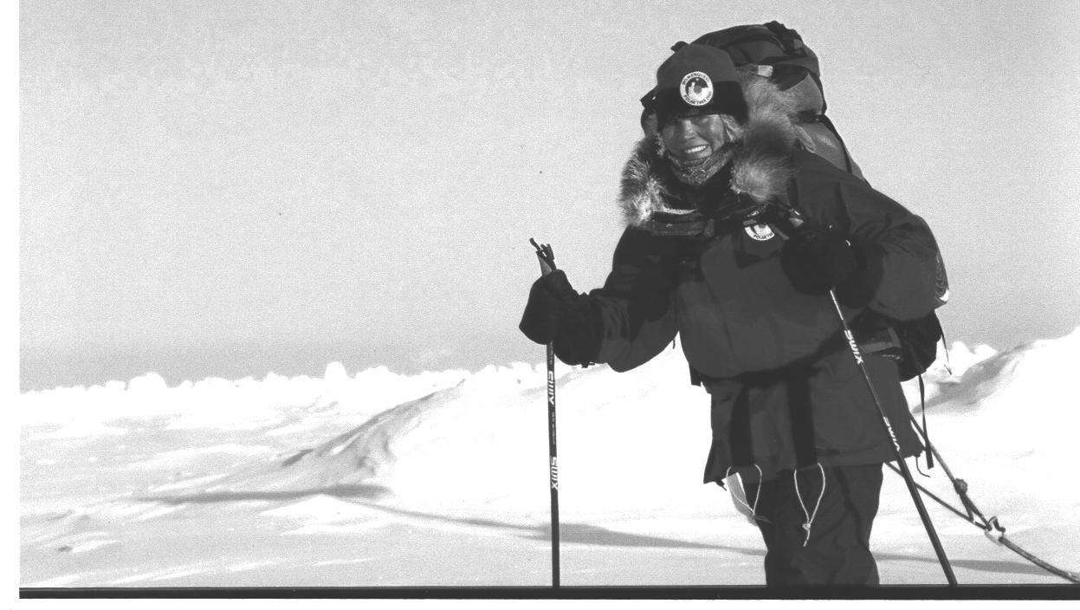

Frida Waara at the North Pole

Announcing the 2003 Student of Achievement Award Winners.
See inside!

“BURL GIRLS”
By Sydney Schoepke

In my experience, I believe the best way to spend time with yourself is to spend it in the wilderness. When you leave the accessories at home, it is amazing how quickly everything at the trailhead can be tossed aside and the focus can be solely on what you need and want to do.
I was fortunate to spend three months in the wilderness on a National Outdoor Leadership School semester in the Rocky Mountains last spring. There were ten men and three women from around the world taking the course with me. Together we were able to reinvent ourselves into a group of individuals who felt we could tackle anything. For me one of the greatest things to witness was the bond that formed between the four women on the trip.
When we met in Lander, Wyoming, we were individuals: a former karate national champion, a world-class figure skater, an equine master, and a former Nordic ski racer. Quickly we became known as the “burl girls” as we mastered telemark skiing and hoisted our seventy-pound packs without complaint. The men on our course were astounded by our unity and determination. Our instructors let us thrive on our own and made sure not to single us out or ask less of us because we were female.
By the time our course was over, we had ascended two mountains in the Wyoming Range, trekked over 90 miles in the Grand Canyon, climbed hundreds of routes in Red Rocks, Nevada, and kayaked class-three rapids on the Green and Yampa Rivers. We never set out to prove anything to anyone, but in the end we realized that we proved more to ourselves than we ever could have imagined.

Q-MSU: What's Happening

Q-MSU is a campus based student organization for Lesbian, Gay, Bisexual, and Transgender students, staff and community members and allies in Bozeman. Weekly meetings are held throughout the academic year . These meetings are an opportunity to get to know one another, discuss current issues, offer support and plan events.
All LGBT students and community members are welcome at our Monday night meetings as well as parents, friends and allies. Meetings are confidential. To find out where meetings are or to get more information about Q-MSU, contact us at 994-4551, or e-mail us at q-msu@montana.edu, or visit our website at www.qmsu.montana.edu. Be sure to keep an eye out for information about our dance on April 26, 2003.

Local Resources:

AIDS Network of Southern Montana, 582-1110
The Network (24-hour Shelter & Crisis Line), 586-4111
Bridger Clinic, Inc. (Reproductive Health Care), 587-0681
Career Transitions, Inc. 388-6701, careertransition.com
Child Care Connections, 587-7786
HELP Center (24-Hour crisis line), 586-3333
Montana Hotline for Domestic Violence & Sexual Assault (24-hour line), 1-800-655-7867
MSU Campus Security (24-hour emergency), 994-2121
MSU Counseling and Psychological Services, 994-4531
MSU Student Health Services, 994-2311
MSU VOICE Center (Victim Options In the Campus Environment), 994-7069 (24-hour line)
MSU Women's Center, 994-3836
Parents, Family & Friends of Lesbians & Gays (PFLAG), 723-7251 (Butte), 252-5440 (Billings)
PRIDE, www.gaymontana.com/pride, 1-800-610-9322
Q-MSU: Lesbian, Gay, Bi-sexual, Transgender, Questioning, 994-4551
Women's Voices for the Earth, 406-543-3747 (Missoula

Getting off your rocker. . . .
By Nora Olsgaard

Mark your calendars every Tuesday night for MSU’s newest
club. You have heard of FFA (Future Farmers of America,)
but have you ever hear of . . . .

Future
Grannies of
America

Come and join us with whatever crafty/knitting project you are working on. Or if you would like to learn any of these wondrous abilities, we have ample number of professionals to help you out on tackling any size project. Meetings are very informal and held at 5:00 p.m. on Tuesday evenings at the Women’s Center (Hamilton Hall Rm.15) on campus. Get off your rockers and get involved in a way that will revolutionize the way people view your hobbies!

Twenty Years Strong and Growing with Your Help

The MSU Women's Center is celebrating our Twentieth Anniversary this year! We continue to provide quality programming and a host of resources for MSU students, faculty and staff and Bozeman community members. We keep an ear open to contemporary issues and concerns to provide seminars that address topics such as: women in Afghanistan, Generation X and feminism, and women's health. We house a lending library that contains over 1,800 books and journals. We publish a quarterly newsletter in which we feature student articles and interviews with dynamic campus personalities.
With your help we can continue to expand our resources and sponsor more exciting and relevant lectures on campus.
20 bucks
for
20 years

Yes! I'd like to be a part of the $20 for 20 Years Campaign!
Enclosed is my check made out to the Women's Center.

Your name (and address if you'd like to be added to our mailing list).

In the spirit of spring-cleaning, please take a moment to help us tidy up our mailing list. Thank you!

To be
removed from
our mailing
list….
If you would like to be removed from our mailing list, please let us know:
Name:

Address:

Please return this slip to: Women’s Center, 15 Hamilton Hall, Bozeman, MT 59717
Or call: 994-3836 or email us at wwwwomen@montana.edu

To get on our
mailing list or update your address….
If you are not on our mailing list and would like to be, or have had an address change, please provide us with your current address:
Name:
Address:

Please return this slip to: Women’s Center, 15 Hamilton Hall, Bozeman, MT 59717
Or call: 994-3836 or email us at wwwwomen@montana.edu

