womanifesto
Newsletter of the MSU-Bozeman Women’s Center November 2003

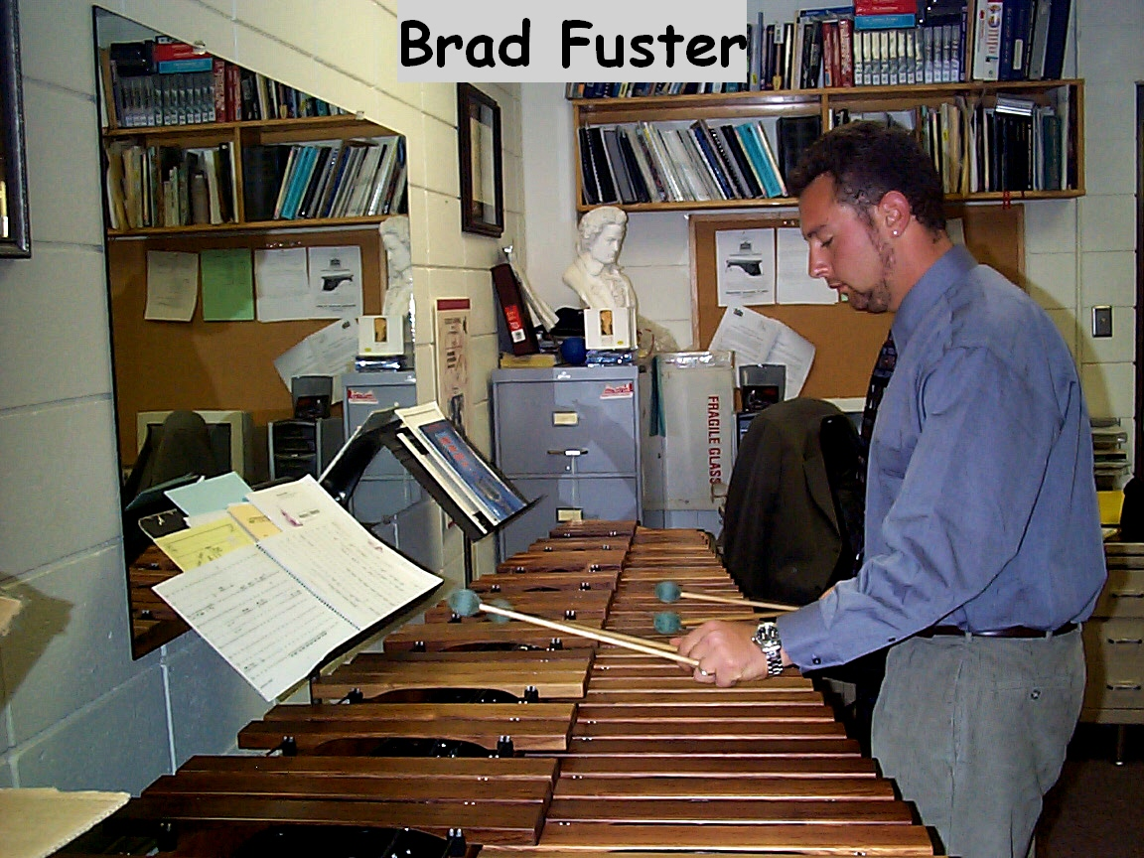

Celebrating Women in the Arts
By Sally Monn

MARIMBA!!! A cool sounding name for a long free-standing musical instrument with wooden keys made of Honduras Rosewood. It looks like a xylophone, was originally made in Guatemala and will be played during the concert “Celebrating Women in the Arts” on Wednesday, November 19th.
This concert is dedicated to women in the arts and all the music except one piece was composed by women all over the world during the 20th century. Brad Fuster, Director of Percussion, and coordinator for this event, wrote a piece to accompany the text of Edna St. Vincent Millay’s poem entitled “Renascence.”
COOL FACT: one of the pieces composed by Johanna Magdalena Beyer (titled “IV,”) was completed in 1935, three years after the very first percussion ensemble piece came out. Percussion is traditionally thought of as male-dominated; that’s what makes this event unusual. Female compositions tend to be less well-known, so savvy percussion enthusiasts may not recognize many pieces performed. Brad said it took a long time to find these pieces.
Brad Fuster came to MSU in 1999 to direct the marching band and percussion section. He now works mainly with percussion, but still has a hand in the marching band and is currently teaching music history. Professor Fuster’s degrees, a BA from State University of New York, and a master’s from Yale, are in percussion and performance. background of a BA from the State University of New York, an MA

He is presently working on a doctorate of Music from the University of Southern California.
DID YOU KNOW that the entire MSU marching band went to New York to march in Macy’s 75th annual Thanksgiving Day parade in 2001, and raised the $250,000 needed for the trip? During Spring break 2002, the percussion ensemble completed a very aggressive 3,200-mile concert tour in 8 days. They played at high schools, public venues, and universities.
The MSU percussion ensemble is currently 14 students and three are female. Brad has wanted to attach a theme to the concerts they perform each semester, but couldn’t make it work until now with “Celebrating Women in the Arts.” The world premiere of a new work for Cello and Percussion Ensemble by Ilse Lee is also featured. Ms. Lee is the Cello instructor at MSU. Please join us at 7:30 in Reynolds Recital Hall in Howard Hall on Wednesday, November 19th to enjoy this premier event.
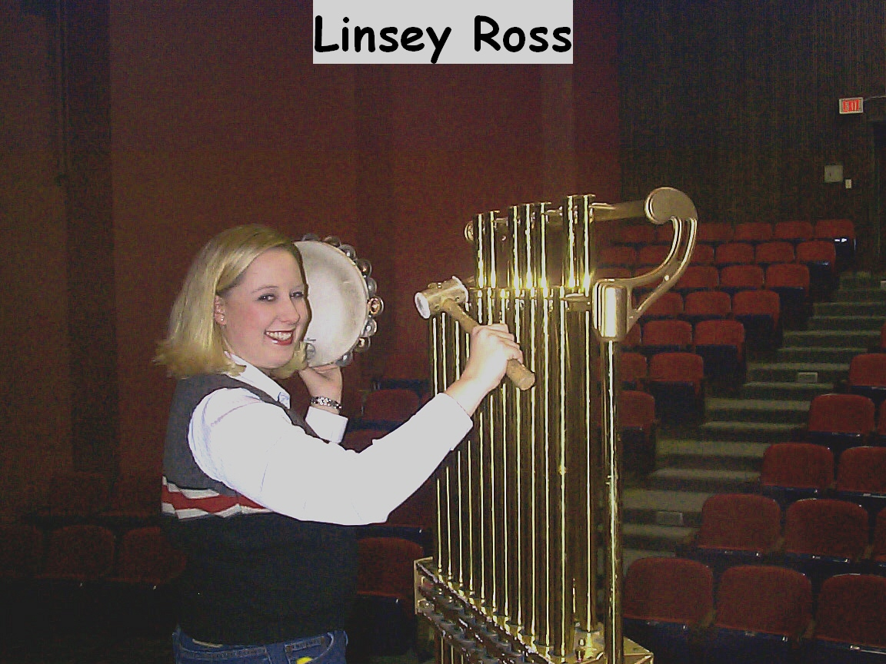

A bright, bubbly senior graduating this spring and performing in the “Celebrating Women in the Arts” concert, Linsey Ross started playing “drums” on her Mom’s pots and pans before she was in kindergarten. She always knew she wanted to play drums, and started playing percussion in school when she was ten. Linsey named her dog after an African hand drum. Her parents were amused that she named the dog well before Christmas, when they were giving her the drum set for Christmas.

Continuing with private lessons at age twelve, her second instructor had played in New York City with Jazz legends Dizzy Gillespie, Benny Goodman and Louie Armstrong. In Billings, her elementary school percussion education was very limited; Linsey didn’t even know the rudiments (the basis of everything percussion) when she started private lessons.

She currently lives in an apartment just off campus with her best friend from West High School. Linsey is a homebody, spending most nights studying or working at the Ask Us Desk in the SUB. She started her college career double-majoring in Marketing and Music, then scaled it down to a major in Business Management and Minor in Music because “it was too much!” She’s planning to go to law school next year.

Mom Ross has never missed a single concert since Linsey was ten, and her Dad, who travels five days a week, has missed only one high school concert. The light of Linsey’s life is her three-year old nephew Mason, her sister Jennifer’s son.

Linsey’s current favorite instrument is the Marimba, and she wanted to play a solo in the upcoming concert, “Celebrating Women in the Arts.” However, she couldn’t work in enough practice time, so will play chimes and other pieces throughout the event. The marimba creates “the most beautiful sound of any instrument,” according to Linsey. “The BEST composition in this concert is based on Japanese Taiko drums, which are HUGE, as big as people, and played really loud. It’s a very technical, drummy, fun piece that starts out with several instruments playing in sync, then gets loud and chaotic,” exclaims Ross. Linsey also loves the tambourine because you can do so much with it – finger rolls, figure eight rolls, shaker rolls, etc.

Linsey enjoyed the Macy’s Day parade; she was one of the 120 MSU marching band students who went to New York City in 2001. It was shortly after 9/11 when airport security was at its highest, and traveling with all the other students, uniforms and accessories, and bulky percussion instruments was “a nightmare!” There weren’t enough flights out of Bozeman, so one busload of students had to fly out of Billings. The whole trip was crazy, but well worth it, according to Linsey. They saw a Broadway play, the Radio City Rockettes, and did the NBC Today Show. The band had to stay in a hotel an hour outside the city so that they had a place to rehearse - the hotel parking lot.

Linsey Ross is extremely pleased with her choice to study music throughout her school years. As she puts it, “I’ll be able to use my background to help others, like giving lessons to younger students as I did throughout high school, no matter where my future business career takes me!”

Join us All for the presentation of
“Celebrating Women in the Arts”
Wednesday, November 15, 2003
At 7:30 pm in Reynolds Recital Hall

Just a reminder from the Craft Corner. . . .
The Knitting and Needlecrafts Club is still meeting in the Women’s Center every Tuesday nights at 5pm. All skill levels are welcome and tea is included.

The Newest Additions to the MSU Women’s Center Library
Creating Sanctuary Sandra Bloom

After Silence Nancy Raine

Feminism: The Essential Historical Writings
Miriam Schneir
Life of Pi Yann Martel
Women for Afghan Women Sunita Mehta
Gay American History Jonathan Katz
The Alyson Almanac Alyson Publications
After You’re Out Karla Jay and Allen Young
Setting Them Straight Betty Berzon
But Some of Us are Brave Gloria Hull, Patricia Scott
Home Girls Barbara Smith
Contemporary Feminist Theory Mary Rogers
Afro-American Women Writers 1746-1933 Ann Allen Schockley
This Is Not For You Jane Rule
Drawing Down the Moon
Margot Adler
Women: a Feminist Perspective (4th edition) Jo Freeman
When and Where I Enter Paula Gibbings
Ain’t I A Woman Illona Linthwaite
Unless Carol Shields
Women and Male Violence Susan Schechter
Lavender Culture Karla Jay and Allen Young
Yours in Struggle Bulkin, Bruce, Pratt, Smith
A Room of One’s Own Virginia Woolf
Moving the Mountain Flora Davis
Lesbian Women Del Martin and Phyllis Lyon
Women: a Feminist Perspective (2th edition) Jo Freeman

Don’t Let’s Go to the Dogs Tonight
Alexandra Fuller
In Glory’s Shadow Catherine S. Manegold
Floreana Margret Wittmer
Women’s Realities Hunter College
The Breast Cancer Book Of Strength and Courage
Ernie Bodai, Panneton
We Are Everywhere Mark Blasius and Helan

THANK YOU for all the donations to the library. They are always greatly appreciated. Come and check out how blessed we are to have such an awesome resource here in the office.

Local Resources for Women

AIDS Network of Southern Montana, 582-1110
The Network (24-hour Shelter & Crisis Line, 586-4111
Bridger Clinic, Inc. (Reproductive Health Care), 587-0681
Child Care Connections, 587-7786
HELP Center (24-Hour crisis line), 586-3333
Montana Hotline for Domestic Violence & Sexual Assault (24-hour line), 1-800-655-7867
MSU Campus Security (24-hour emergency), 994-2121
MSU Counseling and Psychological Services, 994-4531
MSU Student Health Services, 994-2311
MSU VOICE Center (Victim Options In the Campus Environment), 994-7069 (24-hour line)
MSU Women's Center, 994-3836
Parents, Family & Friends of Lesbians & Gays (PFLAG), 723-7251 (Butte), 252-5440 (Billings)
PRIDE, www.gaymontana.com/pride, 1-800-610-9322
Q-MSU: Lesbian, Gay, Bi-sexual, Transgender, Questioning, 994-4551
Women's Voices for the Earth, 406-543-3747 (Missoula)

Q-MSU: What's Happening

Q-MSU is a campus based student organization for Lesbian, Gay, Bisexual, and Transgender students, staff and community members and allies in Bozeman. Weekly meetings are held on Monday evenings throughout the academic year. These meetings are an opportunity to get to know one another, discuss current issues, offer support and plan events. All LGBT students and community members are welcome at our confidential meetings as well as parents, friends and allies. To find out where they are or to get more information about Q-MSU, contact us at 994-4551, or e-mail us at q-msu@montana.edu, or visit our website at www.qmsu.montana.edu.
We will be holding our holiday gay/straight bash on Saturday, December 13th at 9:00 p.m. at the Baxter Ballroom in downtown Bozeman.

Help Celebrate the Women’s Center’s
21st Anniversary
by attending an
Open House
For the MSU Women’s Center and the VOICE Center
Wednesday, Dec 3rd, 4-6 p.m.
14 & 15 Hamilton Hall

Meet our friendly staff and supporters,
See old friends and make new ones, and
enjoy delicious food.
All are Welcome!

