womanifesto
Newsletter of the MSU-Bozeman Women’s Center December 2005

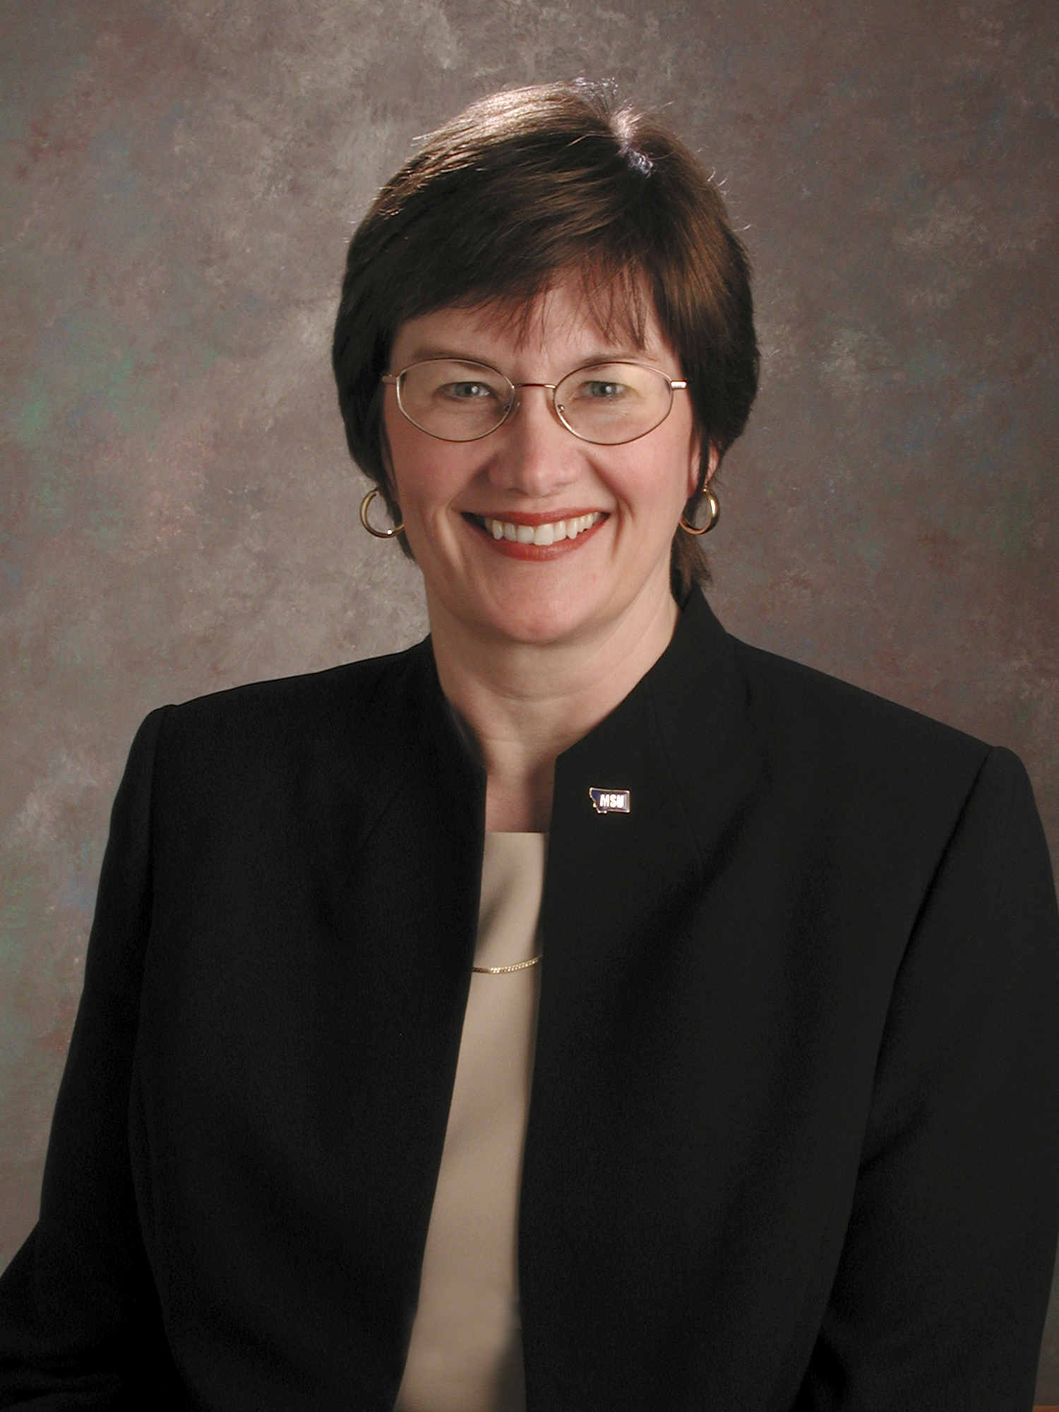
Interview with Dr. Sara Jayne Steen, Dean of Letters and Science
By Aimee Kissel

Dr. Sara Jayne Steen, Dean of the MSU College of Letters and Science and Professor of English, holds graduate degrees from the Ohio State University and Bowling Green State University. A specialist in Shakespeare and early modern women writers, she is the author or editor of seven books and edited collections and approximately one hundred articles, book chapters, bibliographies, and conference presentations. Among other faculty honors, she has received Montana State University's Wiley Award for Meritorious Research, the Presidential Distinguished Teaching Award, and the Cox Family Award for Creative Scholarship and Teaching. Before becoming Dean, she was chair of MSU’s Department of English from 1996 through 2002.
Dr. Steen shared her enthusiasm and affection for Montana State University during a recent interview. Sitting in her office, I felt slightly intimidated by the idea of interviewing someone in charge of 15 different departments, but Sara Jayne quickly made me feel at ease with her warm smile and quiet, confident voice. As she described her duties as Dean, it became clear that she is a visionary leader who inspires, through her example, the faculty, staff and students of MSU to do their best to make exciting things happen here. The College of Letters and Science includes a vast array of different departments that offer three quarters of core curriculum courses and half of the undergraduate and graduate classes on campus. English, Anthropology, Earth Sciences, Biology, Chemistry, Physics, History and Philosophy are some of the departments that make up the College of Letters and Science (CLS).
Sara Jayne’s position requires that she be able to see the broader picture of how all the departments in CLS fit together, enabling her to facilitate their cooperation and collaboration. Some of her responsibilities include developing new programs, helping find funding for new buildings and the remodeling of existing lab spaces, and providing individual support to faculty and students. She openly expressed her passion for her current position, and pride at being part of such a fine university. She enjoys sharing the excitement of researchers who are making discoveries in various departments, and takes pleasure in reports on MSU projects including the global research sites we utilize. Sara Jayne talked about her appreciation of MSU’s administrative staff for their support in allowing her freedom in shaping her research and career. She explained that faculty who are both top rate researchers in their fields and excellent teachers are highly valued; their research does not become stale, and they readily share the joy of discovery with their students. Sara Jayne noted that the teacher / scholar model is alive and well at MSU.
Dr. Steen told me she came to Montana directly from Graduate school expecting to stay a couple years to have a western adventure and find out what it was like to live west of the Mississippi. Luckily for us, she loved it and stayed and became an expert in renaissance studies. Dr. Steen explained her work to me in this way: “What I focused on actually had two aspects. First I focused on women writers and bringing them into the curriculum. When English studies were professionalized in the late 19th and early 20th centuries, it was assumed that there were no women writers earlier than the 19th century; for a lot of people Renaissance Studies was an entirely male field. When I received my PhD, I did not study any female writers, and I spent much of my research career discovering the women who wrote, what they wrote, and helping bring those items to print. There were spectacular poets and playwrights who were very well known in their day… they (later scholars) simply assumed that there weren’t any women writers. That was untrue. There were hundreds of wonderful women writers who were known in England. We had to recover those writers and had to figure out how to assess them and how to teach them. How do you bring them into the classroom? How do you re-interpret Shakespeare when you hear the voice of someone else who would have known Shakespeare?”
I asked Dr. Steen if she had advice for other women who would like to become college or university administrators. She replied that students and professionals should “…seek out mentorship and support and give it a try. It’s a real joy to be able to learn what is involved (in university administration) and be a part of making things happen. A lot of women may not understand how much fun this can be; they may not have seen role models of women in the higher positions. I think they need to talk to other women, and men as well, who work at that level to seek out mentors.” (continued on page 2)
-Page 2-
Dr. Steen explained that CLS is moving forward with four major projects for the future. These will focus on the Greater Yellowstone Ecosystem, health care, public policy issues, and global initiatives. She has also been involved with the creation of the new chemistry and bio-chemistry building, the remodeling of Gaines Hall to make it a first rate teaching facility, and raising money for the new Native American Student Center.
When I asked her what she would like to add to the interview, Sara Jayne replied, “ I would like people to have a sense of just how good this college is. I think sometimes that people, even those who work here, don’t have any idea how wonderful it is. They could have yet more pride than they do, and they should have. Think of all the opportunities you’ve been given. Students are doing really exciting things here and that’s what we are here for, to teach students to discover; and we’re doing a really good job of that.”

Local Women's Resources:
The Network Against Sexual and Domestic Abuse (24-hour Shelter & Crisis Line), 586-4111
Bridger Clinic, Inc. (Reproductive Health Care), 587-0681
Career Transitions, Inc. 388-6701, careertransition.com
Child Care Connections, 587-7786
HELP Center (24-Hour crisis line), 586-3333
MSU Police (24-hour emergency), 994-2121
MSU Counseling and Psychological Services, 994-4531
MSU Student Health Services, 994-2311
MSU VOICE Center (Victim Options In the Campus Environment), 994-7069 (24-hour line)
MSU Women's Center, www.montana.edu/wwwwomen, 994-3836
Montana Women Vote! Project, (406) 543-3550 (Missoula), montanawomenvote.org
Parents, Family & Friends of Lesbians & Gays (PFLAG), 723-7251 (Butte), 252-5440 (Billings)
PRIDE, www.gaymontana.com/pride, 1-800-610-9322
QSA (Formerly Q-MSU): Lesbian, Gay, Bi-sexual, Transgender, Questioning, 994-4551
Women's Voices for the Earth, 585-5549

The Women's Center is Open for You

The MSU Women’s Center is celebrating its 23rd year as an office on campus. This is your Women's Center. We are here to serve all students, faculty, staff and community members. The Women's Center is located in a welcoming space with room to study and explore. We house a special treasure: the Geraldine Fenn Memorial Library. This cozy little lending library houses over 1900 books primarily by or about women and a wall of fantastic newsletters and magazines. Anyone can check out books for free. Donations of books and magazine subscriptions appropriate to our library are always welcomed. Come and check it out.

When you find our office at 15 Hamilton Hall, our staff will greet you and gladly help you find answers to your questions, tell you about our programs and services, steer you to groups or other organizations that may be helpful, show you a big book full of scholarships for women, invite you to volunteer, or try to meet any other needs you might have.

The Women's Center is open Monday - Friday, 9 a.m. - 4 p.m. Be sure to check out our website to find out about upcoming events @ www.montana.edu/~wwwwomen or you can call us at 994-3836 to get your name added to our mailing list.

Women’s Center Staff:
Director: Betsy Danforth
Graduate Assistant: Samantha Gilday
Student Assistant: Aimee Kissel
Volunteers: Sanaa Kiddi
Sarah McConnico
Laaziza Toumma
I am eternally grateful to my staff, you make my days at work adventurous and fulfilling! XO betsy
Celebrate the Women’s Center’s 23rd Anniversary
“Twenty-three Dollars for Twenty-three Years”
The MSU Women’s Center is celebrating our Twenty-third Anniversary this year! We continue to provide quality programming and a host of resources for MSU students, faculty and staff and Bozeman community members. We keep an eye open to contemporary issues and concerns to provide seminars that address topics such as women in politics, Feng Shui, third wave feminism, and the ever-popular women’s health issues. We house a lending library that contains over 1,800 books and journals. We publish a quarterly newsletter in which we feature student and staff editorials, news items, and interviews with dynamic campus personalities.
With your help we can continue to expand our resources and sponsor more exciting and relevant lectures on campus.

Yes! I’d like to be a part of the $23 for 23 Years Campaign!
Enclosed is my check made out to the Women’s Center.

__________________________________________________________________
Your name (and address if you’d like to be added to our mailing list)

Thank you to Donors:
Thank you all so much for your donations to our "Twenty-three Dollars for Twenty-three Years" fundraising campaign. We are truly overwhelmed by the generous and immediate support shown by all of our friends. It warms our hearts to know that you are out there rooting for the Women's Center. Have a wonderful holiday season, for you have enriched ours immensely!

Christy Baldner

Al Bertelsen

Wendy Bianchini

Phyllis Bock

Joseph Fedock

Karen Grigry

Jaynee and Rolf Groseth

Julie Hitchcock

D’Arla King

Dr. Colette Kirchhoff

Edis Kittrell

Bethany Letiecq

Michelle Maskiell

Carmen McSpadden

Mary Murphy

Cindy Newman

Pat and Bill Oriet

Adele Pittendrigh

Tina Rodriguez

Mem Schultz

Jane L. Schumacher

Billy Smith

Sara Jayne Steen

Fred & Julie Videon

Join Amnesty International’s Global Write-a-thon December 9-11, 2005

Join the thousands of Amnesty International (AI) members, groups and friends from around the world by participating in the annual Global Write-a-thon. Last year activists from over thirty countries wrote letters during the Global Write-a-thon. The letters and postcards they wrote effected powerful change in the lives of individuals, helped stop violence against women and contributed to the release of Prisoners of Conscience around the world.

To learn more go to: Http://writeathon.amnestyusa.org

-Page 3-

Women’s Status in Islam
by Sanaa Kiddi
Many claim that the women’s liberation movement began in the 19th century, that women in the west are more liberated, and that in Islam, men and women are not equal and do not share the same rights. Women’s liberation in Islam was not founded by women, but was instead revealed by God in the 7th century through Muhammad (peace be upon him), the last known prophet in Islam. The Qur’an and the traditions of the prophet (Hadith or Sunnah) are the sources from which every Muslim person knows his or her duties. “What makes one valuable and respectable in the eyes of Allah, the creator of mankind and the universe, is neither one’s prosperity, position, physical strength nor beauty, but only one’s Allah-consciousness and awareness.” (Dr. Jamal Badawi, 1971)
One of Islam’s basic principles is justice for all humans and equality in the eyes of God. Women should have the same rights as men, and they are not denigrated anywhere in the Qur’an. Unlike Christianity, Eve is not believed to be the cause of Adam’s fall from the Garden of Eden. In the Qur’an, Adam and Eve are both responsible for what happened: “…by deceit he (Satan) brought them to their fall: when they tasted the tree their shame became manifest to them to theirs.” (Qur’an, Al-A’raf, 7:19) Many westerners would argue that Islam is a backward and “fundamentalist” religion, especially concerning the treatment of women. Western media often portrays the Muslim veil worn by women as an oppressive practice because every Muslim woman is required to wear a scarf or head covering and modest attire. This is not, in fact, considered a symbol of repression or control by Muslim women, however, and is instead a way of avoiding unwanted sexual advances or harassment. By dressing this way, it is believed that men will not consider women sex symbols, but rather come to appreciate them as individuals.The negative stereotypes of Muslim women are probably the result of deviance from Islam. The treatment of women has not been an issue in those countries where the people adhere strongly to the Islamic ideals. The purest form of Islam ensures that men and women will be treated equally and God promises them the same rewards: “Allah had promised to believers, men and women, gardens under which rivers flow, to dwell therin, and beautiful mansions in gardens of everlasting bliss. But the greatest bliss is the good pleasure of Allah. That is the supreme felicity.” (Qur’an: At-Tauba, 9:72)
The image of Muslim women has become distorted because of various misconceptions concerning the status of women within society. Many are not aware that in Islam, the concept of gender equality begins immediately upon birth. In the pre-Islamic period, baby girls were regularly buried alive to prevent shaming the tribe or family. In direct response to this horrific and inhumane practice, Islam forbade treating female and male children differently, and states that both girls and boys are equal blessings. Mohammad (peace be with him) addressed this issue directly stating: “whosoever has a daughter and he does not bury her alive, does not favor his son over her, God will enter him into paradise.” (Ibn-Hanbal, no. 2104)
Divorce is also addressed in the Qur’an, and contrary to common belief, a man cannot divorce his wife by simply stating “I divorce you.” Islam has just rules concerning divorce and requires that the couple think carefully before making this important decision. When the couple feels it is impossible to continue staying married, men are asked to break the tie in a gracious manner. The Qur’an clearly states: “O prophet! When you divorce women, divorce them for their prescribed time, and calculate the number of days prescribed, and be careful of (your duty to) Allah, your Lord. Do not drive them out of their houses, nor should they themselves go forth, unless they
(continued on page 4)

-Page 4-
commit an open indecency; and these are the limits of Allah, and whoever goes beyond the limits of Allah, he indeed does injustice to his own soul. You do not know that Allah may after that bring about reunion.” (Qur’an: Divorce, 65:1)
A common myth about Islam concerns marriage – many believe that women are forced to marry men without their consent, but Muslim women typically marry the men of their choice. Once a couple decides to marry, the man gives his bride-to-be a dowry as a gift for her; no one else has the right to take it from her. The Qur’an states: “And give women their dowries as free gift, but if they of themselves be pleased to give up to you a portion of it, then eat it with enjoyment and with wholesome result.” (Qur’an: Women, 4:4)
Fourteen centuries ago, Islam made women accountable to God and considered them equal to men. “He (God) it is who did create you from a single soul and there from did he create his mate, that he might dwell with her (in love)…” (Qur’an: Al-A’raf, 7:189) Because both men and women came from the same essence, they are equal. Women are not considered inherently evil as in some religions, and thus, are not believed to be inferior to men. In Islam, a woman has the freedom of expression of her opinions and ideas. Women also have other various rights; rights concerning civil, social, economic, and political issues. Thus, God promises them the same rewards as men: “Truly I will never cause the lost of work of any of you, be you male or female, you are embers of one another.” (Qur’an: Al Imran, 3:195) The Islam religion is designed to keep balance in society and values all people, men and women alike. “What people can find unjust or missing in one place is compensated for or explained in another place. Islam is a complete way of life.” (Mary and Anjaum Ali, The Status of Women in Islam)

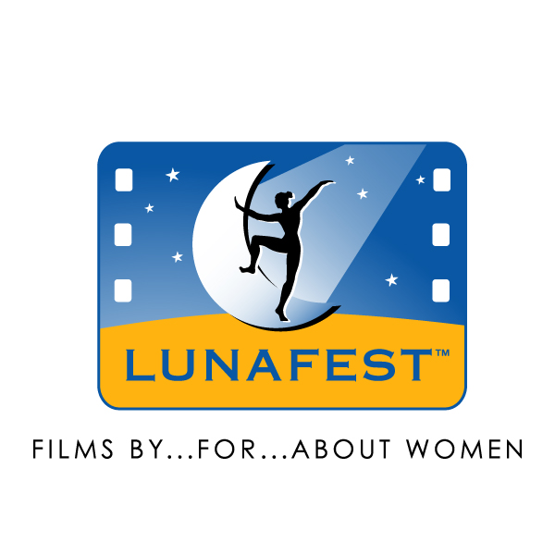

LUNAFEST™ BRINGS AWARD-WINNING FILMS TO BOZEMAN
Sex, Child Care, Menopause, and Cultural Pressures Encompassed In Film Event to Benefit Team LUNA Chix and the Breast Cancer Fund
LUNAFEST, which celebrates its fifth anniversary this year as the only national touring festival of films by, for, and about women, will make its first visit to Bozeman this year on Friday, February 24, 2006. LUNAFEST, produced by LUNA®, the whole nutrition bar for women™, provides a national platform for emerging women filmmakers to share their stories.
The program, which begins at 7:30 p.m. at the Emerson, will include eight winning films selected from more than 200 submissions. Under the direction of LUNAFEST’s professional programmers, the submissions were initially screened on technical merit, then further judged by the LUNAFEST 40-member community panel, assuring winners’ widespread appeal. Final selection followed a review by the LUNAFEST Board of Advisors, a panel of nine women professionals in the fields of film, media, marketing and women’s advocacy.
The films shown at LUNAFEST embody a wide range of topics dealing with what it means to be a woman in the 21st century. LUNAFEST’S 2005 selections are:

- BACKSEAT BINGO, by Liz Blazer, a short, animated documentary about senior citizens’ sexuality;
- ONE WEEKEND A MONTH, by Eric Escobar, a woman soldier’s crisis to find someone to care for her children during her tour of duty in the Middle East;
- TAHARA, by Sara Rashad, the dilemma of an Egyptian housewife living in Los Angeles, whether to follow tradition and circumcise her daughter;
- BLESSING, by Suju Vijayan a daughter’s struggle to be understood by her mother;
- TWILIGHT, by Victoria Gamburg, a mother’s search for her missing daughter;
- PERFECTION, by Karen Lin, a young Asian girl’s internal battle to find herself or continue to try to be “perfect;”
- LAYING DOWN ARMS, by Carol Schreder, the healing power of friendship between an old woman and a troubled young woman; and
- MABEL'S SAGA / LE VOYAGE DE MABELLE, by JoDee Samuelson a humorous look at menopause.
The event is presented by Team LUNA Chix of Bozeman. Team LUNA Chix is a group of professional women who share the same passion for cycling and other outdoor activities. Their goal is to encourage women to challenge themselves, inspire others, and engage their community. The festival is being held as a benefit for Team LUNA Chix and the Breast Cancer Fund. Price of admission is $8.00 and $6.00 for students. Tickets may be obtained by calling 570-5666.
LUNAFEST also raises awareness of, and contributions for, the Breast Cancer Fund. In total, over $75,000 has been raised for the Breast Cancer Fund. This is the first time the event has taken place in Bozeman.
For more information on the Bozeman LUNAFEST, call 570-5666 or email mtlunachix@hotmail.com. Information is also available at www.lunabar.com/lunafest.

